

Stay Strong, Stay Sane, Stay Writing!

‘WRITES’

*The visible hand of friendship*

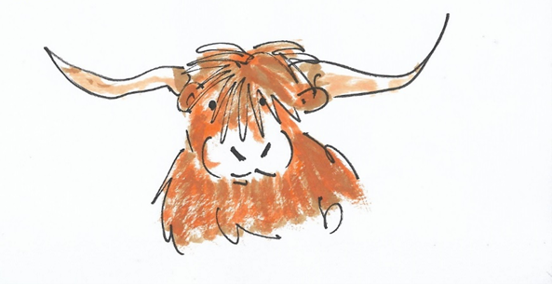

IPA Section UK Writers Special Interest Group and Global Writers Forum Magazine

No. 17

**February 2021**



***This is ‘Writes No.17’***

***May we continue to prosper in friendship and health throughout 2021***

***All copy to: The Editor:*** [***davidlewis@brynstowe.co.uk***](mailto:davidlewis@brynstowe.co.uk)

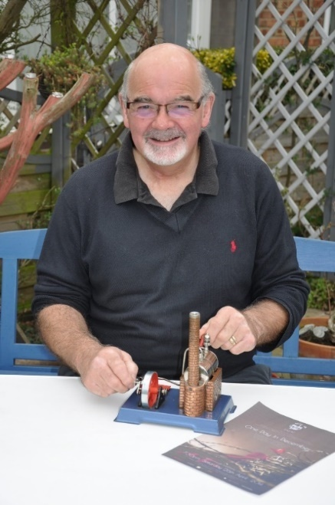***Editorial Chair David Lewis writes:***

*Dear fellow writers,*

*The Zoom meetings so far this year have been exciting, covering new ground and exploring more challenging areas of writing. This is to the good for the development of our individual ‘voices’ as writers and for us as a distinctive, unique ‘school’ or ‘collective’ of writing talent. We have started to look at inviting literary criticism of our work, to the need for constant revision and self-editing and to developing more purposeful works where we so desire. We are looking at how other writers, great writers, fashion their craft.*

*These are powerful aspects of our journey. And yet, as I read and edit the amazing submissions, I constantly ask myself if all our collective efforts are really worthwhile? Are they a power for good? Does anyone actually take note of the brilliance of the creativity on collective offer? It takes a lovely week to put this magazine together, a week of pleasure and indulgence for me as I come to read each piece, to edit and to hopefully improve the ‘usage’ wherever necessary. But is it enough?*

*By the far the greatest thrill of this is to see how our writers are developing, believing as I do, that in some small way, we are all learning from each other, taking notice and enjoying each other both for ourselves and for our writing. In some ways I feel as if we are an extended, growing, supportive family, interdependent one to the other? Perhaps that is the real strength of the IPA? Since becoming chair, I have hardly had time to write myself and this without any doubt, is the biggest downside of the role. But I balance that against the ‘greater good’, to use the words of Utilitarian, Jeremy Bentham, or Simon Pegg of ‘Hot Fuzz’ if you prefer. I both ‘give’ and ‘gain’ by being a member of this group, this family, this school of collective thought.*

*Hopefully, many of us will travel again this year to our spiritual home of Gimborn, there to renew our creative juices, recharge our enthusiasm for the written word and to cement the bonds of the friendships we have so beautifully forged. But it is to the ‘greater good’ I address this piece. How do we really make our mark in the world in which we both live and have influence? Your views are most eagerly awaited. Personally, I feel there is a niche, a major niche, even, whereby we can make a real difference. It may be in the realm of mental health; it may be in the promotion of positivity in the public’s perception of the police. As writers maybe we can help to balance any negativity. Can we find a way to fill this niche?*

*I am acutely conscious that we remain a white majority in the group and the team are working hard, as ever, to encourage the most diverse membership. The development of the ‘Global Forum’ side of our existence maybe something we could look at to help with this? In the ‘Letters to the Editor’ column you will see a powerful note from Ulrike Neuhoff at IBZ Gimborn. I have also had a letter from ‘The Thin Blue Line’ touching on this. Meanwhile here is ‘Writes 17’ to savour and enjoy; we are certainly thriving, but can we embrace the world more widely? I certainly hope so. Please keep writing; we are helping ourselves to help others. You are such incredible people. With love to everyone, David xx*

***In this late February edition:***

* ‘Spring’ *by Sean Hannigan*
* ‘Spring: A Critique’ *by the Editor*
* ‘Inspiration from a Zoom Meeting’ *by Geoff Jackson*
* ‘The Climbing Man’ *by Geoff Jackson*
* ‘Past Tense’ *by Geoff Jackson*
* ‘How I Joined the IPA***’*** *by Will Henry P.*
* ‘The Jaggy Thistle’ *by Will Henry P.*
* ‘Scotland. I Will Come Again’ *by Tony Granger*
* ‘The Six Degrees of Separation’ *by Janet ‘Fizz’ Curtis*
* ‘The Ian Thompson Memorial Prize Competition’
* ‘A Night to Remember’ *by Geoff Jackson*
* ‘Can(n)on Row: The Editor Reminisces’
* ‘Extracts’ No.1. *by Ian McNeish*
* ‘Chapter IV’ *by Tim Mobbs*
* ‘Helping Hands II’ *by Geoff Jackson*
* Letters to the Editor’
* *‘*The Bookshop’ *by Helena Hutt*
* ‘Tales from Madeleine’s Patch’ *by Steve Parnwell*
* ‘The Station Cat’

We are hoping to recruit a bank of regular cartoonists for the magazine and if you are interested in this slot please do let me know, Will Henry P. and Geoff J. and others with these wonderful skills.

**Cover illustration by Will Henry P. Thanks Bill.**

**Spring**

***by Sean Hannigan***

What is it, to Ewe the minted lamb

the metal coil coiled as

Spring

the Step, who had it in their foot and has it

Still

Wound up

Coil is coiled.

looking, yearning for release

To bounce and bouncing in there, foot

Spring whose idle Winter has become week!

Weak is now month to year while nowhere is sprung.

Spring

We yearn as summer earns its Rite of Spring of clashing Russian sound of dissonance note

Too Spring, to Spring

the smile across faces and

Places when this Thing is over when Spring

when When

are arms across the land miles and

Spring

Our arms around those whose tulip-bulbs should

Now.

be bloom

in this

Our

Spring

Spring

It must bee. Must be

as Sky Blue

Where the streaks of white the criss-cross of patterned vapour

Vanished as the help of hope.

Spring

Where the daffodils lightly wonder upon fluffy cloud

We breathe the crisp clear cleansing breath of spring.

not all

some breathe no more in pine and fine handled quick-box

Planted like a bulb

Rooted only in memory

Spring

But we are better than That Wood

The wood we see is tree, fir, cone, and crunch under coiled feet.

The bounce of foot will return

The shuffle of feet in a world of care return, swapped.

Our Spring and theirs is here.

Spring

Season of hope and expectation

Spring Spring Spring

Soft gentle meadow, due on crisp morning air

Spring

**Spring: A Critique**

***by the Editor***

*‘Spring’ was written, a little ‘tongue in cheek’ as a response to an editor’s challenge. The challenge was to write a short poem inspired by one word using a technique of writing down exactly what came into the head when thinking of the subject matter. A critique like this is therefore a little unfair perhaps, but Sean has risen to the challenge of starting to look at editing and revision more deeply within the SIG this year and has agreed to allow the poem to be so critiqued under this proviso.*

When Sean told me he really did not like this poem I thought it would still be useful to offer a poetry critique despite the limitations imposed by the nature of the challenge. With his permission therefore I offer my own views on an unusual style and the use of both space and word.

Do you have to like your own work? Now there is a question for us all as writers! Personally, I have to. Or is just does not go out there. Here we go then.

The author of this poem ‘Spring’ has a unique approach to poetry which is fresh, challenging and breaks the conventional mould as good poetry can do. What is initially striking is the obvious layout, sometimes known as ‘pattern’ or ‘concrete’ poetry which often seeks to match the subject matter it deals with; here there is a kinship with the coils of a spring for instance.

The best lines for me as a traditionalist will always be those that sing; ‘Where the daffodils lightly wonder upon fluffy cloud/We breathe the crisp clear cleansing breath of spring.’ Here there is a wordplay on Wordsworth of course and all his lonely cloud wandering, but the poem also collects various motifs of spring; the lamb, tulip bulbs, meadows, vapour trails, hope. It also resonates with darker themes of coffins, ideas of resistance, the Arab Spring perhaps, as hinted at by ‘Russian dissonance’ and the poem seems to be seeking to curl around itself a little like a spring. I really love those two lines amongst several others.

If anything grates with this poem, and some parts certainly do, it is the lack of self-edit which of course was part of the constraints of the challenge, but there is a definite suggestion of haste and little consideration for how close to brilliance it might later become. Take the line, ‘Spring whose idle Winter has become week!’ With a little application this could have better become, ‘Spring where idle winter has become weak.’ The personification of spring as written (‘whose’) is intriguing but the image of idle winter in spring becoming weaker as the gentle spring proves too much for it in the end is simpler, and also awesome.

Breaking the rules of ‘English usage’ is a risky business but can be indulged in if done so with meaning. In this work there are suggestions that the breakages of form have been plucked from nowhere and the reader is left to search for meaning, any meaning, meaning which may not be there. Take the lines, ‘Too Spring, to Spring/the smile across faces and/Places when this Thing is over when Spring/ when When/are arms across the land miles and/Spring/Our arms around those whose tulip-bulbs should/Now.’(Etc) This to the casual reader, and possibly any other, is unintelligible and yet, on the tenth read, there is a sense of our present

time embedded here, the pandemic ending, for some, sadly to a pine-box, others to a ‘sense of hope and expectation.’ Like a spring, which is made from one continuous piece of material, so this poem flowed from the immediacy of the brain’s associations with the word ‘Spring’ and needs to be read as a whole and not as a series of parts. With work it could be profound. A striving description of where we all are right now. But all great poets work and re-work their masterpieces and this should be no exception for this particular spring. Wordsworth was still revising ‘Daffodils’ years after the first version was panned by his contemporaries and yet today surveys suggest it is the fifth most popular poem of all in the English language. We should take time to edit. The ‘quick-fire’ exercise is possibly best used for inspiration rather than final publication.

A final word of warning and acknowledgement too: some of the word use here is clever and appropriate: ‘Soft gentle meadow, due on crisp morning air’ and ‘lightly wonder’ are strokes of the master if you think about them, but ‘to Ewe the minted lamb’ feels more like a stroke of a Christmas cracker-maker. We should all be selective; we should all take time to cultivate our genius, but this poem hints at a great and unique force striving to force itself upon the world. It has merit in its youthfulness. Dare to write! Dare to speak your words! Thank you, Sean, for this poem and all your words and for agreeing to this exercise. Genius or no, your contributions always challenge us, and this has much merit, whether you like it or not.

***Editorial Note:*** *There is a deliberate intention this year to gently explore the art of critique, editing, revision and writing improvement. It is one of the hardest aspects of the writer’s craft to accept for we all greatly dislike ‘to be told’, do we not?**Well, I know I do but I have learnt to embrace it at long last.* ***Ed.***

**Inspiration from a Zoom Meeting**

***by Geoff Jackson***

The ‘AA’s and ‘BB’s

Are there to help me rhyme,

They are also there to help

Me, with my time.

You can have an AA or ABC

It’s really just a trial for me

So do I write with airs and graces

putting ‘A’s and ‘B’s in places

that ‘A’s and ‘B’s shouldn’t really be?

I think that’s a matter just for me.

**The Climbing Man**

***by Geoff Jackson***

I saw a man who wasn’t there,

Climbing up the outer stair.

Odd thing is, the wall is bare

There’s never been a stairway there.

I saw the man go to a door,

Just up on the second floor.

And though he wasn’t there, in truth.

His countenance was quite aloof.

***Editor’s Note:*** *This is an interesting and neatly penned parody of the poem ‘Antigonish’ by the American poet, William Hughes Mearns written in 1898, a poet who subsequently parodied his own poem in a series of later works. The poem is sometimes used as an example of ‘existential logic’ and a very ‘well-done Geoff’ for teasing this one out. It wins the Editor’s ‘Pick of the Month’! (It is also AAAA AABB!!)*

*(Parody: ‘…*an imitation of the style of a particular writer, artist, or genre with deliberate exaggeration for comic effect.’ An article on ‘parody’ may therefore soon appear!)

**How I Joined the IPA**

***by Will Henry P***

Nearly 40 years ago an advert I was made aware,

Of designing a recruiting poster for something called the IPA.

I read the article with intention as drawing was my game,

And sat down to put pen to paper and claim my right to fame.

My poster was fantastic, well it looked good to me,

Of a space shuttle circumnavigated the earth with bold lettering for all to see.

The shuttle had a famous name embezzled on the nose,

The SS Arthur Troop it read, our founder of long ago.

I sent it off to a Vice President of a Region I now know well,

And waited with bated breath to see if success my chest would swell.

Well goodness me was my shock remark as a letter fell through door,

Dear Sir, you are a winner please complete the form below.

Well, I was overjoyed I had won the first prize,

My talents for what they were, had now been recognised,

The form was my first year’s membership to the world of the IPA

Now 40 years later I am still a member today.

I have held many positions and even reached the top

But there is a twist in this tale, and this is where I have to stop,

The letter I received with my application form,

Congratulating my efforts said PTO and then read on.

The letter said well done Bill for all that you have done,

You have won first prize, congratulations, however, you were the only one.

The only one who entered, and won this amazing prize,

Now 40 years later my passions realized.

I am a member of an Association that is known around the World,

That caters for all police officers whether serving or retired,

We have also welcomed to our ranks our police support staff.

To be part of an organisation where Friendships will last.

You may ask me now,

Has it been worthwhile?

I will answer with a YES,

I have enjoyed all aspects of this group which to me is the best.

So, there you are, a simple little story, of how I joined the IPA,

From the drawing of a recruiting poster that never saw the light of day,

40 years later what can I say,

I am still proud to be a member of the I-P-A.

**Past Tense**

***by Geoff Jackson***

Past tense, in the past,

Into the ether, the mists of time.

Love, Hate, Laugh, Cry.

Neatly packaged, squeezed away from sight and time

Into the minute spaces within our brain…Grey matter

Doesn’t matter,

Can’t feel them anymore.

**The Jaggy Thistle**

***by Will Henry P***.

There was a young laddie called Glen,

Who was Scottish from end to end,

Wearing his kilt as he walked in the breeze,

His manliness froze as it waffed up his knees.

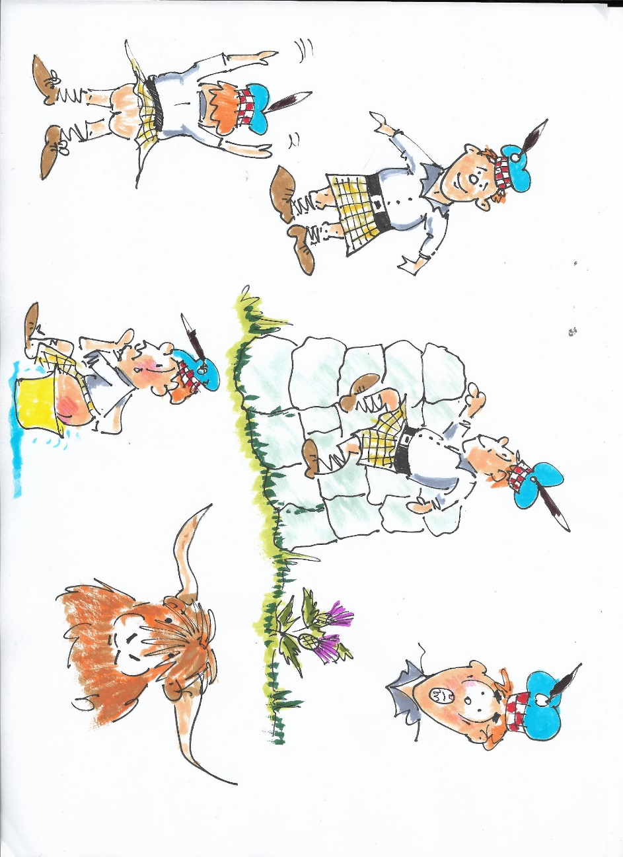

Needing a rest, he stopped for a while,

Took in all the scenery with a wow and a smile.

Then he thought what was over that wall,

So, clambered up taking care not to fall.

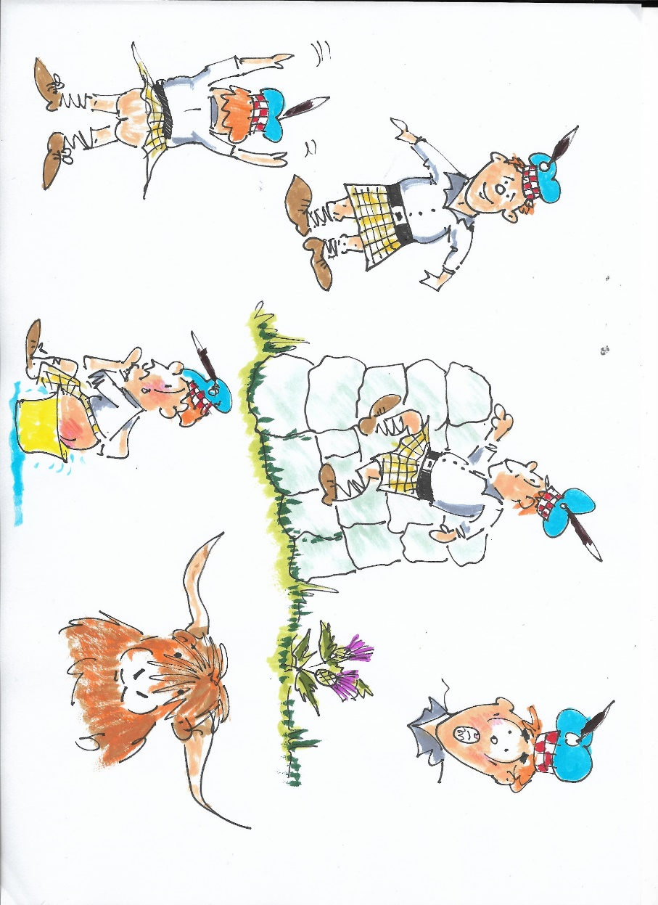

Just at that, a great muckle coo gave oor Glen the eye,

Oh my gosh, what an awfy sight, the poor wee laddie cried,

Glen reeled back losing his grip, As off the wall he FELL,

And headed down towards the ground and jaggie thistle hell.



MOO!

A traditional Jaggy Thistle all thorns, spiky and straight.

Alas amongst the heather that spiky friend did wait,

As he fell on to the flower his bare bum so exposed,

The thistle made its jaggy mark and how wee Glen’s bum glowed.

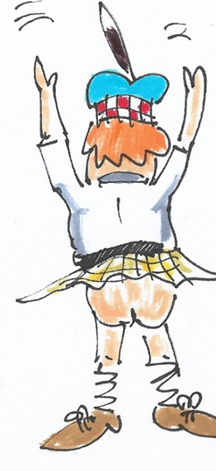

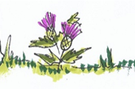

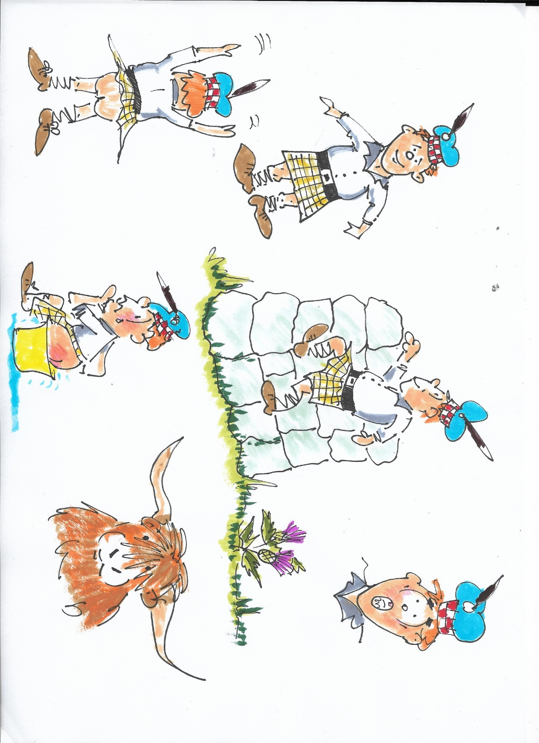

So oor Glen had caused a stir, his bum was fairly gowpin,

The Big Coo laughed thought he was daft as through the glen he

went loupin.

His mother, Agnes sat him doon in a pale of soothing water,

There you are my bonnie boy and burst oot in endless laughter.

**Scotland. I Came and Will Come Again**

***by Tony Granger***

I came from the land of the stinging tsetse flies to the land of the biting midges. I wore short pants, the Scots were resplendent in their tartan kilts and their twirling pipes, welcoming us.

The World Golden Oldies Rugby Tournament was held in Edinburgh in September 2008 and my team the Budgies comprised nationalities from England, Australia, New Zealand, America, Samoa and South Africa. We arrived in Edinburgh and immediately made our way to the Castle overlooking the City where massed pipers played us a welcome. Teams from all over the world, coming together in comradeship, friendship and a vitality that only comes from older generations and their love of the game. I knew that a fellow squad mate from Rhodesia police days was a piper who now served in the Lothian and Borders Police – David Brown – also known as ‘Spider’ Brown – and was hoping to make contact with him. I went up to one of the pipers and asked him if he knew David Brown. He looked at me blankly. I rephrased this and asked him if he knew Davy Broon?

‘Agh yes , ye noo’ he said ‘ Davy Broon is here – I will fetch him’

I hadn’t seen him for 35 years and in those early days he was a quietly- spoken spider-like figure. Imagine my surprise when this fully kilted and piped up burly figure graced my presence and what an event that turned out to be. I have the picture to prove it – we had many an ale afterwards.

Our team the Budgies played at venues around Edinburgh and ended up in the final played on the great Murrayfield rugby turf against a team led by Gavin Hastings. It was a hard-fought match – we had Mark Ella, an Australian retired international playing for us to help stem the Scottish tide as they made attack after attack. In the end we won a hard -fought game. The one thing about Murrayfield I will never forget is the instruction not to walk at all on the side of the pitch as the groundsman wanted to keep it in pristine condition. Players only had one entry and exit point.

Two things stand out on this rugby visit. The first was how touchy the bar staff were at a particular restaurant a group of is visited for a meal and a few drinks after one of our games. Our table of six people decided to order Irish coffees at the end of the meal. The Irish coffee was created by chef Joe Sheridan in 1942. He ran the restaurant at the Foynes airbase outside of Limerick, Ireland.

For those in the know, an Irish coffee is made as follows:

Ingredients are 1 to 2 teaspoons ​brown sugar (to taste), 4 ounces [coffee](https://www.thespruceeats.com/french-roast-coffee-765178) (strong, rich, hot), 1 1/2 ounces ​Irish (but as we were in Scotland their version of Irish) whiskey,1 ounce heavy cream (lightly whipped). Then Place the brown sugar into a warm [Irish coffee glass](https://www.thespruceeats.com/bar-glassware-tour-759984), mug, or other heatproof glass. Add the coffee and Irish (Scottish) whiskey. [Stir](https://www.thespruceeats.com/how-to-stir-a-cocktail-like-the-pros-760322) until the sugar is dissolved. [Float](https://www.thespruceeats.com/create-layered-cocktails-and-shots-759938) the lightly whipped heavy cream on top by slowly pouring it over the back of a spoon. Do not stir. Instead, drink the Irish coffee through the cream.

What arrived were six cups of coffee with what might have been cream mixed into it. Not floating on top so that we could sip the coffee through the cream and enjoy it. So, we sent it back. Another version arrived, but this also not quite right. When we questioned the waiter he fetched the barman who had made it and asked him to describe to us how he had done it. He obviously did not have a clue and someone (probably an Australian) on our table expressed his disdain. The barman picked up the tray with the undrunk Scottish version of Irish coffee and threw it on the floor, splashing coffee all over the occupants of a half a dozen tables near our table, and stormed off. When we called the manager, he said the barman had gone home – apparently a Celtic football supporter who did not like rugby players.

The following evening, I decided to take a walk from my hotel to sample the night life. Around the corner from the hotel was a basement pub and I began to stroll down the steps when a fellow coming up the steps took one look at me and said ‘Ye don’t want to be going down there’. I asked why not, but he carried on climbing and I was none the wiser. That is, until I made it to the bar and two very nice chaps both sporting Village People moustaches, offered to buy me a drink. Only then did I realise that I was a heterosexual in a gay bar. This wasn’t a problem and we spent a pleasant evening discussing sport and the fringe festival before they became otherwise engaged and I left to go to bed.

Somewhere in my past is a Scottish ancestor named Henry de Balloil (according to my mother) and from him sprang John Baillie who led 1820 settlers to Algoa Bay in the Eastern Cape region of South Africa – so I have always felt a great affinity for Scotland, and love to visit there. My Police Regimental Association meets once a year at the Scots Guards Club in Clifton Terrace, Edinburgh, and it always a pleasure to meet fellow and not-so- fellow Scots there. Yes, I will come again.

***At a recent Zoom meeting the subject of ‘Scottish writing’ formed the theme, a subject which was widely interpreted with some fascinating contributions, of which this was one. Ed.***

  **Gimborn**

**International**

**Writers Seminar**

**26th September-1st October 2021**

|  |  |
| --- | --- |
| |  | | --- | | Bok now by email at [info@ibz-gimborn.de](mailto:info@ibz-gimborn.de) .   For further information, please contact the editor at:  [davidlewis@brynstowe.co.uk](mailto:davidlewis@brynstowe.co.uk)  ================================================== | |

|  |  |
| --- | --- |
| |  | | --- | |  | |

|  |  |
| --- | --- |
| |  | | --- | | **Information and Education Center Schloss Gimborn eV | Schlossstrasse 10 | D-51709 Marienheide** Telephone: 02264 40433-0 | Fax: 02264 40433-69 | Email: [info@ibz-gimborn.de](mailto:info@ibz-gimborn.de)  It is strongly suggested that we all book early to secure a place at our wonderful spiritual home, the castle where we first came together to found the group in 2018. Please book directly with IBZ Gimborn. We will keep you posted on Brexit and Covid developments but securing the place is the essential first step. *The excitement mounts! Do contact me, Neil or Sean if you would like further information. (Ed.)* | |

**The Ian Thompson Memorial Prize**

**Writing Competition 2021**

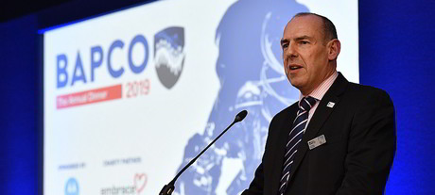

Ian Thompson was a former policing colleague having retired from North Yorkshire Police following service with Thames Valley. On retirement he became the CEO of BAPCO, The British Association of Public Safety Communications Officials, and travelled extensively in their interest. In his two careers Ian did much to promote excellence in communication between the emergency services. Sadly, in late 2020, Ian died of heart disease aged 56, and the family have suggested a writing competition in his memory. We are honoured and grateful that Amanda, Ian’s widow, and their sons Jason and Adam, have agreed to this tribute and we hope that many of our writers will enter the competition in Ian’s memory. It is fitting that Ian strove to promote excellence in communication, something we as writers of course also seek to achieve. He was a dedicated family man, a loyal neighbour, friend, and colleague, and we look forward to some excellent entries which will be judged by the family.

**Competition Rules**

Not less than 1000 and not more than 2,500 words. Or, if poetry of not more than 40 lines. Any genre, form or style, fiction, or non-fiction.

Entries to be submitted in **Calibri 12 pt. 1.5 spacing in a Word** document.

**Subject:** The subject matter of the submission should embrace **one or more** of the following: communication in any form, any aspect of technology, A.I. (Artificial Intelligence), and should be ‘forward facing’ embracing the future rather than the past. Subjects do not necessarily have to be police related.

**The Prize:** The first prize, kindly donated by Ian’s family, is for **£150** together with a certificate. ‘Highly Commended’ certificates will also be awarded for any submissions considered to be so worthy. The submissions will be collated, and the best entries published in pamphlet form. If conditions permit the prizes will be awarded at a suitable ceremony in the autumn.

**Submission deadline: 1st June 2021**

**Award notification: August 2021**

**A Night to Remember**

***by Geoff Jackson***

When it came to reading ‘Writes 16’, I was drawn to a small piece by our editor, ‘Six Degrees of Separation’, that mentioned several things to which my attention was drawn.

First was the name Mick Hills, a PC that I knew from my time working at Cannon Row Police Station as a PC between 1971 and 1975.

The content albeit a small article, took me back to 20th March 1974, a Late turn at Cannon Row, when I was posted to the Reserve Room (Communications Room). On this day I was working with another officer, Dick Lee, who usually worked No. 10 Downing Street, but this day was with us. We also had a civilian telephonist ‘Jim’.

The day started like most days do, radio checks, teleprinter messages, record checks, phone calls and more.

It was pretty quiet for most of the day, until a point in the evening when things took a very different turn.

It was coming up to 8 p.m. when a radio call was made by PC Mick Hills “Alpha Delta, I think there has been an accident involving a royal car”. I don’t remember Mick’s number, but I did know his voice, and it was serious. Dick

answered him, and I went straight to the front office to let the Station Sergeant Bruce Peardon, know immediately. Bruce let out a couple of expletives, while I went back into the Reserve Room.

As I entered the room, I heard Mick on the radio again, it was very serious.

“Alpha Delta, I’ve been shot, I’ve been shot.”

Mick had been posted to St James’s Palace, and was near the Mall at the junction with Marlborough Road.

I’ve never been too athletic, but at this point I ran across the room to the open window behind Dick and leapt onto the windowsill and through to the inner yard, where I ran to my right, and to where the driver’s room was. I burst into the room where three of the drivers were sitting and shouted what was happening.

All of us ran from the room and got into one of the police cars that was there, and left Cannon Row at a very fast speed, making our way to the Mall.

On our arrival at the Mall just before St James’s Palace, we came to a halt. We all jumped out and dispersed. I went along the nearside towards Buckingham Palace, with St James’s Park to my left. Up ahead I saw a male sitting with his

back against a tree, I could see he was holding his chest. There was a lady with him, who told me to carry on, this man turned out to be journalist Brian McConnell. The lady whoever she was, I understand later complained that police had taken a long time to arrive.

A bit further up I saw a male lying on his back with his top half on the pathway and part on the road. I noticed that he had an injury to his right hand, which was bleeding. A colleague of mine Steve Rose was looking after him.

I then ran up to the royal car, where I saw the chauffer, whose name was Callender. Although he was injured, he was still sitting in the driver’s seat, and told me to go to the back, which I did, and went to the rear offside door.

As I reached the door, it was opened, and I stood back in disbelief as HRH The Princess Anne said “Get an Ambulance, get an ambulance quick”. All I could do was to tell her that one had been called already, as I knew that Dick would have done that at Cannon Row.

Princess Anne moved back into the car along with her Husband Captain Mark Phillips and her Lady in Waiting. My one lasting memory of Princess Anne is that she was in full colour and knew exactly what she was doing, she was totally in control.

Shortly after this happened loads more officers had arrived on the scene and were everywhere. A blue Rover ‘Area Car’ arrived on scene and wasn’t too far

from the front of the royal car. Within several minutes another colleague, Geoff Fitzsimmons, got Princess Anne to get into the police vehicle and whisked her off at speed to Buckingham Palace.

Just prior to this happening, there was a commotion at the front of the royal car, and several officers, some in plain clothes came past the car to a white police traffic car that was sitting a little behind the royal vehicle.

The male concerned; a man called Ball, was loaded into the rear of the car followed by a couple of officers, another colleague, Alan Minnis, being one of them.

The evening continued. More officers turned up of various ranks and took over the running of the scene.

Our relief Inspector, Mick Green, our Superintendent Cyril Canham, along with the CID Superintendent attended the scene and were kept very busy.

I was surprised how some PC’s arrived, one being Alex Rozmus, who had been posted to Wellington Arch, arrived on his motorcycle, in his shirt sleeves, and without a helmet.

Our CID car or ‘Q-boat’ as we called it, had also arrived, and with the plain clothes officer, we surveyed the scene, locating the weapons in the gutter. The weapon used by Inspector Jim Beaton, a Walther PP, was noted to be jammed with the round facing inwards with the rear section jammed in the slide. We also saw a revolver and some empty cartridges. This all stayed where it was but was kept secure waiting for forensic support. I cannot recall what happened for the rest of the night. I could not tell you how I got back to the Police Station or what happened after that, but it certainly was a night to remember.

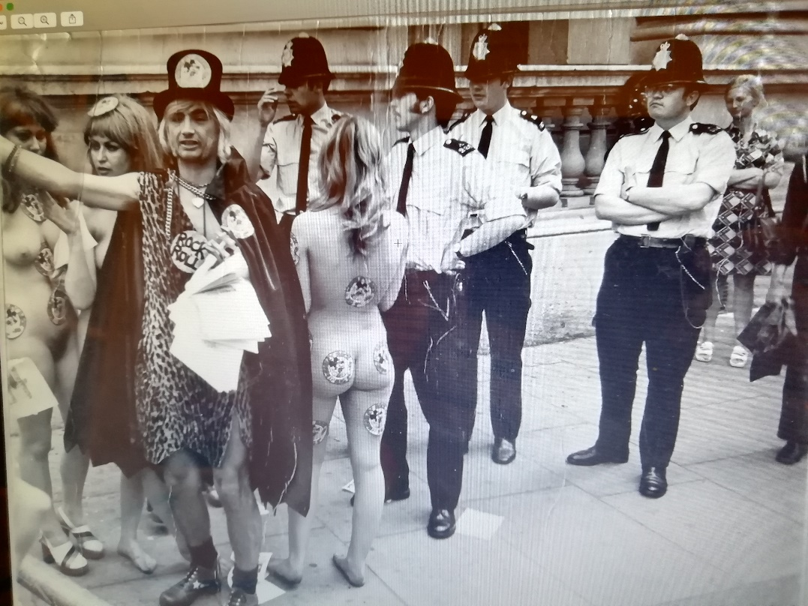

*This famous, much published press picture shows our intrepid hero Geoff (far right) clearly unmoved by the antics leading to the arrest of Screaming Lord Sutch and his followers outside Downing Street in the 1970s. Your editor has tastefully edited out the completely naked young lady in the far left as we now live in far more respectful times. You can be reasonably assured such considerations would not worry the news editor way back then.*

***Editor’s note****: a full description of the kidnap attempt also appears in my book* ***‘A Little Bit of Trouble in London’*** *(Bryn Stowe Publications Price; £5 plus p and p. to members.)*

**Can(n)on Row: The Editor Reminisces**

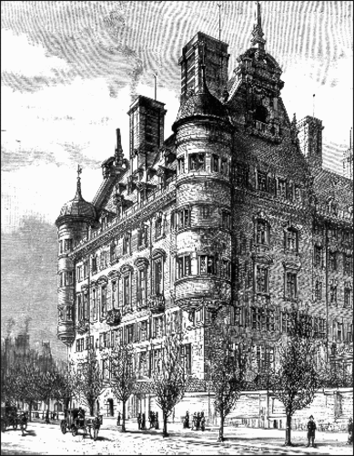Following on from the Six Strands of Separation theme in ‘Writes 16’, unbeknownst to both SIG members, Geoff Jackson and David Lewis, (the editor of this magazine), both served contemporaneously at the same station, Cannon Row, (sometimes called *Canon* Row) Police Station in the 1970s.

Shown in the illustration is the original building designed by the Scottish architect, Norman Shaw in 1898, as ‘New’ Scotland Yard, as distinct from the older ‘Scotland Yard’, a road further north off Whitehall which housed the Central London Recruiting Depot of the Army, the Westminster Crime Squad offices, and the Met Mounted Branch stables. How well I remember those early morning canteen breakfasts eaten to the nostalgically rural smell of horse. Heady times. Happy times.

Readers may wonder why Geoff and I never knew each other? Simple really. Cannon Row housed more officers than several forces. About one thousand bobbies or so were on the books whilst we served there as the ‘nick’ had to staff the Palace of Westminster (‘PoW’ or ‘Parliament’) as well as the Royal Palaces before the advent of the Royalty Protection Group.

But why the anomaly over the name? Because the street name plate was once painted by the scrivener as Canon Row and not Cannon Row as it should have been, and it so remained Canon throughout most of its history. A drunken signwriter perhaps? A bet? Who knows, but all part of the magical myths of the Met. **Ed.**

**‘Extracts’ (No. 1)**

At a recent Zoom gathering of the SIG the attending members discussed the possibility of looking (and hopefully learning) from the works of established authors. In this occasional series Ian McNeish this month chooses a selection of extracts from the incredibly descriptive masterpiece **Seven Pillars of Wisdom** by T.E. Lawrence. The beauty of Lawrence’s wording leaps out from the printed page.

**Seven Pillars of Wisdom (Thomas Edward (T.E.) Lawrence,** born 1888, Tremadog, Wales. Died Bovington, Dorset, 1935.)

‘Half-way through the labour of an index to this book I recalled the practice of my ten years’ study of history; and realized **I had never used the index of a book fit to read. Who would insult his Decline and Fall, by consulting it just upon a specific point? ‘** *(Synopsis – page 7)*

‘For years we lived anyhow with one another in the naked desert, under an indifferent heaven. By day, the hot sun fermented us; we were dizzied by the beating wind. At night we were stained by dew and **shamed into pettiness by the innumerable silence of stars**.’

*(Chapter 1 – page 29 on the Morality of Battle)*

**They were assertions, not arguments; so they required a prophet to set them forth**.

*(Chapter 111 - p39 on Semitic Religiosity)*

But when at last we anchored in the outer harbour, off the white town hung between the blazing sky and its reflection in the mirage which swept and rolled over the white lagoon, **then the heat of Arabia came out like a drawn sword and struck us speechless.**

*(Chapter V111 - p65 Going Ashore arriving at Jidda - also*

*known as Jeddah)*

‘The clay of its building was said to have been kneaded for a greater richness, not with water, but with the precious essential oils of flowers. My guides, sniffing the air like dogs, led me from crumbling room to room, saying, “this is jessamine, this violet, this rose,”…’

*(On the Virtue of Simplicity - P40 Referring to remains*

*of Roman building.)*

‘But at last, Dahoum drew me: “Come and smell the very sweetest scent of all,” and we went into the main lodging, to the gaping window sockets of its eastern face a**nd there drank with open mouths of the effortless, empty, eddy-less wind of the desert, throbbing past. That slow breath had been born somewhere beyond the distant Euphrates and had dragged its way across many days and nights of dead grass, to its first obstacle, the man-made walls of our broken palace. About them it seemed to fret and linger, murmuring in baby-speech. This they told me is the best: it has no taste. My Arabs were turning their backs on perfumes and luxuries to choose the things in which mankind has had no share or part.’**

*More ‘Extracts’ in the next edition. Great selection Ian. Ed.*

**Chapter IV**

***by Tim Mobbs***

‘I said turn left stupid!’

*(A.I.’s attempt at making SatNavs more human!)*

RTA – (Road Traffic Anomaly)

**Synopsis**

The year is 2036.

Once referred to as a ‘Road Traffic Crash’ (RTC), the process of dealing with Road Traffic Anomalies is now fully automated using Artificial Intelligence [A.I.] With the exception of Category 1 RTA’s (Fatal or likely to prove so).

Lesser RTA’s are dealt with by the insurers working under a unified Code of Practice designed to conclude occurrences within twenty four hours. The joint Code of Practice has been translated into code and enhanced by A.I. enabling a consolidated system to recover, collate, analyse and present a conclusive scenario based on probability.

**The Incident**

It is 8.30 a.m. on a cool March Sunday morning. ‘Lofty’, so named for his not so imposing height of 5’6” is an old timer biker who alas finds a window of opportunity to relive his biking days and get out on his 2013 model BMW K1200S. He is soon into the more rural areas of quiet roads with twisting features allowing him to refresh his riding skills and provide that rare spurt of adrenaline to waken his soul.

‘JayCee’ is at home, receives a phone call. ‘I’ll be at the station in 10 minutes.’ Usually a 20-minute drive – we don’t want to be late, so into the car – no time to set the driverless navigation feature, so activates ‘self-drive’ mode, a mandatory optional installation.

The low bright sunlight reflects off the road surface, unrepaired following the severe winter frost damage. Suddenly a left-hand bend looms – too late!

Lofty approaches his umpteenth right hander, takes his line, leans into the bend when a sudden shock hits him at the sight of the car opposing his line. He is committed, - too late!

The electronic alert system brings JayCee to a slow stop. Upon exiting the car both rider and bike are found in a neighbouring field. Both parties dust themselves down and ready themselves to attribute blame to the other in true human tradition.

Meanwhile the now mandatory Telematics or EDR (Event Data Recording) system from both vehicles have been transmitted by a dedicated network to the Insurance company for A.I. to make an immediate assessment.

Just as JayCee and Lofty crescendo into a roaring exchange, both mobile phones ring, “YES” blurts out Lofty, “WHAT” demands JayCee. An automated voice asks their respective clients if they are injured or require medical care, followed by a pricing structure!

Both decline medical care and the recovery package listed with each insurer is instigated by A.I. which is now dealing with the matter and have allocated the incident as a Cat4 RTA. No Police, no medical attention, a quick assessment of the traffic data. Result!

Having calmed themselves and whilst awaiting recovery of their respective vehicles (and a lift home), JayCee & Lofty receive a text direct from the A.I. at the Insurance Assessment Centres (IAC). 70/30 liability against Lofty based on probability of road positioning and the slight excess speed of the motorcyclist. Naturally Lofty isn’t a happy bunny whilst JayCee gracefully retires with one of those knowing looks, a slightly embarrassed look, assumes Lofty!

Days later, Lofty seeks out an old friend who taught him advanced motorcycle riding, using ‘Road-Craft’. He remembered his training – ‘The purpose of the System of Rider Control is to prevent road collisions by providing a way of approaching and negotiating hazards that is methodical, safe, and leaves nothing to chance’. Lofty was sure he rode to the system!

His contact finds ‘Maddison’, a seasoned Detective who joined the once respected traditional Police Service in 2012. Maddison is usually assigned casework that A.I. is unable to resolve. For the offer of a good Cognac, he is persuaded to take a look over the incident on Lofty’s behalf.

Maddison has instant access to the IAC database and downloads the data relevant to the occurrence. The recovered telematics reveal Lofty was travelling at 65mph into the bend, 15mph above the National Speed limit for this road. However, instinct told him there was something not right about the EDR from the vehicle JayCee was driving.

Instinct was a good thing. A.I. knew nothing of such human impulses. For Maddison though it can take you places where real and acceptable evidence could be found.

Maddison heads off to the scene – a rarity for Investigators these days!

Sludging around the muddy field, he recovers an old SatNav, a 2024 Garmin, a high spec device in its day. It belongs to Lofty. Dropped into an exhibit bag and marked Ref No. MAD1 – a rush of satisfaction at recovering key evidence, but a discreet love of being able to endorse those initials onto an official document!

Back at the office, once a hub of activity is now filled with a variety of technical aides for Investigators to recover, decipher and present evidence.

The SatNav is connected to an old computer, via a write blocking device preventing data being written to the SatNav and thus preserving original evidence.

Maddison recovers the data and presents it in a manner fit for human consumption.

**Conclusion**

The report is quickly transmitted to the IAC for review: -

*‘Data recovered from MAD1 has been analysed and shows a precise Positioning line of the Motorcycle. The system used the highest performing hardware of its day and was able to link to 33 satellites thus providing accuracy within 1 metre.*

*It’s clear from the recovered route history and latterly the approach and line taken prior to impact, the person in control of the motorcycle had taken a line to the left side of his lane, thus maximising the view around a right-hand bend.*

*By riding in this manner, it demonstrates the rider was, at all times, giving himself time to react and doing so in this occurrence avoided serious injury.*

*Closer examination of the Data uploaded from vehicle 2 revealed the Insurers black box had been ‘Jail-Breaked.’ Lines of code recovered revealed a hack that recorded the speed limit at 10 mph less than actually being travelled. This evidence is corroborated by the ‘Infotainment’ data acquired from the integral navigation system showing the vehicle travelling at a speed excessive to the mandatory speed limit and the wet conditions.*

*Examination of the left-hand bend JayCee was negotiating, showed there to be serious frost damage to the road surface prior to the bend.*

*Examination of the navigation history of vehicle 2 also shows it to be crossing the centre line just prior to the collision with the motorcycle.’*

None of these facts were recovered by A.I.

**Outcome**

The IAC accepted the report but refused to instigate arrests for Data Tampering and Perverting the Course of Justice, both of which carry considerable terms of imprisonment.

Lofty received a full pay out to replace his bike plus 20% on signing a non-disclosure agreement.

JayCee’s terms of settlement were unchanged so as not to alert the problems discovered. All persons registered at the address were placed on a ‘Fraud Alert System’ for the Insurance industry.

A D-Notice was issued preventing media reporting and the original assessment data was wiped to prevent leaks. The IAC use of its highly invested in A.I. system could not be seen to have errors. Such action was supported by a written authority from NTAC (‘National Technical Assistance Centre’) to protect corporate systems and infrastructure.

Justice?

*Written with some assistance courtesy of: A fresh blend of Costa Coffee’s own Arabica Beans. Kate Bush – 50 words for snow.*



Well, why not?

**Helping Hands II**

***by Geoff Jackson***

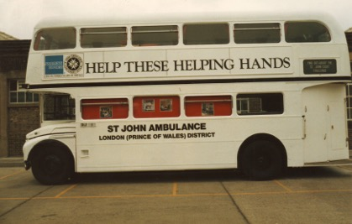

There are forty National Organisations, with over 500,000 Volunteers worldwide. You may well know which organisation this is, from having dealt with them on many occasions at concerts, sports events, demonstrations, accidents, and many more incidents that may well bring back the odd memory.

I am writing about an organisation that I have been a member of since 1975. I have held various ranks and organised aid for many events.

The St John Ambulance Brigade was formed in 1887. It was started as a voluntary organisation offering free medical care. Queen Victoria’s Golden Jubilee saw the Brigade in action for the first time in 1887. At the end of the 1890’s, over 2000 St John Ambulance volunteers offered medical assistance abroad during the wars of that period.

The first major sporting event that they provided assistance at was the London Olympics of 1908. In 1920 the St John Ambulance Cadets was formed, this allowed Boys and Girls aged eleven to eighteen years of age to learn and perform first aid.

The Coronation of King George VI took place in 1937. St John Ambulance provided first aid cover for the event and provided 9,000 members of the public with first aid treatment.

At many events St John Ambulance worked side by side with the Ambulance service and also the British Red Cross. Going back in time even further to the eleventh century in Jerusalem, a hospital was set up by the Knights of St John to care for sick pilgrims.

Many years have passed, and things changed, but one thing that hasn’t changed for the membership, is that the organisation remains a voluntary organisation.

The Mottoes of the Order of St John are:

“Pro Fide“ (For the Faith) and

“Pro Utilitate Hominum” (For the Service of Mankind)

The sudden arrival of Covid-19 meant that there was a call on many thousands of people across the globe to volunteer with the casualties of the virus and even more recently, to train vaccinators, and also to be vaccinators themselves.

That is without the many other roles that they perform regularly to assist the community at Concerts, plays, football & Rugby matches, Cricket, Tennis. This is without training the public in first aid., and much more.

The vast number of members of the organisation, who are constantly working for their communities, surely must be a massive group of “HELPING HANDS”



The Badge of the Order, which can be seen displayed on all St John Ambulance vehicles, buildings, and uniforms, is also truly relevant in its meaning when it comes to the work of the members. The badge itself consists of an eight-pointed cross with Lions and Unicorns.

The Four Arms of the cross symbolise the Christian virtues -- Prudence, Temperance, Justice, and Fortitude.

The ‘Eight Points’ represent the eight beatitudes, which are summed up as; Humility, Compassion, Courtesy, Devotion, Mercy, Purity, Peace and Endurance.

**Letters to the Editor**

*From Ulrike Neuhoff IBZ Gimborn.*

Dear Editor,

Gimborn is still closed and with the mutation the third wave already seems to hold us in its grips. Once again, I’m on a train from Berlin to Bonn. There is a a beautiful landscape flying past my window, and this is only because of a diversion that will make my journey last two hours longer.

We have planned a few online events, - the head of EUROPOL’S EC3 cybercrime unit agreed to give a talk on the landscape of cybercrime during the pandemic. That’s exciting. I wrote an article about our work now for the IEB/IPA newsletter and I mentioned your role in getting IBZ connected with the London Policing College.

I was wondering whether the SIG is in touch with writing IPA members in other countries. The IPA Vice President of Spain would love to get noticed (my impression) and I started thinking about some sort of format to connect. The problem, of course, is the language. It’s always much easier to publish something in English and get noticed.

If someone served in the police, he or she probably came across so many human abysses, has seen the best and the worst in humans, and to write seems to me a way to process these experiences.

We all hope now for the vaccine and the warmer weather.

Best wishes to everyone, Ulrike

*This is an interesting letter on several fronts (as always from Ulrike!) and coincidently comes in at the same time as another letter from ‘The Thin Blue Line’ charity. The two main points for us here as a SIG are:*

*Developing the Global Writers Forum*

*Embracing work with mental health issues.*

*I would like to ask the members for views here please.*

*The Global Writers Forum exists alongside the SIG because when we go to Gimborn for example we are supported by writers from other countries who are not part of IPA Section UK and may not be IPA members at all as the courses are open to non-members. It is possible we could actively embrace writers from other IPA countries and personally I would find it both exciting and rewarding as a writer to so do.*

*We were in dialogue last year with ‘Police Care UK’ with a view to embracing a mental welfare element to our outreach and I still consider this a noble aim. Somehow the issue became delayed by the pandemic, but I feel we could and perhaps should look again at how we could achieve this?*

*Please send all ideas to me as editor at Writes:*

[*davidlewis@brynstowe.co.uk*](mailto:davidlewis@brynstowe.co.uk)

*Thank you, Ulrike for this great letter and we will respond accordingly.*

*From Tony Granger*

*Hello all, Here are some details of a travel insurance offer you may find beneficial.*

## **Special Offer for Single or Annual Trip Travel Cover from HMCA**

**BSAPhas agreed with HMCA to offer discounted rates for travel plans.**

**The cost of medical care overseas can be very expensive, so it is important to purchase comprehensive cover. HMCA has access to a range of travel products suitable for both European and Worldwide trips.**

Travel Plans are available for BSAP members with discounted rates for you and your family. The Travel Plan is underwritten by Axiom Underwriting Agency Limited on behalf of Great Lakes Insurance SE and provides travel benefits including medical expenses cover up to £10 million, up to age 79. Cover may also be available through HMCA if you are over 80 or have complex medical conditions.

A recent quotation for a male aged 76 and a female aged 73 for a one-week, single trip to France with no declared medical conditions, resulted in a premium of £50.86 per person.

Benefits include:

* Medical and emergency expenses (medical, dental, hospital, repatriation and funeral expenses)
* Personal accident (death and disablement)
* Cancellation, curtailment and travel delay
* Personal effects (theft and loss)
* Personal (liability, hijack, kidnap and mugging expenses)
* Legal costs and expenses

To receive a personalised quote, please telephone our helpline on 01423 866985 where we can run through your application including medical screening. Older ages can also be catered for so please telephone for more details.

*HMCA/S PLC (trading as Hospital and Medical Care Association, HMCA and HMCA Members) is authorised and regulated by the Financial Conduct Authority (FRN:307587). HMCA/s PLC is a company registered in England, company number: 01362094, registered office: Beech Hall, Knaresborough, North Yorkshire, HG5 0EA.*

*Axiom Travel Insurance underwritten by ERGO Travel Insurance Services Ltd (ETI) on behalf of Great Lakes Insurance SE (GLISE) except for the End supplier failure insurance and the Legal costs and expenses sections which are underwritten by Liberty Mutual Insurance Europe SE and DAS Legal Expenses Insurance Company Limited respectively.*

**‘The Bookshop Needs You!’**

***by Helena Hutt***

Dear all,

Developing ‘The Bookshop’ for the SIG is going well. The idea is to help market our members’ published works. The intention is to launch a website with all our members’ books listed with links to their own sites. To make it work we need the following from all of you published authors:

* A colour image of each book front cover
* A short description of the book content and genre (Three lines)
* The Recommended Retail Price (RRP) and any member discounts
* The link to your own website
* An image of the author
* A short biography of the author (5 lines)
* Any testimonies the book has received (No more than three)

Please send all of the above in one mail if possible, to: [**helenahutt@btinternet.com**](mailto:helenahutt@btinternet.com)

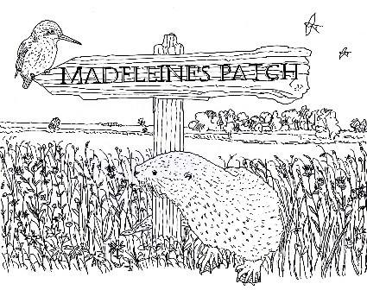

**Tales from Madeleine’s Patch**

***by Steve Parnwell***

**A Friend in Need**

Micro the young water vole was feeling good today. Spring was here and the days were warmer. Young shoots from the reeds that fringed the banks of the pond just outside the entrance to his burrow were delicious. Tired of the bitter willow bark that had formed his winter diet he had gorged himself on the white spears emerging from the roots until he was round and chubby with a sleek, shiny, almost black, pelage. So sated was

he, that tell-tale left over feeding signs nibbled at 45-degree angles were littered all along the water’s edge.

Exploring the bank that sheltered him and his siblings, together with Arvicola their mother, Micro decided to venture further afield despite the warnings of his mother that, “Death is but a moment away.”

Scrambling up the bank, Micro peered over the lush spring grasses into the meadow where the spring flowers of cowslips and buttercups punctuated the deep verdant sward with their petals of gold. Pollen grains drifting on the breeze tickled his nose, making him want to sneeze but he stifled the urge by rubbing his nose on his front paws.

Making a rapid dash through the wildflower meadow, Micro soon came to the edge of the nature reserve in which his pond was situated. This was the furthest he had ever been, and his mother’s words echoed in his mind “Do not leave the meadow, there is danger enough close to home. The human who looks after our pond and the meadow is not like some other humans who want to catch and kill us. They think we are vermin like Norve the brown rat.”

“I won’t be long,” thought Micro, “Where’s the harm in that?”

Crossing the boundary hedge, Micro found himself in a ditch with shallow running water. Warily darting from one clump of rush to another, he soon made progress along the ditch. Suddenly he heard a soft chittering sound. The low painful cry of an animal in distress. Crouching low to the ground, Micro wriggled forwards on his tummy, peering through the tall tussocky grasses bleached white in last year’s sun that had not yet put out new green growth. He could see movement ahead of him, a lithe, russet coloured body thrashed about in the grasses.

The black tip to its long tail lashing frantically from side to side identified it as a stoat, one of nature’s most efficient predators.

At Micro’s approach the animal bared its teeth and hissed fiercely at him. Micro shrank back for a moment waiting for the stoat to attack, but the attack never came. Micro looked up and noticed that the animals left front leg was caught in a wire snare tethered to a stake in the ground. The metal had bitten deep into the leg and dried matted blood told the tale that the animal had been trapped for some time in what must have been excruciating agony. Whitish yellowy fly eggs had already been laid in the wound and more and more flies were buzzing around the injured leg.

“What are you looking at vole?” The stoat hissed, but Micro sensed that this was just bravado. He also realised that the stoat was a juvenile just like him. “My name is Micro,” he said softly. “Can’t you get free?”

“Would I be like this if I could?” the stoat replied bitterly. “My teeth are for eating meat, they aren’t strong enough to chew through this wire, even though I’ve tried.” Micro noticed that the animal’s lips were torn and bleeding too.

“If I help you, will you promise not to bite me?” asked Micro. My teeth are tough for digging earth and chewing roots and they regrow all the time.”

“I promise said the young stoat in a subdued voice.”

Micro cautiously edged closer. Baring his orange incisors, he began to carefully gnaw though the vicious wire that had cut through fur and flesh to reveal the underlying white bone. Enamel began to flake from his teeth to expose the sensitive nerves underneath, but still he persisted.

Strand after entwined strand of the cable parted, until finally, the stoat was free. Feverishly licking his wound, the stoat said, “Thanks vole.”

“Micro,” corrected Micro. “What’s your name?”

“Muste” said the stoat.

At that moment there came a rustling sound through the grass and a furry red body twice the size of Muste hurtled towards Micro and pinned him to the ground. “What’s this you’ve caught Muste?“ said the larger stoat. “A plump juicy water vole, delicious, but how many times have I told you not to play with your food? One quick bite to the jugular vein and they won’t escape. Look this is how it’s done,” and Micro’s captor curled its lips back to bare razor-sharp fangs ready to inflict the fatal bite.

Micro gulped, and his mother’s voice seemed to hover in the warm air,

“Death is but a moment away.”

But then Muste shouted “No mother, don’t, he saved my life, look,” and he stood aside to reveal the cruel snare. Micro released me from this. The older stoat looked from the snare to Muste’s leg that had started bleeding again, now that the pressure from the snare had been relieved, and then she looked down on Micro’s exposed throat, her mouth salivating at the thought of warm juicy water vole meat. Reluctantly she withdrew her hold on Micro.

“Well young vole. It seems we are in your debt. I am Ermine, Queen of the Turf Fen Mustelidae tribe, our code of honour dictates that a life for a life is a fair trade. From now on we will watch over you until our debt is paid. Now on your way back to your burrow. I know where you live, we were planning a raid on your colony soon but now we must look elsewhere for our food.”

Micro thanked the queen and scuttled off back to the nature reserve where he thankfully dived with a resounding “plop” into the sanctuary of the pond’s waters.

Time went on and Micro almost forgot the encounter, until one day he smelt a strange but slightly familiar smell. Almost like Muste’s odour but subtly different. He slid quietly into the pond, ready to dive under to the safety of an underwater burrow entrance. The tried and tested escape measure evolved over centuries of natural selection.

Peeking around the reeds Micro gasped as he saw a sinuous, dark, furry shape resembling a stoat but larger, slowly making its way along the top of the bank sniffing at the air with raised twitching muzzle. Then it disappeared. Just as Micro breathed a sigh of relief, a high-pitched squealing came from the burrow of Terrestris, one of his sisters, and the dark marauder reappeared out of the burrow with the body of his sister hanging limply in its jaws.

With no thought for his own safety Micro launched himself forward screaming at the top of his voice, partly in terror but partly to give him courage in the hope that the noise would deter the animal. Micro closed on the animal ready to give his life to save his sister, if she was not already dead. But suddenly the aggressor was covered in furry red bodies as three ferocious stoats leapt on it biting and scratching. The animal dropped Terrestris and with a high-pitched scream tried to defend itself, but even its superior size was no match for three determined stoats and almost as quickly as it started it was all over. The intruder lay dead on the side of the bank, its thick lustrous fur blood stained from multiple bite wounds.

Micro rushed to his sister’s inert body ready to protect her from this newly perceived threat. She lay whimpering, her flanks heaving with

shock. Micro turned on the stoats, his stained incisors bared, ready to bite back when attacked. The largest of the stoats, a scarred and grey muzzled male, with one blind eye, chuckled. “Easy vole, we are here to help. Queen Ermine has posted us to keep an eye on you. I am Greybeard”

“What is this creature?” asked Micro?

“It’s a mink,” Greybeard replied. “An alien invader released by humans. They are wanton killers and will murder almost every living thing in their path. Unlike us, we hunt for food, not pleasure. It had to be destroyed. Left alive it would keep coming back until your entire colony had been wiped out and all the waterfowl too. We have a saying, A life for a life is a fair trade.”

And we have one too, thought Micro as he looked at the mink’s corpse and his panting sister. “Death is but a moment away.”

**Footnote**

Visit : <https://www.facebook.com/madeleinespatch/videos/841867336666561> to see Greybeard.

***Editor’s Note:*** *I have not edited the use of the speech marks in this article due to time constraints and to be in line with the following article on ‘Direct Speech’ concerning the ‘Writes’ house style. All submitting writers are keenly invited to read the following ‘SIGnal Errors’ piece on the use of inverted commas and ‘house style!*

**‘SIGnal Errors’ (No.2.) ‘Direct Speech’**

*(‘Without doubt the most frequent “misuse” in submitted texts within the group’.)*

**This subject contains the most frequent misuses of punctuation in self-published works generally and certainly within our SIG. As editor I have nearly always corrected submissions to comply with our ‘in house current publishing requirements’, *as well as* always correcting English usage errors where spotted, but these corrections are always very time consuming. This column therefore desperately pleads for compliance both with English Usage and our house style! Please. We are friends. I have given it a four-page spread to reinforce the message! There is a reason for this. Sanity.**

The first thing to say is that there are plenty of published works out there these days that will contain errors in the use of direct speech. These are almost always self-published works and these basic errors, and sometimes a series of errors, always marks them out as amateur productions. You may be fine with this. But in my humble view we as a SIG should strive for excellence and we should certainly strive to comply with the correct usage of written English wherever possible.

The risk in not doing so is to upset the reader, especially publishing editors who you may be seeking to impress at some stage, and to generally denigrate standards within our chosen pursuit. Our house style and my editor’s interpretation of usage is based on the ‘BBC Guide to Writers’ just in case you think I am making all this up!

**The most frequent ‘direct speech’ errors are breaches of one or more of the rules of what is commonly known as ‘English Usage’ that appear below:**

1. **Direct speech marks or ‘inverted commas’** are most commonly accepted as **‘**single**’** in the United Kingdom and **“**double**”** in the United States. However, either is acceptable to some publishers so long as the **usage is consistent** within the publication as a whole. Most publishers will want the use to be single inverted commas as part of their own ‘house style’* if publishing for the UK market.
2. **A speaker using a quotation from someone or something else within their speech requires double inverted commas.**

‘I’ll give you the exact words I heard. “Is that Dr Sheppard? Parker the butler at Fernly, speaking. Will you please come at once, sir. Mr Ackroyd has been murdered.”’ *(from an Agatha Christie)*

*Note the use of double inverted commas at the end of the quotation part followed by a single denoting the end of that person speaking.*

1. **Direct speech is always indented from the left-hand side of the page.**

‘Where is Mr Ackoyd?’ I asked suddenly.

*Note the punctuation (the question mark) appears* ***within*** *the inverted comma, not after it.*

1. **The first word in direct speech is usually capitalized**.

‘Plain as a pikestaff,’ said the inspector. ‘Any valuables missing?’

1. **A new speaker usually has a new line.**

‘Oh!’ I said suddenly.

‘What is it doctor?’

‘I met a man this evening.’

1. **Exclamation marks should be used sparingly in direct speech.**

‘Oh!’

‘The real gold!’

‘You too Dr Sheppard! Oh! It’s too bad.’ *(Unlike here!)*

1. **Misuse of the ‘reporting clause’. The ‘reporting clause’ is a** **clause** which indicates that you are talking about what someone said or thought. For example, in 'She said that she was hungry', 'She said' is a **reporting clause**. Or more obviously:

‘I think there is something moving in the bushes,’ George said, looking carefully in the direction from which the sound came.  
   ‘I can’t see anything,’ said Molly.  
   ‘Perhaps we should turn our torches on,’ whispered George.  
   ‘Okay, but let’s be really quiet.’

A **reporting clause** after the direct speech tells the reader who is speaking. The last line in the above example misses out the reporting clause because the reader can see that the character Molly is replying

to George. Once a conversation has developed between two people, it is usual to drop the reporting clauses until a third person speaks.

1. **Misuse of punctuation with direct speech.**

Each section of **direct speech** should end with a **punctuation** mark. If there is no reporting clause then this is likely to be a full stop, question mark or exclamation mark. If there is a reporting clause, then there is often a comma before the final **speech** marks:

‘I think we should go inside now,’ said Molly.

**\* Note on ‘house style’.** House style is simply the way a particular publisher (or organisation generally) wishes a publication to appear to the reader, usually for marketing and identity reasons. It is important that if publishers state they require a particular ‘house style’ then the submitting writer complies with it. Not to do so means you may not even be read let alone considered for publication. In anthology type publications, such as ‘Writes’ for example, the requirement is for the various authors to comply with the overall look or house style of the work; this will normally be checked by the editor for consistency. The reason for this is to make the work holistic, individual, and more pleasant to read.

The ‘Writes’ house style currently requires all work to be submitted in the following way:

**A WORD document using Calibri as a font in 12-point size and with each line spaced at 1.5 spacing.** For direct speech we require consistent use of single inverted commas for the main speech and using double inverted commas for the speaker using a quotation within it.

***The Station Cat Writes***

**‘SIGnal Errors’**

**This was the second in the series and The Cat really hopes these will be a help to all of us in our writing. They are also intended to help cut down the editorial time! The first ‘SIGnal Errors’ entry was on the use of ‘Ellipses’ and this month the subject is ‘Direct Speech’. In the next edition we will cover ‘Revising texts, self-editing, proof reading, spell and grammar checking and ‘stepping back’ before submission.’**

In order that no one is put off writing these will appear one by one, but if the errors *still* persist the author might well receive a **‘Note from The Cat’** to see the relevant **‘SIGnal Error**’ entry! It is meant light heartedly, but it does cause the editor a lot of extra work editing the errors out so as not to expose the author. Your attention to these errors will therefore, not only improve your writing but save the editor a lot of extra eye strain!

The Cat has not been too active again but hopes you enjoy this offering. Please remember to keep writing and keep submitting; we have never been short of material, but forward planning is always good for the editorial nerves.

One absolute gem that came in was from a certain Ann Holbrook. I cannot think who this is, but she sent in a truly delightful hand-written diary in pencil written aged 8. It was so ‘Ann Holbrook’, a delight but The Cat was told in no uncertain terms that if he published this there would be a rapid one-way trip to the vets. ‘Discretion is the better part of vet avoidance’ said The Cat. Bless you, Ms Holbrook aged 8. Yes, we know it was all a very long time ago now.

***Thank you all once again, wonderful writers; please stay safe and well and continue to have a quiet and peaceful 2021!***

***As if…***

***Editorial Note: This newsletter is copyright to Bryn Stowe Publications and the IPA. Individual submission copyright remains with the contributing authors. For any corrections or omissions please mail:***

***The Editor, ‘Writes’:*** [***davidlewis@brynstowe.co.uk***](mailto:davidlewis@brynstowe.co.uk)

***©IPA and Bryn Stowe Publications 2021***