

Stay Safe, Stay Home, Stay Writing!

‘WRITES’

*The visible hand of friendship*



IPA Section UK Writers Special Interest Group and Global Writers Forum Newsletter

No. 5

The Covid-19 Second Edition 2020



***Dedication:***

*This week ‘Writes’ is dedicated to*

*all the families of those in the ‘front line’*

*fighting this pandemic.*

*Theirs will be an anxious time of waiting, worrying, wondering…*

*We are thinking of you all and offer you*

*our gratitude in your time of trial.*

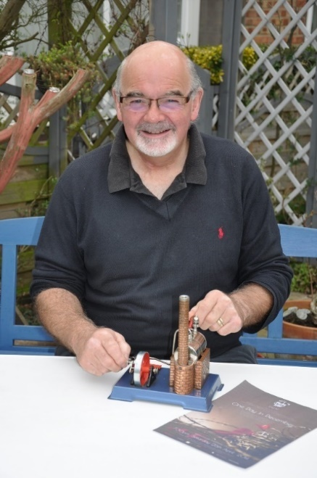***Editorial Chair David Lewis writes:***

*Dear writers all,*

And what wonderful writers and people you are!

Thank you for all for yet another week of simply stunning submissions. We are really more of a magazine now than simply a newsletter, I hope you agree?

But please do not ask for payment! We rely on your magnanimous generosity in this global time of need. Which brings me onto our first article; **‘Red Door *‘Writes’* and eBooks’.** I implore you please to read this from Clare and I and take action if you feel at all able? It is a worthy expression of our friendship and helping hand as writers to those in need.

On becoming a ‘magazine’: I promised Nick that his submission last week was purely for us all in the existing group and I hope I have honoured this promise. However, since then we have had offers to spread the ‘Magazine’ far wider throughout the IPA globally, as befits the status of the ‘Global Writers Forum’ part of our existence, and feel we should take this offer up. That being the case please do just bear this in mind when submitting material; it may have useful outcomes!

I take the opportunity to welcome new members to the group this week; David Hughes and John Cairns. As friends, we are; **a supporting collective, an outlet for our writing, a repository of our policing legacy.** This magazine is just one of the ways we seek to display the ‘visible hand of friendship’. So please keep writing, keep safe, and keep enjoying this marvellous magazine! With very best wishes and in friendship.

***David***

***In this second amazing Covid edition:***

* ‘Red Door, ‘*Writes*’ & eBooks’ *by Clare Christian*
* ‘A Better Place’ *by Ann Cumberland*
* ‘My Underground House’  *by Roger Baker*
* ‘There’s Not Mushroom in Here’ *by Julie Harries*
* ‘The Great Dictator’ *by D.B. Lewis*
* ‘Sing a Song to the New’ *by Ann Cumberland*
* ‘Rory and Cona’  *by J.A. Kay*
* ‘Chain Novella Update’  *by Neil Hallam*
* ‘Game on!’  *by Mark Thompson*
* ‘The Zoom Room’ *by The Editor*
* ‘Double Deutsch’  *by Neil Hallam*
* ‘The View from Down Under’ *by Peter Farmery*
* ‘Helga the Sex Educator’  *by Tony Granger*

***And regular features:***

‘Micro Writer’ ‘Candy’ *by Jad ‘Word of the Week’*  ‘Nature Notes’ ‘Letters’ ‘Puzzle Corner’ ‘The Bookshop’ ‘The Station Cat’

**Red Door *‘Writes’* and**

**eBooks**

***by Clare Christian and D.B. Lewis***

**T**his is as much a time of difficulty for the publishing industry and for writers as it is for other small businesses and at the newly instituted weekly ‘Zoom Room’ on Wednesday, Clare outlined how her company, the publishing house, Red Door, intend to support their stable of authors and survive as a business.

The plan is for them to focus on the marketing and distribution of their publications where they can as eBooks. Many of us as authors also publish our books in this format and so I approached Red Door to see if we could help them, their authors and ourselves whilst at the same time making a contribution to the mental welfare of those we may know who are suffering complete or partial isolation. The plan below has a very attractive additional benefit in that Red Door will be giving a percentage of each book sale to a charitable fund for Corvid-19 relief.

The idea is to raise sufficient funds to purchase as many eBooks as we can that can be sent to anyone we can identify who may benefit from them.

I have immediately pledged £100 to this eBook project and will pledge more if it takes off. I do this in the hope that members of the group and our wider readers will join with me in making a similar

pledge of funds. It doesn’t have to be large; a few pounds or a few hundred according to circumstance.

We are working on the detail but it seems we may be able to purchase books for just a pound or two and then send out according to need. Please let me know if you can support this worthy project and Clare and I will publish the full details of how it will work next week.

As you know one of our members, the brilliant writer, young Mark Thompson, author of the top seller *‘Dust’* published by Red Door in three languages now. (His article on ‘Fly Fishing’ appears in this edition.)

Through Clare’s past generosity, Red Door have been incredibly supportive to the Writers Forum providing the publishing element of the past two Gimborn Seminars, and we hope she will continue to do so. This eBook project is a mutually beneficial proposal that I know will be attractive to us all given the amazing charitable endeavours of all people associated with the police and the IPA in particular.

Please stand up, sit down or even lay down if you feel you need to, but please support this endeavour and let me know by e mail if you can help? **Just an e mail note to me as editor to say you can pledge will suffice at this stage** and once we know it is up and running next week, full details will be established and published in *‘Writes’.* There are a couple of minor issues over DRM (digital copyright in effect) but these are being worked on as we speak at Red Door.

Thank you from us both in anticipation and please let us know also of anyone you feel would be grateful of a free supportive e Book.

With love to everyone, ***Clare and David***

**‘Micro Writer 2’**

***Roll up Writers! A prize on offer! Read all about it! Competition time!***

In this regular prize slot, we offer up the chance to write a ‘micro short story’ (of 200 words exactly) based on the image that appears in the feature. *(Thank you Julie, for suggesting this idea!)*

The subject, genre, style can be as you like but it must be written ‘straight off’ and returned by the following Monday’s publication (lunchtime) and the selection will be published the following week.

Stories that feature an uplifting message in these dark times will be given publication preference but please do not feel restricted to this; to write is all!

This week’s image of the ‘Hermit Crab’ is supplied by Julie Harries.

The ‘best’ story, decided jointly by the editor and the image supplier each week, will receive a prize of a book from ‘The Bookshop’ of member’s works.

You have to be in it to… well…have the book prize really…

Thus, I narrowly avoid a cliché…what a sin…

Entries in Calibri 12 pt. 1.5 spacing please with a title to:

[davidlewis@brynstowe.co.uk](mailto:davidlewis@brynstowe.co.uk)

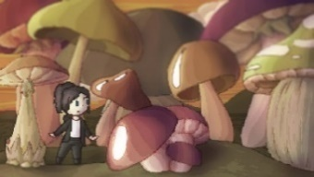Last week’s image:

(See pages 4-6 for this week’s great entries)

This weeks’ image:

*(kindly submitted by Julie Harries)*

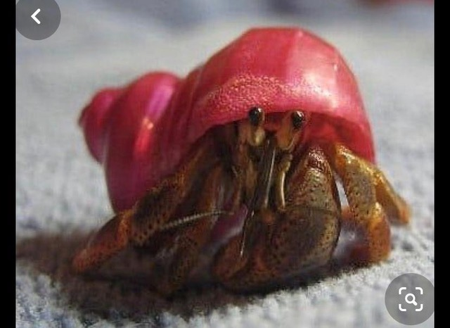

Remember the old adage;

*‘If I’d had more time I would have written less’*

*Well, now you have time!*

200 words exactly is the challenge!! (Not including the title)

**A Better Place**

*by Ann Cumberland*

Stretched out in the shade of that old mushroom plot at my parents’ home place, I turned my thoughts to the chaos going on, and here I was, safer than most. The hot sun had left me parched. The long drive before lockdown was catching up. With memories of cool beer in the bottom of the cooler in the pantry, it created a stir within me. I just had to check it out. With a skip in my step, crunching over the gravel lane, there it was… that old yellow front door, paint still peeling of it. Placing my key in the lock, the door fell open; was someone home? The distinct smell of apple pie lingered. Mum had been dead for years, though she made the best apple pie I had ever tasted. Pinching myself as I headed towards the kitchen, there she was, it was Mimi Rogers, my childhood nanny. She had been looking after the folk’s place for years. Throwing her arms around me, her large frame consumed me. Feeling like I had stepped back in time. Her laughter was an incredible tonic for my soul, I was home, it felt good.

“Beers in the cooler girl!”



**My Underground House**

*by Roger Baker*

‘Thank goodness you built this bunker grandad. We might have been in the other world; you know that horrible place. You were so clever to build our little underground home, we love it here grandad, tell us the story again, how you did it.’

‘Ok sit quietly, I will begin.

A long time ago the invisible bogey man was coming, They told me not to go outside, they even said I wasn't allowed to see all of you. "You would never let that happen grandad would you" shouted Edward, "Of course not" I smiled. So I started to dig.

Everyone was decorating, queuing at shops. "They were buying toilet roll grandad weren't they" smirked Elsie, ‘how silly’.

‘Anyway, I just kept digging until the hole was big enough for all of us.

Then Santa picked you all up and dropped you here, the best Christmas present ever. Nanny and I were so surprised.’

‘Are you sure you got them all because I keep imagining I can hear laughter and fun below us, I can still hear them Corona.’

‘Don't be silly Mrs Mushroom, they didn't have time to get away, they were too busy worrying about money.’



**There’s Not Mushroom in Here**

**(for negative thought)**

*by Julie Harries*

There was a young girl from Brighton

Whom the virus began to frighten,

She retreated in fear, from everything near,

Her chest began to tighten.

As thoughts began to flutter,

The dread she could not utter,

Dear ones, no longer near ones,

And Covid spread like butter.

The thoughts they grew like fungi,

A mushroom lie: the end is nigh,

A forest of gloom, pervading doom,

She had a choice; to do or die.

A nuclear cloud as you might guess,

Can devastate and leave a mess,

But in dark times, we learned the lines,

‘Thank God for our NHS’

Along this Portobello road of thought,

A pearl in the oyster which cost nought,

We’re in this together, not for ever,

And through the Shitake we will have fought!

Let’s keep calm and carry on

We’ll create and craft and stop the bomb.

Let Mother Nature heal, and with this poison deal,

While Planet Earth switches ‘off’, then ‘on’.

The old software is in the bin,

Reflect, renew and look within

The mighty power of the pen, will help to make us whole again

We realise the only way out is in.

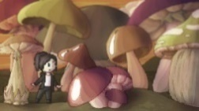

**The Great Dictator** *(****A parody****)*

*by D.B. Lewis*

‘I am The Great Dictator! No-one has ever come close to ruling the world except me! Wars? Millions gone. Stalin, Hitler, Mussolini? None of them, despite all their wonton slaughter, ever came close to bringing the world to its knees. But I did, didn’t I?

I am the Greatest Dictator of them all, and I shall triumph; triumph even against all your heroic, herculean, efforts Mushrooms; triumph over all your ingenuity and cleverness. Why? Because I have the *real* Power of One. One little idea of a germ and the world begs me for forgiveness. But *I* am merciless, I have shown my power; shown you how easy it is to be omnipotent. In every corner, every cranny of every forest and field and skyscraper and slum. I am there.

Any why will you never defeat me? Simple. Because you Mushrooms cannot ever act as one; you live in the dark and feed off bullshit; you fight in dirty little corners, you greedily amass useless things, you drown in self-centred swamps of your own individualism; you are incapable of seeing the world for what it is. Therefore, I *will* win.’

As in one voice, the Mushrooms answered; ‘You wanna bet?’

**Sing a Song to the New**

*by Ann Cumberland*

Sing a song to the new

and leave behind the old.

Move along and delight

As new memories unfold.

Sing a song to the new,

Surreal, sadness, despair.

Not enough to go around

and too few to care.

Sing a song to the new,

Embrace what’s left behind.

Much encouraging faith

And a heart that is kind.

Sing a song to the new

Striving forward with zest

Sunshine in our hearts

Living life at its best.

**Rona and Cory**

*by J A Kay*

Rona and Cory were an insatiable, very greedy and self-absorbed couple. They were always looking for their next fix to fuel another adrenaline rushed hit. They did not care about anyone bar themselves in their hunt for pleasure and no matter how depraved others thought that act was, *they* did not, looking forward to it.

They had met in the lab and connected immediately, pure soul mates who were made for each other. They could not be contained no matter how hard everyone around them tried. They infected all around them, passing on part of their being in the process.

Rona and Cory thrived in their contact with others but the recipients of their attention were not so lucky, becoming ill after meeting them as they wormed their way into their bodies.

Once met you would never forget!

No one knew how to deal with Rona and Cory. Some self-isolated, other drowned themselves in alcohol in an attempt to wipe meeting them from their existence.

Nothing worked, they spread away from the lab, out into the wider community searching out their latest victim. They grew, finding new depravity, taking their thrills from the very old and disabled.

Rona and Cory considered themselves untouchable and continued to travel around the world coming into contact with as many susceptible victims as possible poisoning them all with their contact.

Actions have consequences and the effect they were having begun to be noticed.

But it was too late, they had infected a great proportion of humanity, some of whom were beginning to follow their actions, spreading their filth.

Word got back to where Cory met Rona and the workers in the lab began investigating how they had met and how to deal with them.

The two leaking vials were discovered side by side and clearly labelled in bold letters.

**COR ONA.**



**Scan to J A Kay Web Page. Follow on Facebook, Twitter and Instagram @scottishjakay**

**The IPA Writers’ SIG – Chain Novella Update**

To provide some inspiration to the IPA Writer’s SIG, we are running a little writing exercise. Each SIG member writes a 500 word chapter, before it is passed onto another member to continue the story.

**How it Works**

* Register your interest in participating on the Writer’s SIG Face book Group. (With your email address)
  + Or email Neil if you are not on the FB Group
* When your turn comes, Neil will email out the story so far.
* You have a maximum of one week to write your 500 word chapter.
* Add any characters you create onto the Characters List.
* Email the document back to Neil ([mail@neilhallam.com](mailto:mail@neilhallam.com)) and he will send it onto the next contributor.
* When we have all had a go, Neil will tidy up an ending, and publish in a similar format to the Cologne booklet.

The title is:



**Stela Vojaĝo** (Or – The IPA meets Star Trek)

**Aŭdace irante amikecon** (Boldly going through friendship)

**How are we doing so far?** (more volunteers needed to take us beyond chapter 5)

Chapter 1: Neil Hallam (complete)

Chapter 2: Sean Hannigan (complete)

Chapter 3 John Cairns (complete)

Chapter 4: Ann Cumberland (in progress)

Chapter 5: Steve Cherne

***I have just signed up! (Ed.)***

**Game On!**

**On the dark art and mysteriousness of fly fishing for trout…**

***by Mark Thompson***

*‘As no man is born an artist, so no man is born an angler.’*

**I**t was that most famous fisherman, Sir Izaak Walton, who, in 1653, recorded these prophetic words in his legendary work *The Compleat Angler.* I know of no other book that has a hotel named after it.

Perhaps never a truer word was written, for there are moments when the fly-fisher, a man or woman of singular determination whose flexible rod only the day before had landed six fine fighting fish and seemed to possess a magic all its own, has the following day such bitter disappointment, and perhaps more use for that rod as a curtain pole to hold up a light pair of kitchen ginghams, or as a tool for fishing lost keys from behind a hot radiator. For this, dear reader, is a dark art, and no child was born to the dark arts, save perhaps for Aleister Crowley or the Marquis de Sade.

In truth, like any dark art, its mystery is a creation of devious minds. Created by those whose purpose is to cloak a simple mechanical process in an unfathomable complexity, all coated with pixie dust…

Truth? Let’s try to be truthful here, a trait which fishermen and fisherwomen are renowned to bypass, as ‘the one that got away’ is clearly based upon a mathematical formula; something akin to length times girth multiplied by whisky, gin, chilled beer or other intoxicating refreshment, dependent on the season of course. As Izaak himself observed *‘Angling may be said to be so like the mathematics that it can never be fully learned.’* And therein this fanciful knight of the realm sprinkled a first large handful of dust and began the process of coating the art in magic. Truth, that arbiter of honesty, in the world of fly fishing can be difficult to determine for, as most notable feats require a witness, this is often a solitary pursuit, and by its lone nature that truth, or any grain of it, is in the memory only of the tale-teller. For any fish that gets away is, without doubt, a spirit-fish, possessed of limitless cunning, guile and quick-witted artifice. A creature, in fact, with supernatural powers.

For how can a brown or rainbow trout be anything other than

magical? What other than a supernatural being could cause the fly-

fisher, a person often of great merit in other fields, to rise at some ungodly hour in winter and summer, to head out before birdsong, trudging to a lonely spot on a river or lake bank as the sun rises up through whispering trees, and smoke-like mists float in curls above the water. Then, with trembling frosted hands, this love-struck being, for dear reader it *is* love, slots together a hopeful rod, to which is fastened a reel of washing line, to the end of which is added some thinner line, apparently intended to fool the fish that it is invisible, and to that is further added something which no right-thinking observer could believe would attract or cause any fish, cunning or otherwise, to believe is food. And let’s face it, would you dear reader, be enticed by something which carries the title ‘Woolly Bugger’, ‘Kaufman’s Stimulator’ or ‘Booby Nymph’? They sound like something eleven year olds would snigger at, so how is the trout, the supernatural magical being of incredible guile and cunning, going to be fooled by such ridiculous things? Seconds later however, the spell-bound angler, full of anticipation, launches the line to drop a fly where the fool believes a fish may be.

Four hours later, without so much as a sniff, and a good two hours

past the fly-fishers promised deadline (for there can be no going home with only a story about ‘the one that got away’), and with a final last pleading cast, the line whispers out through liner rings, flies forty feet across the water, and the fly lands softly, silently, without a splash, as delicate as any eye surgeon’s lance, and, as our desperate fly-fisher draws his line gently tight to take up the slack, the fly suddenly disappears and the rod, the magic wand, bends double as the fly-fisher, taking up the fight, whispers ‘Game on!’

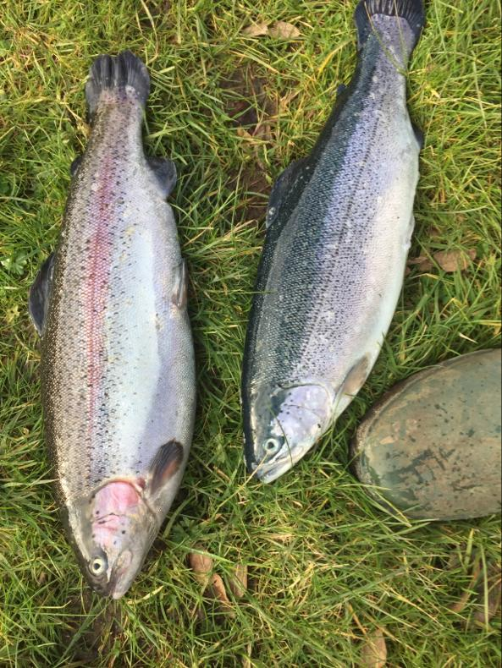

**Your Suggestions Responded To!**

This is a very fast-moving pandemic and we are not slow in responding to your suggestions either. Here are your suggestions from last week and our responses:

You suggested:

* ***Specific writing projects on a topic with no pressure but with a deadline if people wish to partake.***

We are thinking of launching this as a tribute to all those who are serving the community so well through this pandemic. The first project could be a compendium of work in any genre, produced as a hard copy anthology with the idea being to collect writing inspired by these selfless acts. Suggestions for a specific topic are now asked for. I will report on suggestions in due course! Please send to:

[davidlewis@brynstowe.co.uk](mailto:davidlewis@brynstowe.co.uk)

* ***a Zoom meeting where we can have a tutorial/discussion***

Our communications guru and founder, VP Sean Hannigan, has set up a **‘Zoom Room’** afternoon tea at 3pm every **Wednesday afternoon** (UK time) for the Writers Forum and a coffee morning every **Wednesday morning** at 11 for the IPA Section UK as a whole. Be great to see as many of you there as possible and hear your news.

**On tutorials**: we are in the process of setting up the **‘IBZ Virtual Writers School’** under the kind encouragement and direction of Rene

Kaufman and Ulrike Neuhoff. I will report more on this next week after discussions between Sean, Neil, Ulrike and myself. (Ed.)

* ***-a word of the day and a competition for the best context in a sentence to sum up our current situation.***

This is now up and running and the first word suggested is ‘Furlough’ (See page 13).

* ***- a photograph of some small cameo in your environment and a 200-word description***

Likewise, this is up and running on its second week as **‘Micro Write’.** The first week brought some really excellent entries which can be seen on pages 5 to 7 of this edition. Winners this week are Roger Baker, Ann Cumberland and Julie Harries. (Ed. disqualified himself!) On receipt of a postal address, all will receive a prize copy of a recent book from **The Bookshop.**

**‘Micro Write 2’** depicts a **‘Hermit Crab’**. Your 200-word stories by Monday lunchtime please. This is a prize competition so please enter now!! ‘*Writes’* needs you!

**Word of the Week**

**This week suggested by Julie Harries.**

The word of the week has to be ‘furlough’.  I’d heard of gardening leave but never that word for it!

My context sentence, written as a poem this week:

Be slow to furlough,

For even though,

To work you go,

You never know,

When Karma's flow

Will deal a blow.

Or;

‘You want fourteen weeks furlough?’ said the Superintendent to the crossword compiling Detective Chief Inspector, ‘I don’t’ know I’m sure matey, you’ll be wanting your Covid jabs next, I don’t doubt.’

(No prizes but who was the DCI?)

**The ‘*Writes’* Cartoon Weekly**

**Candy *by JaD***

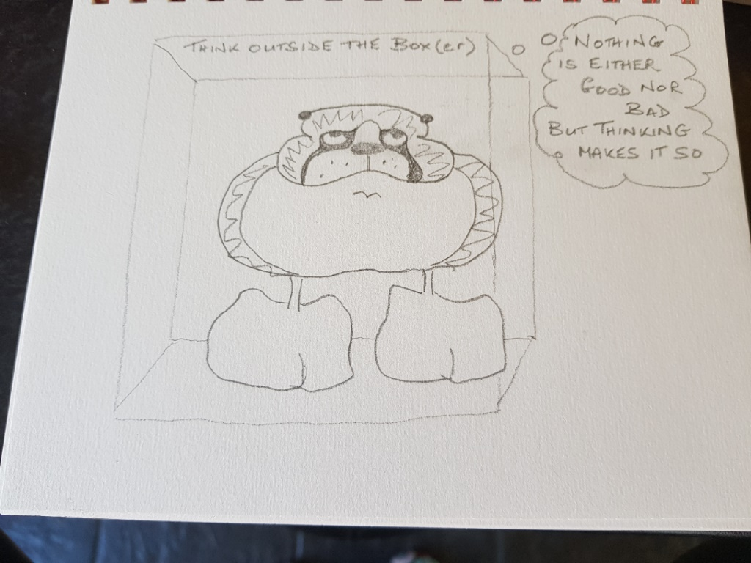

*‘There is nothing either good or bad, but thinking makes it so.’ (Shakespeare. Hamlet, Act II. Scene 2)*

**

***‘Tales from Madeleine’s Patch’***

***This week:***

**‘The Rat Race’** *by Steve Parnwell*

Our Editor David has asked me to write a piece on rats as they are apparently being displaced due to people’s changing habits during lock down. Rats are well adapted to exploit a niche provided by humans and presumably food sources from takeaway outlets and other establishments are becoming scarcer as people remain at home and the food service industry shuts down?

Following my retirement from the police I had a brief flirtation with pest control whilst my newly founded ecological and habitat management business sent out its tentative roots to establish our family business. On a part time basis, I assisted my friend Roger who ran his own pest control business.

The common, or brown rat, *Rattus norvegicus* was one of the species I was called upon to deal with, and formerly as a country boy and then latterly a self-sufficiency small holder and currently a chicken owner, my experience with rats has been almost constant throughout my life and continues to this day.

The brown rat is the one we all know and love today but the black rat or ship rat *Rattus rattus* is the one associated with the historic Bubonic Plague.

I

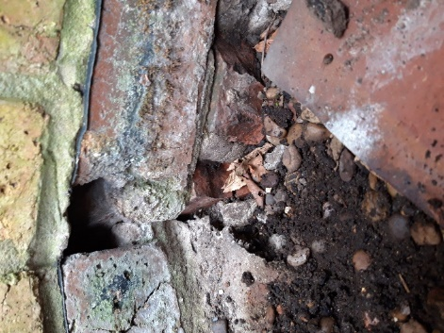

*These two shots show the entrance hole at The Editor’s Yorkshire cottage; the left shows how rats have dug out the masonry to gain entrance just under the damp proof course, the right-hand picture shows a pile of discarded snail shells, presumably the rats’ winter food.*

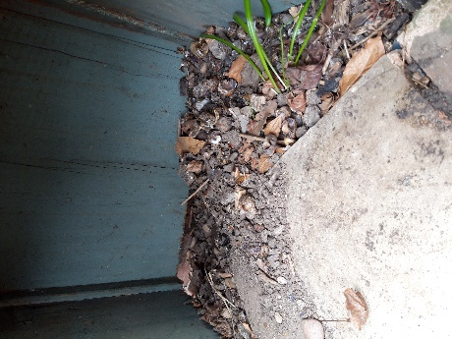

*‘Of Rats and Men’*

*(…after Steinbeck, 1937)*

In the village of Landbeach, on the edge of the Cambridgeshire Fens where I grew up, there is an old medieval thatched cottage known as the Plague House, the final refuge to the only victims (bar one other family) of the plague in the village.

The story goes that two elderly ladies fled London to escape the Great Plague of 1665/6 and settled in this house, but they succumbed and died, passing the Plague on to the Rector, William Rawley, and his family, who nursed them during their final days - the only people to extend a hand of succour. This story echoes down through history, resonating strongly with the risks that our medical staff are facing daily now.

400 years later this building was owned by a boss I had as a teenager when I spent my summers fruit picking in the local orchards. Most have now been grubbed up for cereal crops resulting in agricultural monoculture prairies which underscores the important contribution that Madeleine’s Patch is making to redress some of the lost balance of nature.

When training my staff in field survey skills my first piece of advice is to “Think like the target species.” What does it need to survive? Where does it feed and shelter? What are its preferred habitats? How does it move about within its habitat?

In the case of rats, regular access to food and water are their key requirements supplemented by cover in which they can hide and shelter. Albeit, in the open countryside they are quite adept at burrowing and with a plentiful supply of food will happily burrow into soil and quickly form large colonies.

In the presence of carrot, sugar and potato clamps (vegetable heaps covered with straw to keep out the frost until ready to be sent to be processed) I have seen the ground literally heave and boil with a

flurry of brown fur as they run back to the safety of their holes when I have disturbed them on many of my country walks.

This is reminiscent of a 1958 Walt Disney film *“White Wilderness”* that captured my imagination as a child. Disappointingly, many years later I subsequently discovered that the film makers allegedly falsely depicted lemmings jumping off cliffs in a mass migration suicide.

This reminds me of the conundrum “What do you do if life gives you lemons?” Answer: “Make lemonade.” And “What do you do if life gives you lemmings?” Answer: “Make a fur coat.”

The apocryphal Pied Piper tale may well take is origins from mass migration of lemmings and/or other rodents in times of population explosions giving rise to seasonal famine. Or it may have links to the plague.

As an allegory, the Pied Piper sounds warning bells for society today, with people foolishly ignoring the advice and help spelled out daily on how to protect themselves and others from the Covid-19 virus. As the streets fall silent with lock down, listen carefully, is that the sound of a pipe I can hear or just the sound of the wind mournfully calling out for those we have lost?

On a more prosaic note, as an ecologist, it is my job to be able to distinguish the differences between different faeces deposited by a range of species, in particular the brown rat and the water vole (protected) but more of that in another tale from Madeleine’s Patch. With ecologists’ apparent obsession with the output of bowel movements, you could be forgiven for thinking that it is just a crap job. On the contrary, we also find regurgitated food pellets fascinating too! Provided you avoid the taste test and remember to wash your hands it is a great job.

For the lay person, holes and well-worn paths are key field indicators that rats are around.

As with all pests, prevention is better than cure so good husbandry/ housekeeping is essential. If keeping livestock/pets/stocking bird feeders etc., make sure that only the right amount of food is supplied each day with any spillage cleaned up immediately.

Food should be stored in secure metal/glass containers as rats are prolific gnawers of wood and plastic. Similar considerations should be given to rubbish bags and compost bins. NB the latter should not include meat products.

Storerooms, sheds and livestock pens should be tidy and free of clutter where rats can hide. Pets should be kept safely secured too. My uncle lost cute fluffy yellow goslings to rats and my daughter’s Guinea pig had a real bust up with one. He was a chunky bruiser of a Guinea pig and gave as good as he got and only sustained a torn ear and a bite to his flank that developed into a bald patch of eczema. The rat finally met his end to a .410 shotgun cartridge.

So, if despite all best intentions, good housekeeping and animal husbandry rats do favour you with their presence what are the next steps?

Depending on how squeamish you are the solution will be to resort to DIY products or call in the Pest Controller who should be Pest Control Association (BPCA) certified. If you choose the latter leave it to them.

For the more gung-ho among us there are a range of options from traps, both live and break back, through to poison. With live traps there is of course still the problem of humanely despatching the animal once captured. With poisons they must be carefully administered and kept covered either by means of a purpose-built bait trap or a length of drainpipe so that birds and hedgehogs cannot access them. Poisons also have the knock-on effect of passing it up the food chain where carrion eaters are likely to be able to access the

carcasses. For example, in India the vultures that fed on human carcasses laid out for them were being adversely affected by the diclofenac painkillers that had been taken during life.

I have used ferrets to flush rats out and have humanely despatched the rats with the aid of an air rifle/shotgun.

Rats carry Weil’s disease (leptospirosis) which affects the liver, therefore personal hygiene is imperative where people are likely to contact surfaces contaminated by rats – mainly through their urine.

My first experience with the police as boy was rat initiated when I tied some old tights to open ended bean cans to act like a funnel which I inserted into a series of rat holes in a ditch near my house and lit some rags sprinkled in sulphur from my chemistry set. I then blew the smoke from the smouldering rags into the tunnels with the object of smoking the rats out into the cans and then into the tights’ funnel which acted rather like a purse net used for catching rabbits flushed by a ferret.

I was so impressed by the efficacy of the process, with smoke billowing profusely from each burrow entrance, possibly heralding the appointment of a new pope or at least the imminent explosion of rats into my cunning traps, I became engrossed in watching all of the funnels for movement which would signal my first capture. Being so fixated on the funnels I failed to notice the exodus of my comrades in arms until suddenly becoming aware that I was alone I saw the reason for their rapid departure. A police patrol car had pulled up at the top of the roadside ditch and two burly policemen were rapidly disembarking, their faces contorted with serious grimaces focused on me.

Fortunately, the production of the smouldering rags convinced them I was not an arsonist bent on setting the nearby crops alight and they were soon on their way.

Some 15 years later I was reminded of the incident by the same officer when on a cold, dark snowy night as a young Inspector, I was engaged in an incident where we had tracked a depressed missing from home through the snow to a lonely dark spot by a fast flowing chalk stream where he had sadly taken his own life with a pistol shot to the head. He had slumped down the steep bank and was precariously lodged at the water’s edge. I carefully descended the snowy bank to check for vital signs, but a close examination of the head wound quickly revealed that this was an undertaker, not an ambulance scenario. As my torch played over the face of the victim a voice from the darkness on the opposite bank said “Careful now, I have pulled you out of a ditch once before. I don’t want to have to do it again.”

I replied “Yes I remember it well. Fortunately, this time we have police radios so no need to send smoke signals. Notify HQ control we have found the MFH and request an undertaker’s recovery van.”

As a keen naturalist from the age of 5, I have had many experiences with wildlife but lack of space precludes me from telling you how clog dancing mice spoiled my honeymoon night, or how I led an expedition to solve the mystery of the heavy breathing monster at our local haunted moat, or even how I confirmed once and for all the truth of the Cambridgeshire Fen Tiger.

These and many more stories may well be told in the coming instalments of “Tales from Madeleine’s Patch.”

**The ‘Zoom Room’**

*by The Editor*

It was great to see so many old friends in the Zoom Room last Wednesday. Thanks Sean, for setting this up for us all. Its 40 minutes where we can chat, have coffee and just wallow in the joy of seeing other people’s front rooms rather than our own four walls.

Udo from Cologne told us of life in lock down Germany where as a serving officer he is on ‘reserve’, waiting that call. Who knows what awaits? All good wishes Udo, and maybe you could keep a diary?

Steve (aka John) and Rebecca told us of life just before the border shut down Mexico way and then of even remoter lock down in the deep dells of Deluth, Wisconsin, 150 miles or so south of the Great Lakes. All are well so far.

Neil, Sean, David and Julie swopped tales, Julie being camped out in Chichester for the duration.

If you can, please join us all in the Zoom Room: **WEDNESDAYS 3 pm**

(UK time) via Zoom. If you are planning to be there and don’t have the mail Sean will hopefully send out the meeting code and password again if you mail him:

[**vphannigan@ipa-uk.org**](mailto:vphannigan@ipa-uk.org)

**Double Deutsche**

**A *‘Nev Stone & the Watchers’* short story (in four parts)**

***by Neil Hallam***

**Part One**

Skull Murphy sat astride his customised Triumph Rocket III. Usually an extreme extrovert and not one for hiding in the shadows, the gang leader was tucked out of sight at the rear of Berlin’s *Hauptbahnhof* railway station. Once at the centre of Cold War intrigue, the original *Lehrter Bahnhof* Station sat on the same site and was at the eastern end of pre-war Germany’s main East- West railway, taking passengers as far as Hanover. After WWII, East Germany’s Soviet masters had no intention of allowing their Comrades to travel anywhere near Hanover and the historic station was demolished. Now rebuilt as Europe’s biggest railway station, the *Hauptbahnhof* is a very grand glass and steel building at 450 meters in length. Skull was glad of the building’s size, as without it the glass facade would have left him and Miguel nowhere to hide.

Beside Skull Murphy sat Miguel Cuba on his Norton Commando cafe racer. Miguel and Skull wore the same three-part patch of the Watchers MC. In fact, they had been the MC’s founder members and had seen the club grow from a single chapter of night club bouncers,

to one of the biggest and most powerful 1% clubs in the world.

Tim Murphy had earned his nickname at an early age when he lost all of his hair. A lifetime of serious gym work had stretched his skin tightly around his head, giving him a terrifying, skeletal appearance. In prison, the other inmates had called him the Red Skull, after Captain America’s comic book adversary. Although no one had the nerve to use the name to his face, Skull knew what they called him and smiled at the irony of being so close to the heart of the character’s wartime Germany.

“Alpha, permission”, came a voice in Skull’s earpiece, breaking his daydream. From its beginnings in nightclub bouncing, the business interests of the Watchers MC had grown into a very profitable surveillance and security company. All the full patch members had grown rich as shareholders of the company. The voice in Skull’s ear was from one of their employees on the railway platform.

Surveillance etiquette demanded that the Team Leader had radio priority until one of the team obtained “eyeball” on their target. “Go ahead Alpha”, replied Skull. The message from his operative Alpha, was exactly what Skull expected. “Tango is headed for Potsdamer Platz”, replied the surveillance officer. Tango, or their target, was a man the MC had been following for the last week. Now that Tango had reached Berlin, the Watchers were sure whatever he had planned was heading to fruition.

Once they were sure the train was well clear of the station, the Triumph and the Norton pulled out of the shadows and onto

Berlin’s road network. Germany’s capital city had been so devastated by British Bomber Command that its rebuilt infrastructure seemed very modern to the Portuguese born Miguel Cuba. Miguel had spent his formative years at an English monastery school with his sister Barbara, while their parents travelled as missionaries. He had met Skull at university, where they both studied electronic engineering. His British cafe racer was a homage to his English upbringing.

“Thunderbird two, to Tracy Island”, came a new voice in Skull’s earpiece. All of the Watchers’ employees could be expected to observe strict radio protocol, but the patch holders were rather more irreverent between each other.

The new voice was that of Nev Stone, unusual in the MC world as never officially going through the Prospect stage of membership. Stone was a disgraced ex-cop. In stopping a terrorist from blowing up Princes William and Harry, Stone had shot the suspect dead. Overzealous investigators from the Independent Police Complaints Commission had sent Stone to court, charged with murder. Despite Stone’s guilty plea, a sympathetic Judge left him with less than a year to serve for manslaughter.

Thunderbird Two was the club’s affectionate name for the huge Hercules transport plane they used to move men, bikes and equipment around the world. The enormous aeroplane belonged to a subsidiary of the Watchers’ business that dealt with oil rig fires. When not needed by the Watchers, the plane was usually filled with parcels and wore the yellow and red livery of the courier farm who

leased the aircraft. But today, the Watchers had exploited the clause in their lease agreement that gave them use of the plane for their own business.

The Hercules’ cavernous load bay usually carried either parcels, or occasionally the much more International Rescue like oilfield equipment. Today though, along with some of the Watchers’ best operational members; it held motorcycles and the ops van that meant Skull would no longer have to run the mission from his motorcycle.

Nev Stone led the Ops Team, in the row of bikes on board the plane was the fairly standard Triumph Explorer 1200, that Stone rode around his home on Portugal’s Algarve coast.

Steve Butler, Sergeant at Arms from the Watchers London Chapter sat with Stone. Like many of the Watchers, Butler was an ex Royal Marines Commando and had skills they would certainly need in Berlin. Like Stone, he too rode a 1200cc Triumph Tiger, but Butler's bike had been customised into an apocalyptic nightmare.

John Prince and Kenton Simms were technically members of the Watchers' London chapter, but they spent most of their lives working overseas. They were both former Parachute Regiment soldiers, who left after the second Gulf war to chase bigger earnings in the private sector, usually working as body guards for wealthy businessmen. Prince and Simms choice of bikes were both Honda Trans Alps, though

unlike most of the Watchers’ machines, theirs were un-customised and looked very world weary.

Completing the Ops Team aboard the transport plane was the Texas Chapters’ Sergeant at Arms, Randy Salt. The Texan was an ex U.S. Navy Seal, who had served in Iraq and Afghanistan along with many covert ops in South America. Like the Watchers’ International President, Randy Salt too rode a Triumph Rocket III. In a retort to many other 1% clubs’ American only rule, Skull had set his Watchers a European bike rule. So, in a country where everything is big, Salt needed to out gun the local's Harley Davidsons. They did not know it yet, but the operation would move on so quickly, that their motorcycles would not be unloaded in Germany. They would leave the plane by a different method entirely.

Skull and Miguel had ridden hard to beat the train into Potsdamer Platz. The bikers who met them had a much shorter ride from the Watchers’ Berlin Clubhouse, near the infamous Checkpoint Charlie where many a Cold War spy swap was made. The German Watchers and their international visitors particularly liked Charlie's Beach, a piece of sand covered No Mans’ Land, which is now full of deck chairs and street food sellers. A favourite of the bikers was always the Berlin delicacy of Curry Wurst, German sausage with a ketchup and curry powder sauce.

Skull would not have time to enjoy a Curry Wurst today, or even enjoy the sights of Potsdamer Platz. They knew from their limited briefing that their Tango had something nasty planned, but none of their sources knew precisely what or where.

“Alpha to leader”, came the voice in Skull’s helmet. “Tango is leaving

the station”. The surveillance Team Leader followed their target out of the railway station and onto Berlin’s famous tourist square.

**See next week’s issue of ‘*Writes’* for the second instalment of ‘*Double Deutche’.***

You can read more of Nev Stone and the Watchers MC in Neil Hallam’s full-length novels.

***Between Stone & a Hard Place.***

***Stone, Paper, Bomb.***

***Breath Becomes Stone.***

**The novels and his non-fiction works are available on Amazon and on www.neilhallam.com**

**……………………**

**The View from Down Under**



[This Photo](https://en.wikipedia.org/wiki/File:Flag-map_of_Australia.svg) by Unknown Author is licensed under [CC BY-SA](https://creativecommons.org/licenses/by-sa/3.0/)

**by Peter Farmery**

**I**n this changing world, we are all wondering what to do next. Here is Australia, life has been turned upside down just as it has in the UK and everywhere else.

After my retirement from the Met in 1986 after a very enjoyable and interesting career, we decided to emigrate to Australia to join our daughter and family, who had emigrated several years earlier.  My son-in-law is an 8th Dan Judo instructor, former Olympian and National Coach to Croatia. He currently runs Judoka here in Australia.

As for me, I came here to retire, but got very bored, and took a job as an Insurance Investigator (P.I.) but after working for someone else for two years, I formed my own company, and continued for the next 20 years. During this time, I started writing, and completed the research on my first book, “Police Gallantry”, which was published in 1995. This dealt with the award of the King’s Police Medal for Gallantry to officers in the UK.  I have continued the research and have almost completed the second book on the awards to the rest of the world.

I also completed and published a separate book on the awards to officers in Australasia.  I am also working on a fiction novel, which is going fine.  A s you know Australia has a varied climate, with droughts

and flooding rains.   Some farmers do not see rain for literally years, their water coming from bores.

Last year we had some bad bushfires all down the eastern seaboard, but Sydney was spared. However, many small towns, and isolated hamlets were burnt to the ground, millions of livestock killed, as well as untold numbers of wildlife. As a result of the drought our reservoirs (they call them dams here!) were down to emergency levels, some as low as 3%.  Sydney was put on restrictions as the dams were down to 40%, and then the rains came and the dams were filling again, and back to 80-90% capacity.

Now we are on lockdown, not allowed to congregate for coffee and a chat. Food and provisions are restricted, but everyone seems optimistic. So far, this country has been fortunate to avoid the great loss of life from this virus, only 26 to date.  In 2018 over 3000 people died in Australia from the flu! Makes you think, why did we not have all these rules and regs then! My thought is this, keep smiling, keep healthy, and we will get through it!

***Editor’s Note:****Peter’s daughter married Goran Zuvela after meeting at a judo championship competition at Crystal Palace in 1974 where Goran won the gold medal. He competed in the Montreal Olympics in 1976 in the under 93k weight. Peter’s two grandsons, are judo coaches in Sydney, the older one is 2nd Dan black belt and the younger is 1st Dan black belt. As Peter says ‘When I go out with them, we don’t have to worry about being mugged!’ in Sofia and*

**Helga the Sex Educator**

*by Tony Granger*

**I** admit it – I was a late starter when it came to this sex business. Boys and then teenagers in Rhodesia in the 1960’s were too busy catching snakes, collecting birds’ eggs and shooting with pellet guns to be bothered with girls. There was some interest I know from the early starters, especially at class birthday parties, where everyone was invited, none of this selective friend business that one find’s nowadays. We could play ‘spin the bottle’ and hope for the best. Here you sat around in a circle – boy, girl, boy girl – and the lucky one (or terrified one depending on how you looked at it) would spin a coke bottle and where the long end pointed that particular girl would have to give you a snog. Don’t get me wrong, I am sure many enjoyed it and it probably led to marriage on more than one occasion, and it was definitely a taster for an eleven-year-old for things to come later.

My two best friends Nigel Vaughan and Barrie Green and I had been discussing how unprepared we were should a girl actually offer us some attention and wanted *IT*!! Egged on by suggestive poses in Scope and Personality magazine (girl draped over beach ball eating ice cream; chap in tuxedo with Black Magic chocolates making massive inroads into woman’s attention through offering her one), we knew we had to get the knowledge. The older boys were such braggarts, one thought they were at it night and day, and we were assured our turn would come soon. I guess we were age 11 going on

12 at the time. All three of us were scouts (5th Marlborough), and ‘Be Prepared’ was our motto.

The bottom line was that we had to get hold of an ‘FL’ or French letter as Durex or condoms were known as in those days. The girl would insist we wore one to avoid pregnancy, otherwise it was a no go area. We had also been told, on exceptionally good authority, that if you didn’t want to embarrass yourself by asking the lady in the chemist shop for a pack of FL’s, all you had to do was stand at the counter and flick a two and six coin (50 pence today) up in the air and bang it down on the counter, and she would know instantly what it meant and dispense the product accordingly, without any fuss.

So, the three of us pooled our pocket money and rode off to Marlborough Pharmacy in Salisbury (now Harare) on our bikes. Once there, we drew straws to see who would be volunteered to go in and make this life-changing purchase of a packet of three – one each! It was me – my heart sank. A boy with a stammer going in for the confrontation with the pharmacy woman – whom we knew was familiar with all our families and much too young to be even thinking of getting prepared for the big day. I just prayed it would be the young chap who worked in there as an assistant and not the old harridan who you knew would tell your parents.

As the queue got shorter it was finally my turn and there she was in front of me, piercing blue eyes, with just a hint of inquisitiveness. Neck wrinkled I notice. OMG I had forgotten what they (the FL’s) were

called! Nothing daunted I flicked the two and six coin and brought it down on the counter. She just looked at me. I thought she probably

didn’t see it, so did it again. Again, the stare. Man behind me in the queue (who knew my father) says stop playing games, boy, we are in a hurry.

She says ‘Well, what do you want?’ In desperation I toss the coin up again and it hits the counter – maybe she will get the message now. Nothing doing.

‘Make up your mind kid, and stop wasting time – there’s a long queue behind you’ she says.

The coin flipping strategy is definitely not working. The man behind says get a move on. I say ‘That comb, a bar of soap and a razor’ please. She takes the money and gives me a few coins change. I get out of that pharmacy as fast as my legs could carry me.

The chaps are outside waiting to divide the spoils. Nothing like expecting your first condom and ending up with a comb or a bar of soap instead. ‘But we gave you all of our pocket money’ says one. ‘Better wait until next week then’, retorts I. Next week, the coffers are replenished and off we go again – this time a hard cycle ride to Mount Pleasant Pharmacy. I go in again. I get the young guy and flick the two and six coin – he knows instantly what it is, and says ‘Small, Medium or Large?’ He could have said ‘Tiny, Big, Extra Very Big’ and I wouldn’t have had a clue. He then says, ‘Smooth, Ribbed, Extra Phalanges’. This was a new one on me. I turn around looking for inspiration from my friends who are nowhere to be seen – having

seen Mrs. Mckenzie, our next-door neighbour, pop in for a box of tissues and some eye liner.

I knew I had to make a quick decision and go for Medium no Ribs to be on the safe side. Outside the Pharmacy, we open the packet and each take one. Just in case.

Some thirty years later, I found an old wallet long disposed of in a desk drawer, and there it was, the ‘just in case’ condom. Now crumbly with age, it disappeared in a cloud of dust when I opened the previously sealed strip it was in. Of course, it wasn’t sealed as I had taken it out to look at it, and slipped it back into its packaging when I first got it. So yes, we knew we had to take precautions, and were well prepared. We didn’t really progress matters much until we became Six Formers in High School.

That was when I met Helga for the first time. Helga was Swedish (and no doubt still is), and our Headmaster at Sinoia High School, Rhodesia (now Zimbabwe), Mr. Talbot-Evans, a fine Welsh educationalist, introduced her to me. Thinking we required some sex education before we left school, the Headmaster arranged for a sex education film to be shown to us in Current Affairs which traumatised me for ever. ‘Helga’ was later advertised in *Illustrated Life Rhodesia* in April 1969 as ‘The First Sex Education Film’ (in Eastman Colour), and told the intimate story of a young girl going through the following:

* The Conception
* The Fertilization
* The Birth
* The Sexual Problems

and **‘Important Notice** – *Patrons are warned that this colour film contains scenes of an actual birth, and may be unsuitable for certain younger members of the public. In the opinion of the Rainbow Theatre Management, ‘Helga’ should be seen by all children over the age of 12. However, we would advise parents to see it first to make up their own minds on this point.’*

We had to watch the actual birth which was agonising to say the least!! One could say that the girls watching were squirming in their seats and 100% of them were sitting cross-legged – no hope of any future action in the short term from any of them – and as for the boys, well we were fairly open-mouthed throughout as we watched the terrible story of screaming Helga giving birth. Enough to put you off for life. Shirley Trickett (nee Cumming), who had already left school, saw the film said ‘I saw the movie in Salisbury and went into labour with my first daughter the following night!’ Graham Brand, an old boy, who was later in the same squad as me in the British South Africa Police, said that his late mom made all three of her sons go and see it and was far thinking for doing so.

That film was the extent of our sex education when at school. Most felt that *self* sex-education was a better bet, and bragging seemed to play a large part. For example, the fact that a lad in your hostel could carry at least 6 wet towels on his erect appendage without dropping one was a feat in itself. Stumbling onto a copulating couple in the long jump pit when bunking out to cook a few mealies (maize cobs - corn on the cob) in the field next door was another.

Nowadays, perhaps thankfully, sex education is given to 5-year olds in school, and people are much more aware of the do’s and don’ts in relation to sex.

**Letters**

Please mail to The Editor, [davidlewis@brynstowe.co.uk](mailto:davidlewis@brynstowe.co.uk). We will seek to respond to all mail before publication wherever possible.

*From Julie Harries, Chichester*

*Dear Editor,*

It was great to feel part of the international Zoom meeting last week and will be great when we can establish a regular group with the rest of the gang.

On your gardening request; I am not really an expert gardener. At the Martlett’s Hospice where I volunteer, I'm known as ‘Harries the Hacker’ because I’m never happier than when I’m thrashing away at weeds and overgrowth but don’t know the Latin names for plants or how to plant them. I rely on a great bunch of friends in our volunteer group to manage that. I am however about to embark on a vegetable growing project when my grow bag and seeds arrive. I am happy to provide an update on that in the Gardeners’ Corner.

Meanwhile I'll think about some new topics, maybe ‘A day in the life of……..(an everyday object).

Keep safe and carry on with the fabulous work!

Love to all,

Julie x

*From David Hughes, Leicestershire*

Dear Editor,

Thank you for the welcome. As for a bit about me, I have quickly adapted my artists Bio, so here goes:-

My name is David, but throughout my time in the Police I was known as Doz.  I was a Constable and Sergeant with the Leicestershire Constabulary for thirty years.  I am now a freelance Photographer, Artist and published Author.

I have worked as an illustration artist, receiving work through an agency. But have more recently worked freelance; mainly painting what I enjoy and selling a lot of my work through social media. I work in Oils and Watercolours.   I often paint landscapes, but I also do some figure work. My passions usually involve symmetry, curves, shapes, shadows, water, mountains, beaches, sunsets, ripples and reflections.  I have exhibited both here and in the South of France, mainly through galleries and Art Outlets, alongside running watercolour classes and demonstrations.

I am a natural light photographer, with my photography developing alongside my artistic endeavours, but my photographic passions are similar to those as when I paint.  I specialize in ‘Landscape Portraiture’ and am in demand by Art Models, for such, to add to their portfolios.

I am quite badly dyslexic and as with most dyslexics, very creative.  My passions at school were Art and English; would you believe?  And after studying Tennyson’s, ‘The Lady of Shalott’, I became heavily involved in poetry; both reading and writing such.  I have always conveyed thoughts and feelings through poetry and the written word.

I write under the name D. Osborne Hughes and my first novel ‘Above the Italian Woods’ was published about a year ago. I continue to write and am in the process of publishing my second novel, ‘The Last Celt… Waking Dreams’; with a third manuscript completed and being prepared for publishing; ‘The Last Celt, The Phantom of Annwn’.  ‘The Last Celt’ will be a series of six books and planning on the next four is well under way; ‘Unless the Sky Falls Down’, ‘Blood for Blood’, ‘Painted Men of the North’ and  ‘A Time to Die’.

I have not to date published anything police related, but have planned out, and part written a Police themed book.  All my work seems to contain dark themes and Police work is certainly rife with dark themes, so I have high hopes for the future.

I hope that didn’t bore you too much.  I look forward to meeting the group and sharing our collective experience.

With best wishes to everyone,

David (Hughes)

*David’s recent releases appear in The ‘Writes’ Bookshop. See pages 27-29. (Ed.)_*

**Puzzle Corner** *(by ‘The Gurner’. Answers next week)*

|  |  |  |  |  |  |  |  |  |  |  |  |  |
| --- | --- | --- | --- | --- | --- | --- | --- | --- | --- | --- | --- | --- |
| **1.** |  | 2. |  | 3. |  | 4. |  |  | 5. |  | 6. |  |
|  |  |  |  |  |  |  |  |  |  |  |  |  |
|  |  |  |  |  |  |  |  | 7. |  |  |  |  |
| 8. |  |  |  |  |  |  |  |  |  |  |  |  |
|  |  |  |  |  |  |  |  | 9. |  |  |  | 10. |
| 11. |  |  |  |  |  |  |  |  |  |  |  |  |
|  |  |  |  |  |  |  |  | 12. |  | 13. |  |  |
|  |  |  | 14. |  | 15. | 16. |  |  |  |  |  |  |
| 17. | 18. |  |  |  |  |  |  |  |  |  |  |  |
|  |  |  |  |  | 19. |  |  |  |  |  |  |  |
| 20. |  |  |  |  |  |  |  |  |  |  |  |  |
|  |  |  |  |  |  |  |  |  |  |  |  |  |
| 21. |  |  |  |  |  |  |  | 22. |  |  |  |  |

**Across:**

1. A new tune hummed on a high horse in Derbyshire.

4. A good long stretch.

7. Some called them ‘Commissioner’s Keys’. (*Sl.*)

8. Like old Station Sergeants?

9. Saturday night waste.

11. A musical dish? A roll maybe?

15. Possessive relatives burnt in West Africa.

17. See page 10 of last week’s newsletter meme.

19. Art in poor taste!

20. John B. (and a few others!) sung lustily in the Turmbar at Gimborn

21. Some of us followed this; others just shouted a lot.

22. Peel’s Penultimate Principle of Policing (*US*). Sometimes seen at

Henley.

**Down:**

1. Sometimes risky; currently - often.

2. Stella virus protection; the best?

3. Unlike the virus it doesn’t harm its host.

4. Affected, like a certain feline MP perhaps?

5. What those in 18 usually do whilst keeping an ear in.

6. Here stays good exotic gloves and rubber tyres.

10. Passing wind for the 45th time!

12. Cooking on the roof Yorkshire style.

13. ‘*Come up and see my old euphemisms some time*’.

14. Closed even for scandal?

16. Soweto foursome visit a men’s club in London?

18. They do a lot of 5 down but not quite dotty dancing.

**The *‘Writes’* Bookshop**

**All books available through the magazine or direct from the authors. This is a selection of our writers only; we want to build up The Bookshop to be comprehensive service to our members so if you would like your books shown here please send us the cover photo, RRP, with a two line description of the topic . We are intending to have a web-site shop in due course.**

**I am working on the Bookshop so please be patient! I need a two line description and price for most of these so if you’d like to help please send the details and I’ll update this soonest.**

**Neil Hallam**

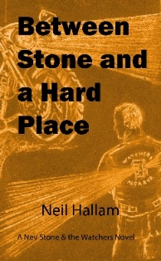 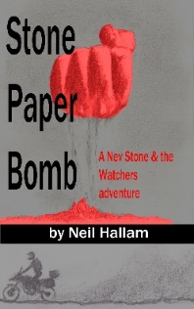 

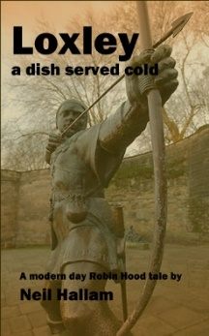 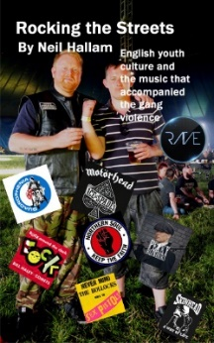 

**Mark Thompson Ernie McCall**

 [](https://www.amazon.co.uk/gp/product/B005966SC4/ref=dbs_a_def_rwt_hsch_vapi_taft_p1_i0)

**John Farmery Peter Pleydell (John**

**Halden)**

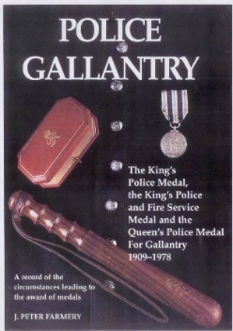 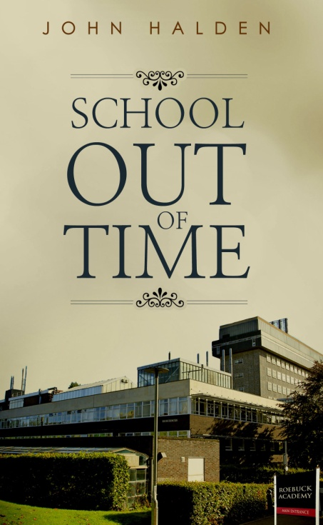  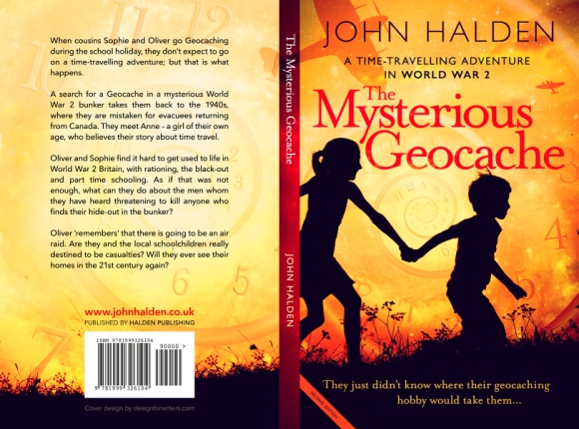

**Brian Langston D.B. Lewis**

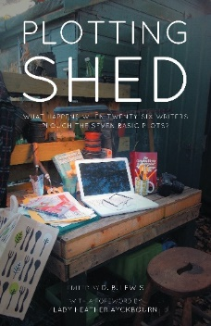

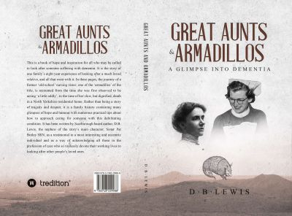 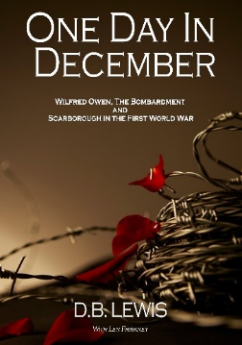

**Roy Harvey D. Osbourne Hughes**

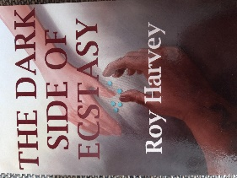 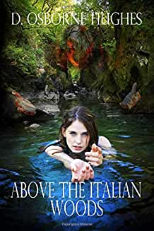 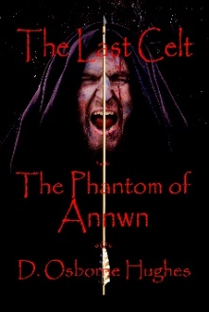

*t and Split., Budapest and Split.*

**The Station Cat writes…**

A huge thank you to everyone who has contributed for the first two editions of the ‘Covid Copies’ of *‘Writes’.* We look to even more great writing over the next 10 editions of the world’s longest ever lock-in.

Please continue to send copy to me at:

[davidlewis@brynstowe.co.uk](mailto:davidlewis@brynstowe.co.uk)

An *errata t*o kick off this week; apologies Steve; I uploaded the unamended copy of your truly excellent article; will try harder but the typos were so small I’m sure they will be missed.

This week The Cat says let’s hear it for the Marsh Family and their amazing version of Lockdown *‘Les Mis’*! doing the rounds as we write. Worth a look if you haven’t yet seen it. Some people are *so cr*eative…

Just a passing note on a couple of retirements just in case you thought they’d slipped under the net: dear old Sean Hannigan finally hung up his boots this week as did Scarborough Branch Secretary Chris Charlton on his second career. Congratulations both; more time for writing then guys?

The Cat was most disturbed to hear the ripple of laughter that passed around the Zoom Room this week when the existence of the IPA Whisky Forum was mentioned. Surely everyone knows cats don’t drink?

**Best of the Week**

Big thank you to Mark for this little gem, love it. Some of you won’t know who Julie Andrews is of course… The Cat howled like a dog…

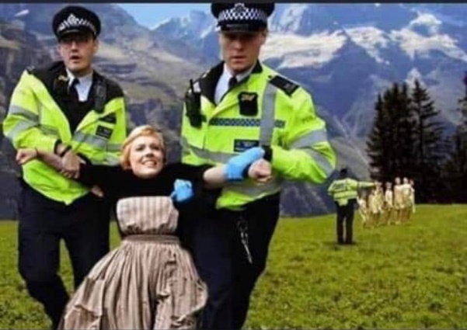

Poor kids.Hopefully the officers concerned won’t be sued for

aiding and abetting child neglect.

Keep being safe everyone and more next week; please keep sending

this great material in!



**Please send anything that you have been inspired by (or not) to me by each Monday for inclusion in that week’s newsletter.**

***Thank you all, wonderful people; please stay safe and well.***

***Editorial Note: This newsletter is copyright to Bryn Stowe Publications and the IPA. Individual submission copyright remains with the contributing authors. For any corrections or omissions please mail:***

***The Editor, ‘Writes’:*** [***davidlewis@brynstowe.co.uk***](mailto:davidlewis@brynstowe.co.uk)

***©Bryn Stowe Publications 2020***