

Stay Strong, Stay Sane, Stay Writing!

‘WRITES’

*The visible hand of friendship*

IPA Section UK Writers Special Interest Group and Global Writers Forum Magazine

No. 19

**The 2021-2022 Review**



***This is the much delayed ‘Writes No.19’***

***A Happy Christmas and great New Year to all our members. May we continue to prosper in friendship and health throughout 2023.***

***All copy to: The Editor:*** [***davidlewis@brynstowe.co.uk***](mailto:davidlewis@brynstowe.co.uk)

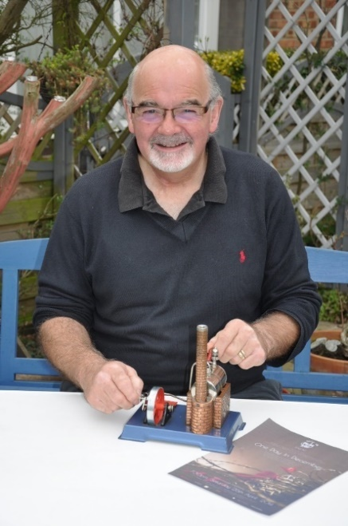***Editorial Chair David Lewis writes:***

*Dear fellow writers and friends,*

*It is a long (far too long) time since the last magazine, a situation I intend to address in 2023 and I make no excuses: I just failed to prioritise the group sufficiently in my own over-busy life. Dear Bill showed me just how important the group can be in people’s lives, a factor I had not given enough credence to. His legacy is to us all: the power and the privilege we share as creative writers and the incredible power of friendship that our great organisation engenders. I feel Bill’s loss greatly as all those who knew and loved him will, he was a giant amongst us all across the globe. Here’s to you Bill.*

*This edition is short because I promised to have a copy out before Christmas but it is a statement of intent. The most powerful of messages is that despite the setbacks of the post-covid period that we have endured, the group thrives of itself: a great testimony to the depth of friendship we have collectively created. The fortnightly Zoom meetings never fail to inspire and humble me: every meeting produces content of wonder and joy. An amazing achievement, thank you all for making each one so brilliant.*

*Despite the sad losses of Bill Petherick and Mike Baker during 2022, there have been many positive moments. Books have continued to be written, we have the huge achievement in the publication and distribution of our Ukrainian support book ‘Sunflowers for Ukraine’ and our unofficial but important fund ‘Hoggy’s Fund’ continues to raise money and distribute them to the Ukrainians we are supporting. Over £3000 has now been donated to support fifteen Ukrainians and bringing hope to many more. Thank you all for this magnificent gesture.*

*I was in Gimborn recently coaching on a course for IBZ, a programme where, through the generosity of both IPA Section Germany at Stuttgart and David Neuhoff, Ulrike’s son, I took two of the Ukrainians we are supporting, Serhii and Helen with me. They made a huge contribution to the programme and in turn we distributed 20 copies of ‘Sunflowers’ to which the seminar members donated over £200 to Hoggy’s Fund. In particular I add our thanks to Kerstin Schönner of IPA Waiblingen who has made a significant contribution on that branch’s behalf. Thank you, Kerstin, and all of your members!*

*Although this is a brief edition, I offer my heartfelt thanks to the committee for their work and to you all: in particular thanks to Colin and Helena Hutt for continuing in the secretarial role and to Janet Fizz Curtis for the AGM role. We shall prosper thanks to everyone’s enthusiasm, commitment, and friendship. You are all lovely!*

*Meanwhile, please keep writing, keep positive all and see you again soon!*

*A very happy and peaceful Christmas to everyone wherever possible.*

*Love to everyone as ever,* ***David*** *x*

**Sunflowers for Ukraine**

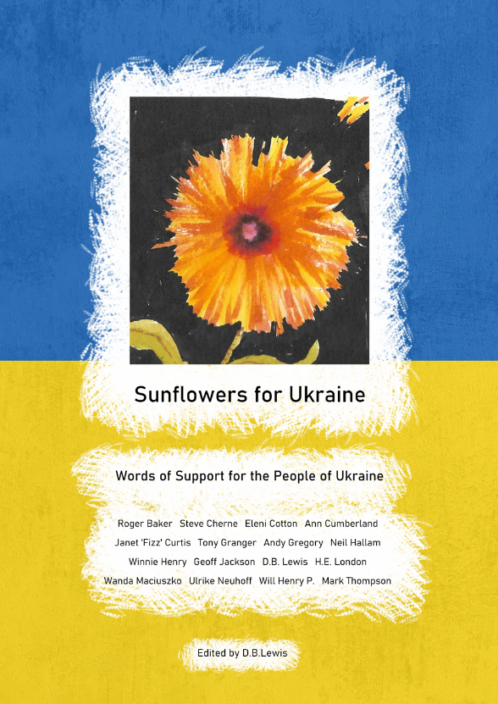

**What an amazing piece of work this is! Thank you to everyone who has contributed in whatever way: as writers, sellers, buyers, artists, supporters. We have now distributed over 200 of the 300 copies in the first print run and together we have raised over £3000.**

I will be giving a full report on this project of ours in the January newsletter but I wanted to give a huge thank you to everyone for making it such a success so far.

Lina and Lora, Katya, Serhii, Helen and all their extended family members are amongst the beneficiaries to date and we have been able to promise them all regular support throughout the winter months. A life-saving commitment helping with food and fuel and they are all extremely grateful.

Please let me know if you can help distributing the last copies: I have one big event in January where I hope to be able to sell some but we can always go to a second print run if people feel able.

Also, if you feel you can still donate to Hoggy’s Fund please let me know: the winter is long and we will be running short of funds by March. I will not let the fund run out on the beneficiaries but some help will be most appreciated if possible.

**Bill Petherick (1948-2022) RIP**



**Artist, Writer, Poet, Sage.**

**As most of us will know, sadly our dear friend Bill passed away from Covid complications in October 2022. I represented the Writers SIG at his funeral in Kilmarnock on 20th October and laid a wreath which many of the group subscribed to at his graveside. It was a very moving day and I will report fully in January on Bill’s life and times with us.**

**Ann’s Book Launch Review**

**Friday 25th June 2021 4 -5.30 pm**

**‘Which Way to The Gambia?’** was Vice-chair Ann Cumberland’s first book and had its grand launch on Friday 25th June 2021 at The Theatre, Cober Hill Hotel and Conference Centre, Cloughton, North Yorkshire, courtesy of Number 3 Region IPA and the publishers, Bryn Stowe Publications of Scarborough.

There was an excellent attendance both as a live audience and via Zoom for this charity fund raising event in aid of sending a bike or two to the children of a school in The Gambia, via the IPA *Valles Occidental* Branch of Barcelona in Spain: a true act of IPA friendship.

The book has sold well but if you would still like to purchase a copy, please let Ann know and she will send one to you. Contact direct or via the publishers: [davidlewis@brynstowe.co.uk](mailto:davidlewis@brynstowe.co.uk) £12 plus p and p.

**Annual Christmas Dialogue**

***by Proinsias Donlon***

“It’s the most wonderful time of the year” somebody is screeming out on the kitchen radio. The bad sound of the cheap radio with vibrating plastic can put you into a bad mood straight away.

*The most wonderful time of the year, ha ha, nonsense, loads of work, plenty of stress, hectic unlimited.*

But what about all the good food we will have?

*Nonsense.*

The smell of beautiful cake and mulled wine, aaahhhh.

*My answer to that is a messy kitchen, spending hours and hours baking and cooking but munching away everything in only some minutes, not efficient, not at all.*

There’s a special mood in the air that lights up your heart.

*Rubbish. I have experience in that. Believe me. A marathon to get all these presents, to wrap them, and at the end of the day they are the wrong presents   
anyway.*

Mmmmmhhh.

*Did you notice the lights at the house at the end of the street. They always want to be the first. Terrible. Far too early.*

It’s such a short season. We should make the most out of it.

*No and no. Even the shops are full of Christmas stuff already. One day we will have Christmas before Halloween.*

Interior Design magazines are full of good Christmas ideas.

*It’s all the same, like every year. You can’t bring Christmas to a new level.*

There’s a new lighting system in town. The Christmas tree at the square is much taller this year. It looks impressive. All shops look impressive with their Christmas decorations.

*I’m happy not to pay their electricity bills.*

But it creates a nice atmosphere in town.

*And the store with the private Christmas trees? More expensive again like every year, with all the pine needles in the house.*

But the fresh smell of the Christmas tree is fantastic. With beautiful decorations.

*Don’t even think about real candles.*

Electric lights at the Christmas tree look artificial. Don’t like them.

*I love candles. But just some scented candles are nice. Just a bit of vanilla or cinnamon in the air. That’s a nice smell in the house.*

This summer a candle nearly burnt down the house.

*That was just the strong wind which blew the candles out of it’s holder. This strong gust we had because of the open window*

At this time of the year, we have to keep the windows closed. It’s cold and damp anyway. I don’t like winter.

*What I like most is the smell of baked apples. Some raisins with it. And yummy custard. Lovely.*

All I can remember is that tray of cremated apples two years ago. That smell was awful.

*Your alternative then is your own bag of Christmas sweets. You can’t go wrong with that.*

Do I have to wear this ugly Christmas jumper again? With the reindeers on the front and the polar bear on the back? The thought of it gives me cold shivers.

*You can warm yourself up with lively Christmas music. Not all of that Christmas music is tragic.*

Can’t stand this lullaby about White Christmas.

*There is so much different Christmas music available. Even some in a Jazz version. Very nice.*

The most important festive season is Easter. Do you think some musician would write funky Easter music? Nothing at all.

*A pretty wreath on the door is a nice decoration for both festive seasons.*

Yes, and again, it’s all about the presents and a day off.

*And, like at Easter time, we will receive plenty of christmas cards.*

Help. I’ve totally forgotten to write Christmas cards. Will get them tomorrow.

*You’re right. Christmas cards are much nicer than a text message on the phone.*

Oh yes, my honey. A hand-written Christmas card comes from the heart.

*Will I make two Irish coffees for the two of us?*

Perfect, my honey. And let’s watch a nice Christmas movie. That always puts me into a good Christmas mood.

*Merry Christmas, my love.*

Merry Christmas, my honey.

**For those who do not recognise the writer he is our own dear friend and writer extraordinaire Udo Lauterborn from Cologne, Germany. Thanks Udo, and Happy Christmas to you too!**

**Some Ghost Stories: A Christmas Tradition**

**A Ghostly Presence.**

***by William Petherick***

*(This is Bill’s very last submission of a great many over the past few years sent to us just three days before he died. Bless you Bill.)*

One night shift two police officers were on foot patrol in the Irvine Town Centre area. The officers one male, and one female were returning to the police station for their break when the male officer suggested taking a shortcut through the High Church graveyard.

His colleague was less enthusiastic about this idea and declined and advised him that she would take the normal well-lit route back to the office.

Undisturbed by this the brave male officer strode off through the walkway leading down through the graveyard past the church. Not long into his detour he suddenly realised just how dark and eerie the graveyard looked. Large headstones silhouetted into the dark bluey-black of the night sky. Angels atop monuments looked ungodly in their dark coating of the night.

Still, our hero took a sharp intake of breath and walked on. As he approached the church the surroundings seemed even darker. The path had narrowed with the church on one side and a single row of very large and sinister headstones on the other side of the path.

At this, he heard the distinct sound of someone chiselling stone. As he walked on, he approached what he could see was a very old man

apparently sitting in front of one of the headstones with a hammer and chisel in hand and feverishly chipping away at the front of the headstone.

On approaching closer he also realised that his heart was beating not only faster but louder, and he was going into a cold sweat. Still, bravely he approached the old man and opened a conversation.

“A bit late in the night to be out sir, is it not?”

There was no response as the elderly gentleman stuck to his task.

Our now nervous police officer noticed that his style of clothing was a bit old-fashioned. For a start, he wore a flat cap. He was also wearing what appeared to be a dress suit, white shirt, and tie. All very strange for someone refreshing the lettering on a headstone.

“How are you, Sir?” the policeman enquired.

This time the old man turned to the officer, and in a very quiet but clear voice replied, “Sorry officer but they have spelled my name wrong.”

The policeman at first laughed and continued his walk towards the exit then he realised just what had been said. Turning around he saw the old man nod his head, smile, and slowly sink into the ground in the front of his headstone. He stood there in awe of what he had just witnessed convincing himself that it had been an illusion. On returning to the police station, two of his colleagues remarked that it was the quietest, they had ever seen Alex. Another chipped in remarking, “Did you see the colour of his face, it was as if he had seen a ghost?

Now, a few days later the same officer was on backshift and decided to re-visit his `encounter` this time in the daylight. As he approached the headstone, he could see what looked like objects behind the headstone. On investigating he found a very old and rusty hammer and cold chisel. On standing in front of the headstone he could clearly see that the name Tom Johnstone had been altered with the addition of the letters M and Y to the deceased’s first name so that it read Tommy Johnstone born 1888 died in 1972. A soldier of two Great Wars.

As our somewhat flummoxed police officer stood in front of the newly altered headstone the minister of the church approached him.

“Anything wrong officer?” he asked.

“You would not believe me if I told you.” was the reply.

“Ah!” said the minister. “So, you have met Tommy one of our resident ghosts. He was a very well-known gentleman in the town. A bit of a character and although christened Tom he always went to great lengths to be known as Tommy. How was he?”

The policeman looked at the minister in a state of shock and replied, “He looked fine”

The minister asked the police officer his name stating that he was the very Reverend Donald Robertson.

“My name is constable Alex Hall.” replied, the police officer.

“It has been a pleasure meeting you Alex, take care.” at that he walked off.

On returning to the police office he was passing the front of the church when his attention was drawn to a very ornate headstone near the main door. The heading was inscribed a Minister of this Parish. Underneath the inscription read,

In memory of the Very Reverend Donald Robertson

Born July 20th, 1861. Died November 19th, 1959

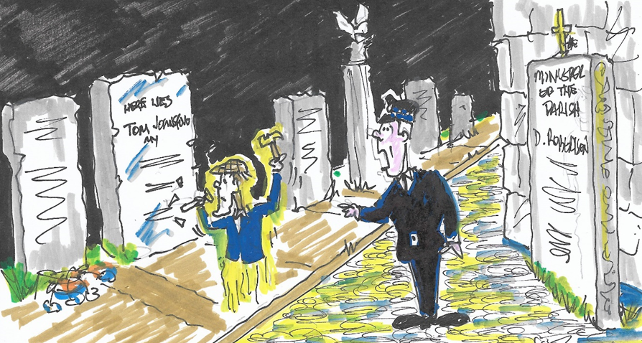

**The Mirror**

***by D.B. Lewis***

Jack, waking, found himself in a light blue room. Airy, spacious, light, a bed he felt comfortable in, crisply sheeted, high off the ground, sterile. Opposite him and on either side, similarly linen-ed beds all unoccupied. The bleep-bleep of machinery focused his empty mind to the realisation he was in a hospital ward. He found he was immobile, only his senses providing any sort of reason. The acrid smell of antiseptic freshly applied crept into his consciousness; hazy, indistinct, remote.

A sound, a moving trolly drew his gaze. A nurse wheeling in a man possibly 20 years younger than himself Jack thought, was transferred to a dormant bed. Jack saw his familiar face, recognition dawning - his dark beard just like his own he thought, but 20 years ago, ‘a broken leg too by the looks of it, the left like mine’, the memory of a former folly that had caused his own misfortune – an angry exchange with his partner of the time, and anger carried onto his motorbike causing him not to see the breaking car ahead.

No sooner had the nurse retreated than Jack was conscious of another man entering, this time in a wheelchair, the same nurse strangely

familiar. The man had his head bandaged, his eye covered, a spot of blood just visible. ‘How strange.’ Jack thought, ‘he wears a ring like mine on his right forefinger’. A strange coincidence with an injury that reminded him of his own reckless behaviour during his youth, a prank with stolen theatrical black powder in a matchbox left in a telephone kiosk which when lit blew the door off . And him with it. Life and death a single minute in between.

A third man entered, ‘walking wounded’ didn’t they call it in the war? His left wrist was bound, held in sling. Jack saw the look in the man’s eyes, a middle-aged man, a slight paunch, and Jack noticed the man’s red rimmed glasses, just like his own a few years ago – they were Spanish-made and very unusual. He would ask him how he came by them. They were pricey Jack recalled. Jack became aware that his nurse was speaking to him.

‘Mr Flint, you feeling drowsy that is good’. The misplaced articles indicated she was not completely fluent but she was demure, attractive, briskly efficient.

‘You is very like the last patient in this bed, but he was young, I mean younger. He was very poorly too, and infection, delirious but he is not here now’.

Jack remembered an illness of his own many years before contracted by his inadvertent use of ice in a whisky on a wild night in India abroad many years ago. Jack found himself unable to speak,

‘Never you mind speaking Mr Flint, you remind me of my husband, he is Brit like you, also he wanders the eyes. I saw you. I don’t mind, shows there’s life still there isn’t it?’

Jack thought of all the pretty sites his eyes had seen, the girls of his youth, untouchable, unavailable, dismissive. Jack rued his missed opportunities.

‘I will put TV on for you Mr Flint, you probably cannot be able to see it but I have to see to your notes now.’

On the screen Jack saw a news reporter, a familiar face, ‘Smiles a lot’ he thought, ‘twitches his head to one side like me to, what a cheek, took me years to perfect that,’ thought Jack. Jack heard him introducing a parcel of experts, they seemed to be talking about people’s interests, hobbies, pastimes, some sort of health programme. Now they were talking of

model trains, gardening, reading, writing, fishing, poetry, music, trees, ‘How appropriate,’ he thought. The nurse couldn’t have chosen a better. ‘These are my interests at different times of my life’. He noted the speakers were all familiar in one way or another but they drifted in and out – a varied age range with about 10 years between each one he thought.

Another nurse was hovering about. ‘We are taking you down Mr Flint, you have chosen not to be sedated and there is possibility to see the procedure in a mirror if you wish over your head. What you think?’

‘Yes’, Jack thought, ‘A mirror to see what is going on. A great idea’.

Jack was wheeled to a larger room there was noise lights, more sound the mirror placed above him into which he looked to see the image of a surgeon a blunt looking man but a sharp looking knife.

‘Now Mr Flint we are going to remove all these nasty things from you, it may take a while but relax, close your eyes if you find you cannot watch’. Jack realised he must have done so as on waking he found himself back in he had been in before. There were unoccupied beds around him still.

The nurse was with him ‘Where are the others,’ he said.

‘What others?’ replied the nurse. ‘There is only you, you have had the whole ward to yourself all day, no other admissions were allowed today because we will need to deep clean after you have been here your disease is highly contagious and very dangerous to everyone.’

‘But the others, the broken leg the head injury, the rest the surgeon the other nurse?’

‘No, no one but you and me, Mr Flint – but you are heavily sedated because of your disease and perhaps you were dreaming or may be a nightmare, but now I must take you to pre-op – the surgeon will be here shortly then you can rest – what is this about a mirror Mr Flint? Mirrors are for seeing ourselves as we are. Who wants to do that?’

Jack looked aghast.

‘We don’t use mirrors here, it’s better not to dwell on the past Mr Flint, better to look out of the window and see the future isn’t it?’

Jack closed his eyes. He couldn’t agree more.

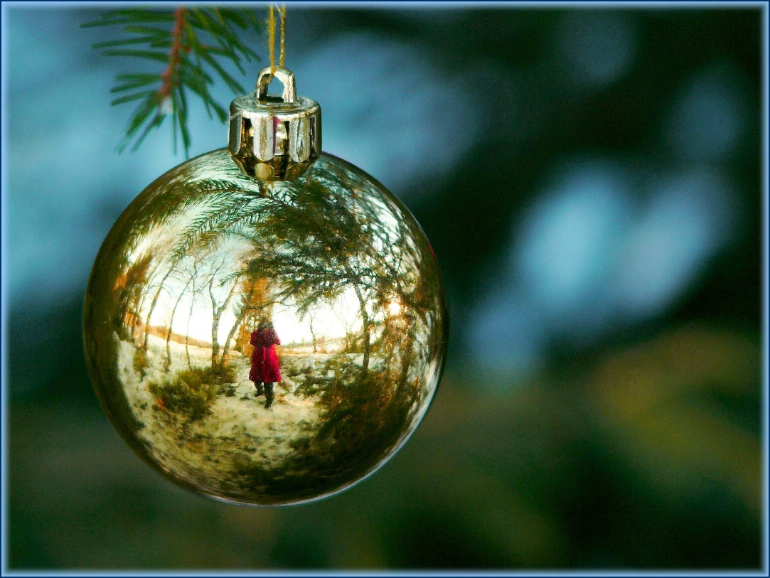

**A Ghostly Presence**

***By H.E. London***

There was no bright sunlight streaming across the peaks as I had let myself believe would be the reward for my hike.

There was just the dark veil being lowered over the face of the mountain like that of the grieving woman inside me.

My tears being the light drops of rain that ran down my cheeks falling at my feet, as I stood alone looking at the bleak but beautiful landscape.

The ground beneath me strewn with the fragmented pieces of broken rock that was my heart.

In that deepest, darkest moment I sensed his presence.

The very light pressure as he lent into me gazing together at the horizon in companiable silence.

Time stood still, daring me to move, yet anchoring me to that place, with the certainty that I wanted this precious, treasured time to last as long as possible, knowing that he was preparing to go forwards whilst I needed to return home. Our inseparable bond to be broken.

I gently let my hand fall, my fingers softly caressing his fur, never averting my gaze ahead lest he should leave my side, taking with him the peace and companionship his loyalty had always lovingly given.

As I slowly closed my eyes, I could feel the sting of cold wind on my face and hear the rumble of thunder in the distance. He was gone and I knew deep within my heart that my best friend had accompanied me one last time as I had walked this trail. Our favourite walk.

Taking a deep breath I tentatively raised my eyelids and It was then, I could see a small chink of light. A little shade of hope on the horizon peering through the heavy sky. Forcing its way through the rain clouds, promising a brighter day.

As I turned to walk back down the mountain, I was sure I heard a bark. Or was it just the elements playing tricks on my senses?

**The Ghost Rider**

***by Tony Granger***

It was set to be a wintry Christmas – we knew that. Flurries of snow were eddying across the valley, swirling amongst the crags above us and beginning to settle on the rocky ground and tufted grass around the cottage. It was cold and wet-weather clothing with scarves and a turned down cap was all I had for comfort. This was unusual weather as it was supposed to be summer – but one could have all four seasons in one day in that part of the world.

This was going to be my first Christmas on Balcraig farm, situated on the south-facing lee of the first little hill as you came down the winding gravel road described as Woest Hill on the road between Grahamstown and Kenton, in the Eastern Cape of South Africa. The farm itself was developed in the 1820s following the arrival of the first settlors from England and Scotland to that area, after their small ships docked at Algoa Bay and disgorged their human cargos into the hinterland. It was only about six miles from Grahamstown, where I was a student, but far enough away from the City to provide tranquility if that was your wont.

I had rented out the main farmhouse to students to provide me with extra income and converted the dairy into a cottage, which was some distance from the main house. Around three sides of the cottage were paddocks with fences leading up to the sides of the cottage like spokes on a wheel. My solitary cow was inherited with the farm. She had one broken horn and had a pleasant disposition and provided us with daily milk which was lovely and creamy. Occasionally sheep grazed the pasture but over winter were kept at my neighbour’s who owned them. I lived in the cottage with my girlfriend Vyv who was also a student. It was fairly primitive – there was no toilet in the cottage but a nearby privy or ‘long drop’ as it was known in those days, complete with spiders and other creepie crawlies and no electricity. Quite an experience for the unwary!

Christmas Eve was upon us, and the excitement of Christmas day was looming – a time to remember and a time to put any past bad experiences behind us. A log fire burned in the hearth and Vyv played on her guitar, the Christmas tree was up and I was feeling content. Christmas day would be spent in the traditional festive manner with friends. We went to bed and were soon asleep.

I woke up with a start. I could hear a horse’s hoofbeats running around the cottage. I nudged Vyv who immediately woke up and said ‘Can you hear that? It sounds like a horse running around the cottage’. We both lay there and listened to it for a full minute – ‘Impossible’ I remarked, ‘there are fences up to the cottage, it must be jumping over them’. Then the sound of hoofbeats faded away and we both thought it must have been the wind or some other phenomenon, and went back to sleep.

Early the next morning we woke up and went outside – a cold shiver ran down my spine as I saw clear impressions of a horse’s hooves in the snow running through our fences as if they were not there. We couldn’t believe it, but there they were clearly outlined in the snow. We knew then that we had not been dreaming.

On the first day after the Christmas period that the local records office and museum was open, I went in to do some research. Some time ago, way back in the 1820s, a rider had appeared at the farm begging accommodation and assistance on Christmas Eve from the farmer who lived there. He was turned away with nothing and died on the farm, alone and hungry, without friends or the comfort of a friendly fire. Legend had it that the spirit of the rider and his steed were often manifest at that time of year, having perished on that farm.

Christmas is a time to be kind and welcoming to others and to bring joy to their hearts, as I do to you.



**Be Still the Night**

***by Ann Cumberland***

He was dying, in the bed beside my dad,

in a whitewashed cottage with a beach at the front door.

He was sleeping, then quickly woken,

By a glass bottle falling hard on to the floor.

He was startled, the bottle placed where he had left it

on the table, contents moving on their own.

He switched the light on, the other house guests hadn’t heard

the noise beside him, the old man awoke and began to moan.

He was dying, in the bed beside my dad,

in the storm, lights were playing with his eyes

The door was banging, flashing lightening lit the room

The wind was howling, he breathes his last, the old man dies.

Windows blow open, screaming from outside,

hearts are broken, as news breaks the old man died.

An eerie silence, emptiness fills the room,

Though He’s still here, he’s left us much too soon.

**A Ghostly Presence**

***by Geoff Jackson***

In the dim light of the evening, the house was dark throughout, and was totally silent.

There was the sound of keys outside, as the keys were being used to open the front door. The door opened and a middle- aged man made his way into the hallway and turned to close the door, switching the hall light on, he made his way slowly along the hall to the front room, where he on another light, not a very bright one, in fact quite dim.

The man dropped himself on the settee and dumped a small briefcase he had been carrying onto the floor. As he sat, he put his hands to his face and began to sob uncontrollably. He said nothing at this point but fished out a bottle of tablets from his pocket. As the man sat and cried, he started taking the tablets.

Elsewhere in the room, there was a shimmering light that appeared, not too bright, but noticeable. Slowly he kept taking the tablets, not in a large amount at a time, but it was constant with his crying and sobbing.

A second shimmering light suddenly appeared near to the other. There was suddenly a quiet voice that could just be heard, ‘Do you think we could help him?’ said the voice.

Both shimmering lights moved towards the man, and began to change their form, still maintaining their brightness, but now taking on the appearances of two men. They each went and stood either side of the man, who, at this point was totally unaware of any form of presence.

One of the forms spoke, ‘Hello, why are you crying? ‘ The man sat back, appeared bemused. He stopped crying and put the

tablets down. He chocked and coughed, In a very surprised tone, he asked, ‘Who are you, are you real? ‘

One of the forms that had spoken, said, ‘ I was James and my friend was Tim.’

‘What are you? ‘ said the man.

‘Does that matter?’ said James.

‘We are here to help you.’ said Tim. ‘We live here and have done for a very long time now.’

James added, ‘You are in need of help, and we can help you’.

The man looked stunned and said, ‘How can you help me?. I’ve lost my job, I have nothing left, and I’ve decided to end it all. ‘

James said ‘ But it isn’t your time yet my friend, you still have a great deal to do.’

He looked up at both lights and stared into them.

‘I can see both of you, how can that be, you are not really here.’

As one, they both replied, ‘We are both here and are here for you. As we have said …it is not your time.‘

Just after they had spoken, the man’s mobile phone rang. He answered the call and was listening intently to the caller.

‘Oh,’ he said in a shocked voice,’ Are you really sure? Thank you for letting me know.’

He ended his call slowly looked at the two shimmering forms, James and Tim.

‘That was my work, I still have my job if I want it back. They said that they had made a big mistake and have even offered me a promotion.’

James and Tim moved back from where he was sitting. Tim said ‘ We’re glad that you took the call, our job is done, but you know where to find us if you really need our help.’ With

that, both forms, James and Tim moved further back and gradually faded away, leaving the man sitting on the settee. He put the tablets back in the bottle and threw it in a nearby bin.

He felt very grateful that he had only taken a very few tablets.

He called out in a loud voice ‘ James, Tim…Wherever you are, Thank You, Thank You very very much. ‘

He sat in silence for a long while, before falling asleep.

***Thank you to all our submitters on this Zoom based writing competition inspired by one of our new members recently. We are all winners I reckon! Happy Christmas! Ed.***

**‘The Bookshop (Still) Needs You!’**

***by Helena Hutt***

Dear all,

Developing ‘The Bookshop’ for the SIG is going well. The idea is to help market our members’ published works. The intention is to launch the website early in 2023 with all our members’ books listed with links to their own sites. To make it work we need the following from all of you published authors:

* A colour image of each book front cover
* A short description of the book content and genre (Three lines)
* The Recommended Retail Price (RRP) and any member discounts
* The link to your own website
* An image of the author
* A short biography of the author (5 lines)
* Any testimonies the book has received (No more than three)

Please send all of the above in one mail if possible, to:

[**helenahutt@btinternet.com**](mailto:helenahutt@btinternet.com)

**Coming soon in early 2023!**

**The ‘Fifty Shades of Blue’ Project: towards Completion!**

***by The Editor***

Decision taken. This much delayed project has worried me a for a while but now I feel the breakthrough moment has arrived. ***‘Fifty Shades of Blue’*** was a great idea without enough petrol in the engine. Now I believe we have a new fuel supply. The cause of helping to address the ongoing need for good mental health is still a major need in our community. I know, because over the past three years many of us have become firm friends and we have shared our angst, our distresses, our low points, and our need to just switch off for a while. It is part of the creative journey. A part of the writer’s journey. It is also an often-understated part of the policing journey we have all been a part of.

The plan is this. We have over fifty members in the group now and I will be writing personally to each member in 2023, and a few more potential members too. The invitation will be to submit another piece of creative writing that in some way has a positive bearing on the issue of mental well-being. We already have many pieces from the Gimborn seminar.

It could be in any medium or genre: poetry, prose, reminiscence, article, exercise suggestion, a case history, a personal experience of mental anguish and its outcome, a medical piece, or humour. As the old Reader’s Digest cliché went, ‘Laughter is the best medicine’. (But sadly, we do not send you the £50 the RD did way back in the day). It could be a painting with a commentary, a hobby piece, a description of a sculpture, a travel piece, any form of writing or use of words you might be able to conjure up. The key is it must have a bearing on mental well-being.

The process then will be:

* Letter out to members
* Submissions returned
* Editorial processes
* Usual book publishing process by Bryn Stowe Publications of Scarborough during 2023
* Book published at an affordable price with any surplus fees donated to Police Care UK and The Thin Blue Line.

As an example, I have included in this article the submission of a serving officer who has been gracious to give us access to this piece, a heart-rending story of his own journey with post-traumatic stress.

I hope you will all feel as I do that this is a worthy way to complete this project? And I know you will have stories!!!!!

There are no limits to submissions, but I suggest no longer than 2500 words as an absolute maximum and around 1000 words would be ideal. That would give a book of around 150 pages.

Usual Writes guidance please:

PLEASE!!!! Word document. Calibri 12 pt.

1.5 spacing. *Please.*

(And yes, I know the shading in blue in this article did not work too well!) Looking forward to seeing this one in print now!

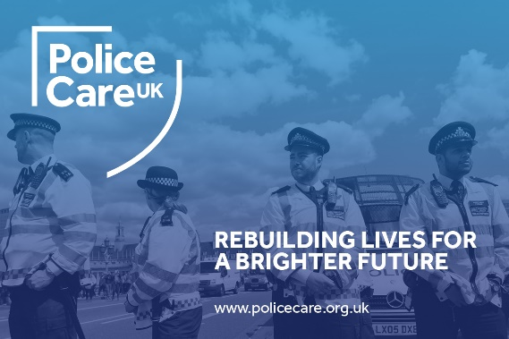

**Letters to the Editor**

Dear Editor,

I wanted to say how impressed I was to hear of your experience when you challenged your publishers about the type of books they were publishing.

I think it was very brave of you. Most of us would have shielded our eyes and pretended not to notice.  I do believe that we have a duty to speak up when we see things that shouldn't be happening and which, in some way, harm humanity. But we also must be prepared to be slapped down for our efforts as you were. It's tough.

I was very touched at the meeting when many of you pitched in to try and help out with my KDP problem. For the first time, I felt I truly belonged to the group and I'm really grateful for that. Tony managed to get the proper listing and buy a copy but I got the same old rubbish on my screen. It must surely be a technical fault for computers to be receiving different messages?

It's been a blow to lose Christmas sales but having a firm belief that all is for the best when one has done one's best, I get on with other things and wait to be shown the way.

Keep up the good work,

Eleni Cotton

Dear Eleni,

Thank you for this letter which refers to an ongoing discussion with one of my publishers in Germany who justify publishing scurrilous works on the platform of the right to free speech.

Whilst I certainly agree with their position on free speech, I deplore the publication of abusive and demeaning writing: but I accept it is a difficult debate.

After two years of listening to constant rejoinders that ‘I should really watch ‘Peaky Blinders’ it’s right up your street,’ I did finally watch the first two series. The script is incredibly good and I enjoyed it for that reason but the level of violence was just too much for me in the end: why the audience needs to see someone’s throat cut open in full shot is beyond me. (My biggest concern was why did people think it was ‘right up my street’? I rest my self-esteem on the fact that it is about historical Birmingham which I am studying for my book on the Ironmasters and it is indeed extremely interesting from that point of view. But the extreme levels of violence kept me awake at night.

The point I suppose is that we have the choice: we do not have to watch or read if we do not choose to do so.

The debate about publication will no doubt go on: the main thing is to continue to seek the highest possible standards of English usage and book design which is something we can work with?

Your works are excellent Eleni and a good example to us all.

*Ed.*

**Gimborn 2022 or maybe 2023!**

## Sadly, as you will probably know we had to cancel Gimborn this year: the issue being the need to book early and positively.

Even more sadly it looks like we would have had sufficient numbers including two from Africa and one from the Netherlands but I was pressed hard by Gimborn about a month before the start to provide a definite delegate list that week which I was unable to do and did not have the capacity at that moment to chase everyone up.

So now I am actively seeking a slot for 2023 although it will not appear in the seminar booklet.

Once we have that slot, we will approach the issue differently and seek a non-refundable deposit to secure a place.

Let us not lose this priceless gem of a venue? Yes, we can run seminars in the UK and will look to do so but Gimborn has its own special inspiration for all writers. Please do join us and make it a special opccasion.

## 

  **Gimborn Writers**

**The Fifth International**

**Writers Seminar**

**2023**

***The Station Cat Writes***

The Cat has been out on the tiles for a while but crawled back in as you know, a bit bedraggled but alive and kicking. But lots of things are now starting to revitalise the world and here are a few of them…

Funny Insurance Claims Quotes (allegedly) – any of your own?

"I knew the dog was possessive about the car but I would not have asked her to drive it if I had thought there was any risk."

"The other car collided with mine without giving warning of its intention."

"When I saw I could not avoid a collision I stepped on the gas and crashed into the other car."

"The accident happened when the right front door of a car came round the corner without giving a signal."

"The pedestrian ran for the pavement, but I got him."

"I saw her look at me twice. She appeared to be making slow progress when we met on impact."

"The accident occurred when I was attempting to bring my car out of a skid by steering it into the other vehicle."

"I had been learning to drive with power steering. I turned the wheel to what I thought was enough and found myself in a different direction going the opposite way."

"The guy was all over the road. I had to swerve a number of times before I hit him."

(Extract courtesy of ‘Businessballs’)

Offers: See Main NARPO site [www.narpo.org](http://www.narpo.org)

Here’s a recent FB post: who was this wild thing?

- We danced at the Mount Soche hotel (where I often sang in cabaret) until 6 a.m. and had champagne breakfasts.  Then we drove to our lake cottage, swam, played in the water and tore around in the speedboat.  Slept for a few hours then back to town and a film at the Rainbow Cinema. The interval was where we all met up again and talked about where we'd go on the following Saturday.  The boys rode motorbikes crazily and we hung onto them like limpets then my brother George got an MG for his birthday and we usually managed to fit about six into it.  The drive-in was fun. We took collapsible chairs and tables, snacks and lots of beers. And, oh yes, we watched bits of the films too.  The boys drank quite a lot but we girls would never hear the end of it if we returned home smelling of alcohol so we had orange squash and tonic.  We had to be careful what we wore though because Dr Banda was very strict about that.  If so much as a knee showed the police had the power to tear your skirt off. And if the boys' hair was long enough to touch their collar, it was cut off.  We also went to our farm for the weekend where we boated, went hunting depending on the season and partied in the evenings to the sound of frogs croaking in the reeds of the river which flowed about fifteen metres from the house. And, oh yes, if the professional crocodile hunter was around the boys went crocodile hunting at midnight.  Whatever time we made it back to town, sometimes having been stuck on the road all night, we always made it to work on time.  
I suppose that sounds pretty tame?????

*In case you hadn’t guessed it was Eleni: good on you! Ed.*

**SIG Nature Writing Weekend**

Steve Parnwell has kindly invited us all down to Madeleine’s Patch again, this time for a writing weekend on the theme of nature writing. For those who attended our last event there, a hedge planting weekend in January 2020, just before the pandemic struck, we know just how amazing Steve’s place is; a fascinating weekend is assured. The dates are proving a little tricky but early summer 2023 is looking favourite: we will confirm these in due course once the situation is clearer. Thank you, Steve!

**Murder Mystery Weekend**

This long-awaited extravaganza of a weekend also had to be cancelled or as we hope, postponed. Covid did for the initial high level of enthusiasm and it just wasn’t possible to rekindle it on a date suitable to everyone. Thank you, Tony for all your work on this which was considerable and I hope that in some way or another we can run this exciting event.

**A Final Note on Delayed Publication Submissions**

If you have submitted material between the end of February 2021 and the beginning of December 2022 (yes, really! So so sorry!) and it has not appeared in this edition, please accept all due apologies. I will make sure all of these appear in the following editions. It is just that having such a long break I felt I must have ‘Writes’ out there again and start on the next one straight away. Each edition takes a very great deal of work, extremely enjoyable work I must say, but a lot of time and effort does go into each one.

**A Zoom Note**

Please do keep writing: we are an amazing library of writers beyond any doubt and for those who have not attended a Zoom fortnightly gathering, you would be staggered at the range, depth and sincerity of the friendship: we are an excellent example of the living embodiment of the IPA. Do join us if you can; we are usually around a varying dozen or so and all very welcoming and friendly. The usual format is to have a ‘round robin’ of each member’s news, writing wise, but from time to time we have themed weeks which have included Irish Writing, Scottish Writing and soon we shall have English Writing! Not to mention African Writing as we know have so many ‘ex Africans’ amongst our number!

It has long been the Cat’s wish to have a Zoom News article each edition so if anyone fancies taking this on, they would be most welcome!

***Thank you all once again, wonderful writers; please stay safe and well and have a quiet and peaceful Christmas 2022!***

***As if…***

***Editorial Note: This newsletter is copyright to Bryn Stowe Publications and the IPA. Individual submission copyright remains with the contributing authors. For any corrections or omissions please mail:***

***The Editor, ‘Writes’:*** [***davidlewis@brynstowe.co.uk***](mailto:davidlewis@brynstowe.co.uk)

***©IPA and Bryn Stowe Publications 2022***

***Future Editions: Coming in 2023!!!***

