

Stay Strong, Stay Sane, Stay Writing!

‘WRITES’

*The visible hand of friendship*

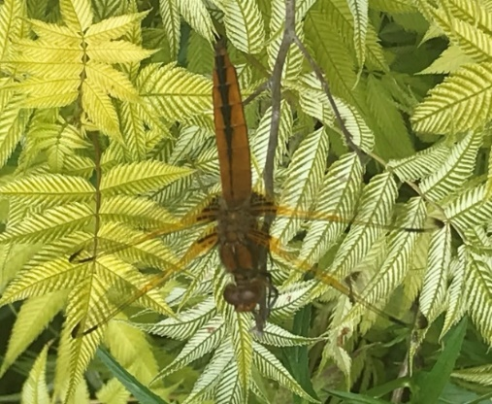

IPA Section UK Writers Special Interest Group and Global Writers Forum Magazine

No. 13

**September – October 2020**



***‘Writes No.14’ will be published in November 2020: all submissions please in WORD Calibri 12 pt. 1.5 spacing to:***

***The Editor:*** [***davidlewis@brynstowe.co.uk***](mailto:davidlewis@brynstowe.co.uk)

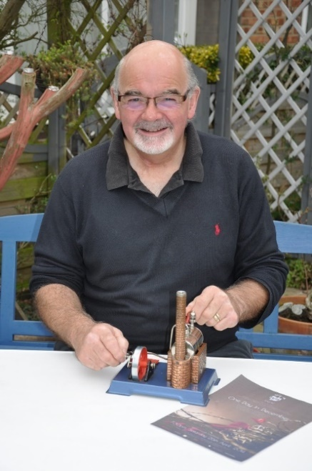***Editorial Chair David Lewis writes:***

*Dear writers all,*

***‘50 and over!’***

**I**t seems an age since the August edition. Life just stood in the way I am afraid, but I am now back and hopefully we can pick up where **‘*Writes’***left off? Since August my family has had three major trips to hospital, a ruptured Achilles tendon for me, and a school Covid scare: thankfully all now discharged and recovering, I also picked up a very complex policing contract to write the classroom phase of the degree holder’s direct entry detective training programme, and I started a major biographical work on the Holcroft Dynasty of West Midland Ironmasters. But now peace has returned. Hopefullly? (I will come to ‘50 and over’ at the end).

On the writing front, I am pleased to say that the fortnightly Zoom meeting has progressed well with one of us: Sean, Neil or myself, usually managing to make the chair. Many of you have been in regular touch which is wonderful and there are some exciting projects coming along well. Do please continue to keep in touch where you can.

We are currently planning for coming events in the hope that the world will be a safer place before too long. I wrote...’quite soon…’ but realised that was none too realistic? The first event is a weekend writers seminar gathering from **21st to 22nd November:** this will now have to be online and we will circulate details shortly. Then we may have the Murder Mystery weekend in the new year.

Gimborn 2021 is scheduled for **April 26th to 30th 2021.** If this is affected by Covid then we shall postpone until the autumn – we are

looking for a date in September, but if delayed we shall also run a week online again: the plan is to create a ‘Print on Demand’ publication at Gimborn this time; an anthology of our work starting from scratch and delivering sessions on all the various phases of creation through to production.

I have also been feeling that all the wonderful words that you write for the magazine should have more of a commentary attached to them so I will mention some of them in each edition as appropriate. In this month’s for example, we have had some excellent poetry submissions: Bill Petherick’s has caused me some heart searching, as it might for many of us? We should take good note: this is a very important poem. I ask us all to give it due regard and action the message wherever we can please: a Bard has spoken.

It is so good to see the development of our poetry over these past three years: those who remember when we started at Gimborn, we had just a poem from Ann but not much else being shared. Now we have some exceptional poetry being written and many of us are trying our hand, often for the first time: this is heartening and augers well for the poetry section of the anthology next year.

**‘50 and over’?** This is a great milestone for the group as in the intervening two months since ***Writes 12*** we have reached a membership figure of 50, most of whom are actively contributing or maintaining regular contact. We have thereby been granted £100 by the NEC which has been banked during the Covid Emergency with Scarborough Branch of 3 Region. Many thanks to Judith and Chris for helping with this. We have few expenses at present, but we can decide on how to best use this in due course. Meanwhile…enjoy and, of course

… ***Stay strong, stay sane, stay writing! Love you all! David***

***In this wonderfully packed edition:***

* ‘You, Them and Me ‘ *by Will Henry P.*
* ‘Friendship’ *by Steve Cherne*
* ‘Peace’ *by Roger Baker*
* ‘Poseidon’s Chargers’ *by Helena Hutt*
* ‘Love Song’ *by D. Osbourne Hughes*
* ‘Skirmish at Knocken Crag***’*** *by Ian Mcneish*
* ‘Timeless’ *by Ann Cumberland*
* ‘I Wonder if We’ll See the Comet’ *by Geoff Jackson*
* ‘Concentrate Space Lady’ *by D. Osbourne Hughes*
* ‘Marrying a Known Terrorist’ *by Tony Granger*
* ‘Meet the Author: Henrik Ellert’
* ‘Roads: A Christmas Writing Challenge’
* ‘The Plaza Woman: Netflix Unsolved Mysteries’
* ‘William Soutar’ *by Ian McNeish*
* ‘My Dream’ *by Ian McNeish*
* ‘One Morning Glasgow Woke’ *by Malky McEwan*
* ‘Dawn Breaker’  *by Steve Parnwell*

***And regular features:***

‘Candy’ *by JaD,*

‘Nature Notes’

‘The Station Cat’

The fabulous cover image photograph of the Chaser dragonfly is courtesy of Steve Parnwell

*(See ‘Nature Notes’ in this edition).*

Thanks, Steve.

**You and Them, and Me**

***By Will Henry P.***

As I sit looking out my window

The rain is pouring down,

And little, tiny droplets

Race each other to the ground.

I am isolating here at home

To avoid the Covid drain

Lonely, afraid, but wishing

I could be out there in the rain.

I watch with pangs of jealousy

At people walking by,

And all I do is wonder

If my turn will soon be nigh.

Do not forget me, is my plea

To my family; friends, the same:

A phone call, message; even Zoom

Will help to ease my pain.

I am here, alive, but in despair,

I really need to chat,

The tele, radio and music

are leaving me so flat.

`Don’t worry Bill’, l heard you say

‘We will always call, you’ll see -

To make sure you are still alright’

Of that we did agree.

So where are you, my family?

Where are you all, my friends?

I am waiting here in my living room

As teardrop-rain descends.

So, to You and Them:

‘Remember Me’,

As I sit here by the ‘phone,

Please pick up and call me soon,

Then I won’t be left alone.

**Friendship**

***by Steve Cherne***

I reached out across the sea,

To make a friend I may never see.

My “friend” accepted my request,

And is not that the best,

To live in a world,

Of friends, we have not met.

**Peace**

***by Roger Baker***

There are certain things I’m pretty sure will never visit me

Happiness, love, contentment; a feeling that I'm free.

I want to lay my soul upon the ground and feel the warming sun

Hear the waves, smell the sea; feel no need to run.

To all the people in my life that matter so much to me,

Hold my hand, feel my pain, only you can set me free.

**Poseidon’s Chargers**

***by Helena Hutt***

White horses ride the waves.

Wind howling from the east.

Rearing manes charge at the shore.

Forward thunders the galloping beast.

**Love Song**

***by D. Osborne Hughes***

True love should warm you,

Like the soft rays of a summers sun.

Friendship should lift you,

As if, the summer had just begun.

Taking the blame for the meaningless words

Of someone else’s guilted love song:

We plead with life,

“Where has your flame gone?”

Lift up your head,

And warm your face;

For you are still a child,

Full of grace

**Skirmish at Knockan Crag:**

***by ian mcneish***

The bairns o' the Cambrian dynasty,

the quartzites and limestones,

in Assynt they had gathered,

to meet their foe head on.

They waited and they waited

and time was hanging slow,

no matter how they baited,

the gneisses did not show.

They clustered for a council,

around the Knockan Crag,

Outliers on the horizon

had spotted something bad.

To the west the oceans parted,

their wait would soon be o'er,

the Lewisian Gneisses were gathering

and in time would breach thone shore.

Young Cambrians stood, undaunted,

they did not fear the flow

of the old rocks on manoeuvre,

as they pressed in, sure, but slow.

But they'd failed to spot the danger

and before the chance to blink, (a short geological timescale)

the Moine was thrusting o'er them

and the Cambo's were doomed to sink.

Then it was all over,

but it all seemed upside down

to the Geo experts gathered,

of whom, many could only frown.

**Timeless**

***by Ann Cumberland***

I am the first snow of winter,

drifting, falling…

I am the Robin searching,

flying, feeding…

I am the morning sunrise,

shining, rising…

I am the light breeze blowing

sweeping, cooling…

I am a rose in springtime,

fragrant, timid…

I am a mountain breathing,

rugged, hungry…

I am a shadow passing,

Searching, clinging…

I am life increasing,

tranquil, pleasing…

forever fleeting.

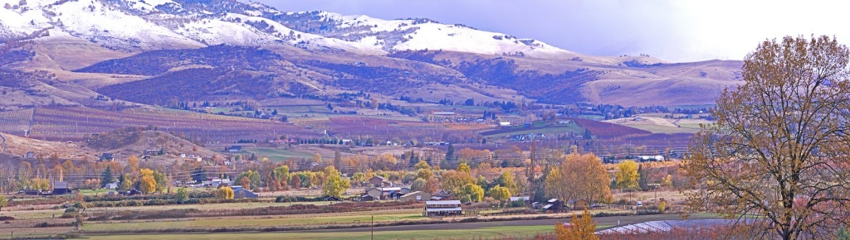

*Photo used under Creative Commons Licensing Agreements*

**I Wonder if We’ll See the Comet**

***by Geoff Jackson***

A clear night sky, slight chill in the air,

Some thin high cloud slowly comes into view.

Small twinkling stars glint, others disappear.

Will we see the comet, will it grace our sky?

Staying put a while longer,

The satellites are getting stronger,

One from the east, another from the west

Slowly gliding across the sky, at a distance so high.

Will the Starlink and its satellites,

Make its presence known,

Moving slowly across the sky

Seemingly like a string of glittering diamonds?

Then…from nowhere… a bright streak from the east.

An explosion of light, that gave me a fright, a beautiful, beautiful sight.

Its long fiery trail flowing into the night, the star at its head

That started out bright, subdued as it flew, now gone in the night.

Think I will sleep with a smile on my face.

**Concentrate Space Lady**

***by D. Osbourne Hughes***

Concentrate Space Lady!

You have no idea.

There I was, shooting the breeze,

From the spice giants of Ursa Romulus

Trimming the moon-worm silken sails

Of my Intergalactic Space Junk.

Oh their cries, a sweet intoxication,

The bed-nag Claxion Space Sirens,

Slowly seducing my mind.

My mainframe showing,

All systems go!

Quantum levels up,

Spermazium count, a little down,

(But always at acceptable levels.)

I was just about to engage

The interstellar overdrive when,

Crash, Bang, Wallop,

You rear ended both my after burners,

Sending me spinning;

Careering through the gamma quadrant.

With my mainframe shot

And my spermazium count,

Half way around the Milky-way.

Space lady!

You haven’t got a clue!

Get your moon dust together,

Cuz the Interstellar Pirate,

Is about to come through!

**Marrying a Known Terrorist**

***by Tony Granger***

Joy was an English rose who had come out from Shropshire in England, after a few years of the Harold Wilson government, to see the world. She had applied to go to Canada where a friend of hers was working, but did not receive a satisfactory reply when a radiologist friend whom she had worked for at Royal Shrewsbury Hospital, contacted her and said ‘come to Rhodesia – there’s a radiographer’s job going at Dr. Duffy’s & Muller in Salisbury, Rhodesia – and I can put in a good word for you’.

So off she went and not before long made some very good friends. Two of those friends, Jan Walmesley and Paddy Krynauw, who worked with her, had husbands in the BSAP, and were invited to our Camelot braai (BBQ) and brought Joy along for an afternoon of festivities. That is how I met her and was immediately smitten.

At that time the Rhodesian bush war was in full swing and I had been posted to the North East of Rhodesia for long periods, with few trips back to Salisbury, but I made the most of them. My courtship included driving Joy up Dombashawa rock in a police Land Rover, almost vertical at times, and terrifying!; trips to Lake McIlwaine where I stranded us out in the lake by losing the oars on one occasion, and visits to my parents. Over nine months, I think I saw her five or six times. My dog Blondie did not take kindly to female opposition and began a regime of growling and nipping whenever she was near. Her favourite trick was to leopard crawl up the bed and get between the two of us, turn to me and give me licks, then turn to her and begin growling!

Then came the bombshell. Joy said that she was thinking of going back to England for her sister Jane’s wedding and may not be coming back – unless…… we got married! That came as quite a shock to me as I had naively not considered it in my planning, and immediately thought of applying for more bush time. However, I was in love and proposed to her, selling my drum kit to buy the engagement ring.

Under section 2(1) of the Police (Marriage) Regulations, 1965 a serving officer had to make ‘Application for Permission to Marry’. This was on Form BSAP 101. Application is made in terms of Standing Orders, Chapter 11, Section 32, ‘Marriage of Members’. This application form was passed up the chain of command for eventual permission either given or declined by the Commissioner of Police. I submitted the form 101 on 18 January 1977, from my station at Special Branch, Bindura. It gave all the relevant particulars, including Joy’s personal details. She had entered the country on 7 January 1976, met me and now we were due to be married on 30 April 1977 – I actually hardly knew her and we had only met up half a dozen times in total.

After waiting for about two weeks, I was called to PGHQ in Salisbury for a meeting with the Commissioner of Police, then Mr. Bristow. I thought, ‘wow’, the Commissioner wants to personally congratulate me for my wonderful choice of wife.

I was marched into his office, and there he was with my Special Branch OC and various aides. He then began to question me.

‘Where did you meet your intended wife?’ he asked. I said ‘at a house party in Salisbury’. He said ‘Are you sure it wasn’t in Germany when you were on holiday in Europe in 1975?’

I replied no, it was definitely in Salisbury. He then said that the information he had from the Central Bureau Registry was such that I was lying and it was a very serious offence to give incorrect information. Naturally, I was flabbergasted and I objected in bewilderment that this could not possibly be!

The Commissioner then asked me if I knew that my intended was a notorious European terrorist. I replied that it could not possibly be. He then read from my ‘Permission to Marry’ form that Ulrike Meinhoff born on 7 October 1934 at Oldenburg, Germany was my intended spouse. I said, no it was not, it was Joy Benson from Shropshire England.

Then the penny dropped – I had been sabotaged and set up – yet again. My form had been intercepted by my colleagues as it went up the chain of command and the spouse name changed from Joy Benson to UIrike Meinhoff! She was part of the notorious Red Brigades faction that had been terrorising Germany for decades. (Ulrike Meinhof was arrested in 1972 and hanged herself in Stammheim prison during her trial in 1976).

To this day I don’t know whether the Commissioner of Police was in on the joke or misdirection, but he certainly played his part well.

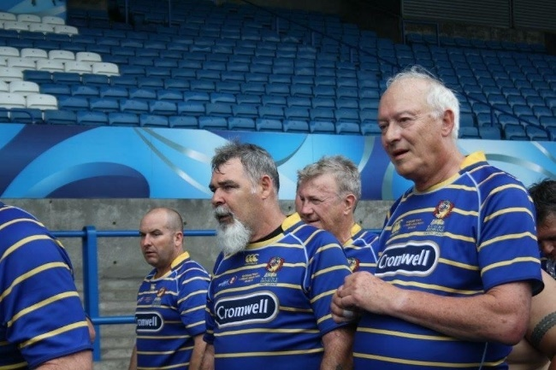

***Tony in later years***

*(Photo: the author and courtesy of Police World)*

**Meet the Author: Henrik Ellert**

Henrik Ellert started his career as a Constable in the then British South Africa Police (BSAP) in 1964, joining the IPA the same year.   He retired in 1980 with the rank of Detective Inspector having served first in the CID and later in Special Branch.

After leaving police service Henrik, with partners,  started a manufacturing business producing paraffin stoves and Tilley lamps from 1982 until 1992 when he joined the International Finance Corporation (World Bank) as consultant investment officer – based in Harare and later as an independent business advisor for mainly NGOs and international development agencies.  From 1994 to 1996 he was engaged by USAID as an advisor  and later country director in Mozambique and Angola  for demobilization, disarmament and reintegration of former combatants.  In 1996 he joined a Nordic development finance organization focusing on private sector business development throughout southern Africa based in Lusaka.   In 2002 Henrik relocated to Denmark continuing to work in the field of development finance and agro-business value-chain lending in mainly Lusophone Africa.   During 2017-18 Henrik worked with a Mozambique development Finance Institution

setting up a small equity investment fund and since then focusing on being ‘not quite retired’.

While in police service Henrik developed an interest in ethnography and history and this led to a number of books.  It all started with short articles and stories for a monthly magazine, published by the Catholic Church.    Henrik plans to do some travel writing - mainly covering Portugal – and intends dusting off old papers to write up some experience episodes.  Reconnecting with the IPA and the SIG Writer’s Group members with a shared interest in writing, seems like a good way to reinvigorate.

Henrik has a son and daughter and three grandchildren all resident in the UK.

Welcome Henrik!

<http://www.africanbookscollective.com/books/a-brutal-state-of-affairs>

[www.mozambiquemosaic.com](http://www.mozambiquemosaic.com/)

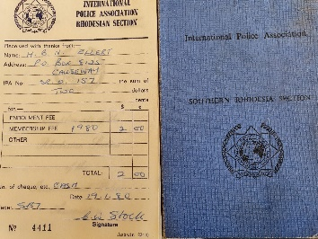 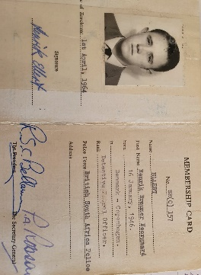

**‘Roads’ Christmas Writing Challenge**

***by Neil Hallam***

The roadbuilding companies I work with are planning a few community projects during the run up to Christmas. One of the group members writes to elderly people, who are on their own. We agreed to take this up as a group, to reach more of these people who will have been affected badly during the Covid crisis.

I thought it might be nice to include pieces of writing from our IPA Writers Group along with the letters.

The challenge to you is: write something suitable for a wide ranging, but elderly audience, on the subject **“Roads” or “The Road”.**

It can be a poem, short story, or anything that takes your fancy. But please limit it to a single side of A4 (at Ariel 14 font)





***Closing Date: 5th November (ish)***

***NETFLIX***[](https://tvline.com/2020/10/08/unsolved-mysteries-trailer-season-1-part-2-netflix/)

***‘MUST SEE’ PRESENTATION: 19th October 2020***

***As a few of you may know, member Rod Repton is researching for a book about two unsolved murders, to be published with our encouragement and support.***

***The following Netflix programme will feature an hour-long episode on one of the cases: the so-called ‘Plaza Woman’ who the programme makers think was a spy.***

Netflix’s ‘Unsolved Mysteries’ Series 2 will cover the mystery murder in an Oslo hotel room and if any of our readers have any information or background that would assist Rod in his book please let him, and/or us, know.

Your support to Rod will be much appreciated. It should be a great story.

<https://tvline.com/2020/10/08/unsolved-mysteries-trailer-season-1-part-2-netflix/>

**William Soutar**

***by ian mcneish***

the tryst

O luely, luely, cam she in,

and luely she lay doun:

I kent her by her caller lips

and her breasts sae sma’ and roun’.

A’ thru the nicht we spak nae word

nor sinder’d bane frae bane:

A’ throu the nicht I heard her hert

gang soundin’ wi’ ma ain.

It was aboot the waukrif hour

when cocks begin to craw

that she smool’d saftly thru the mirk

afore the day wad daw.

Sae luely, luely, cam she in,

Sae luely was she gaen;

and wi’ her a’ my simmer days

like they had never been.

This love poem, so poignant, so lovely, was written by a Scot’s poet in the bed he was confined to for the last thirteen years of his too short life. He dreamed and no doubt he remembered the days before being struck down and paralysed.

He wrote in his own Scot’s tongue and through his poetic genius, demonstrated how that rustic old tongue, despised and dismissed by so many, possesses the ability to create beauty coupled with delicate and subtle depths of meaning. A poem that, in my eyes, ranks alongside the best of Burns and outmatches many of other more well-known poets of this and any other country. Yet, due to dint of circumstances, he is little known outside his home town.

William Souter hailed from Perth, born in 1898, son of a carpenter. He was a handsome and fit teenager. He went into the navy as a young man and was at the location of the surrender of the German Fleet in November 1918. Soon after that William was invalided out of the navy with sever leg pains. His athletic youth was falling away and in his mid twenties still a young man, his illness continued. After graduating from Edinburgh University things got worse and he became incapable of work.

By the time he was thirty he was bedridden and paralysed. He was taken by dreadful bouts of depression, but between such lows he drove himself to write and to become a poet. It seems he was not a natural poet, he was not born to it. He did what many have to do, he worked at it, he was self-made. He toiled over diaries, epigrams rhymes for children, whimsical jottings and poems. Not everything he jotted down was memorable, but much of the rest was powerful, beautiful.

William Soutar, who spent the last thirteen years of his life totally paralysed and bed ridden, died in 1943 at the age of 45 after suffering for years with the paralysing Ankylosing Spondylitis.

His first published work, ‘Gleanings of an Undergraduate’ was published, anonymously, in 1923, ‘Conflict’ followed that a few years later when he was confined to his bed in a room his carpenter dad designed and built for him. Amongst his other works were; ‘Seeds in the Wind’ 1933, a poetry book to encourage children to read and learn the language, ‘Poems in Scots’ and ‘Riddles in Scots’ followed a few years later. His gathering of poems about his home town and surrounds was published under the title, ‘Yon Toun’.

His diaries, entitled; ‘diaries of a Dying Man’ as well as his journals and much of his poetry are kept at the National Library of Scotland. He is honoured in his home town and the Library Theatre carries his name; The Soutar Theatre I launched straight into this small appreciation of the Perth Poet with, The Tryst, one of my favourite poems. I will finish with another, in which he summarizes his life and anticipates his death. I need say no more;

**Autobiography**

Out of the darkness of the womb,

Into a bed, into a room,

Out of garden into a town.

And to a country and up and down

The earth; the touch of women and men

And into the back garden again:

Into a garden; into a room;

Into a bed and into a tomb;

And the darkness of the world’s womb.

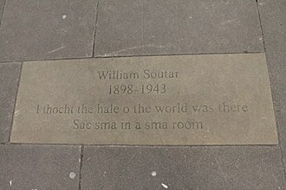

[This Photo](https://en.m.wikipedia.org/wiki/William_Soutar) by Unknown Author is licensed under [CC BY-SA](https://creativecommons.org/licenses/by-sa/3.0/)

**My Dream**

***by ian mcneish***

'I say it is useless to waste your life on one path, especially if that path has no heart.'

'But how do you know if a path has no heart?'

'Before you embark on it you ask the question: Does this heart have a heart? If the answer is no, you will know it and then you must choose another path.'

'But how will I know for sure whether a path has a heart or not?'

'Anybody would know that. The trouble is nobody asks the question: and when a man finally realises that he has taken a path without a heart, the path is ready to kill him. At that point very few men can stop to deliberate and leave the path.'

Carlos Castanada

'Teachings of Don Juan.'

It was the autumn of 1973, I was twenty-seven years old. My young son, seven months old, was sitting on the living room floor in the middle of a large white blanket. His mum and I were searching him and his clothes for Ceratophyllus hirundinis and Oeciacus hirundinis. To be honest I would not recognize either. There was a big empty glass jar on the blanket. It was not empty. On the bottom was a very small thingy. It may well have been one of the former, we did not know. What we did know was it was an intruder, a parasite. The former named is better known as a 'house martin flea,’ a nasty blood sucking critter. You guessed correctly. Our house had several house martin nests under the eaves. We resided in a top flat apartment in a council block in Peterculter on the western outskirts of Aberdeen near the main Aberdeen to Braemar road. We had been visited by the council pest control officer, who had advised us of the perils of house martins nesting on your building. It appears their nests can be infested by twenty or more ectoparasites. Often some will migrate inside the building and find a human host. The two most popular would appear to be the two I named. The pest control officers, left the jar and advised we search our son, his bedclothes and his clothes. We had to check our clothing. We only ever found a couple on the wee one. We took our captured species to be identified. The pest control returned and spread powder and removed the nests, which were empty of young House Martins by then. If you are interested, we had captured a house martin flea. By the way, so you can get a timescale to this event, Zolton Varga was a player with Aberdeen football club. I used to wonder if Ceratophyllus hirundinis was also a Don. I recount that incident, not only because we found an infestation on my young son, but because I found something else. I found a dream, a reawakening, a realization, and it was as vivid as finding the house martin flea on my son. So, with captured flea in the jar I chose that moment to tell my wife that I needed to move on from Aberdeen County Council. She asked my why. I told her I wanted to become a police officer, that is all I ever wanted to be and at my age perhaps this will be my last chance. Her reply was short and supportive. 'If that is what you want, just do it'. A walking Nike advert, years before they even thought of it.

Decision made, just get it done. Fleas had absolutely nothing to do with my decision. I have often thought of that moment and my police dream that had lain dormant. An old aunt has since told me that she always knew I would be a police officer. Not only was I certain that I wanted to join the police service, I was equally certain it would be north of Inverness. I did not immediately start the ball rolling as I wanted to run it past my dad. A couple of weeks later he and I were in the bar of the Rothes Arms Hotel in Glenrothes. He had moved again and the co-op in Glenrothes was where he was now gainfully employed. His last co-operative as things turned out. It was a rare occasion to find us in a bar together, in fact I do not recall another such liaison. My mum had died earlier that year, June 1973. I tried to visit dad as often as I could. He was an extremely self-sufficient individual and never gave any indication he needed support.

Mum had suffered from cancer, various outbreaks, over many years. She was a survivor, but there comes a time, no matter how spirited and stoic, when death arrives. We had been told towards the end of 1972 that mum would not live that year out. She spent a lot of time in her bed. She was reading the Isaac Asimov, 'Foundation Trilogy' and was obviously in a hurry to get it finished. Her doctor was also hurrying her along as he was also reading it. Her copy. As mum finished the first book, he took it away. Then the second and so on.

It was a poignant, muted, Hogmanay as we headed into 1973. New year was big in our household, much more important and emotional than Christmas. We never partied during Hogmanay; cleaning done, house gleaming, drinks charged, and we waited, glasses poised, for the bells and the new year. Our toasts to family and friends, past and present were meaningful and heartfelt. Be assured, we did party after the bells. Mum had joined us and sat quietly in the corner of the living room. It was midnight, we were entering the new year and I just stood looking at her, hesitant, I did not know what to do. What was there to celebrate? Looking at her and thinking about her. She smiled and raised her glass, as if telling me it was fine. She beckoned me over and as I sat on the arm of her chair. Life is what it is she said, death is as real as living. Celebrate what we have and have had. Tears were running down my face as I took that sip then hugged her. She whispered something to me I will never forget. It was not a secret. It was a message of hope, because that was mum. She said, ' Dying is a consequence of living, don't be frightened of it. Please be what you can be and remember, they told me I was going to die before new year, they don't know everything. I will live to see my first grandson; I can go then.' Our first born was due in April 1974. Yes, the infested one. He was born on 20th April and mum died on the tenth day of June.

That night in the bar in the Rothes Arms, Glenrothes, I told my dad about my police dream. He was less than enthusiastic and tried to talk me out of it. He said I was not suited to be a police officer and interestingly, he did not think I was 'hard' enough and my character was not tough enough. That conversation was perhaps the only meaningful one dad and I had ever had in the twenty-seven years of my life. I never forget it. I was not angry, I was disheartened. I think I was also a bit lost, as the main influence on my life was trying to turn me from my dream. I wondered if I was being foolish for even having a dream. Do working class people have dreams? Anyway, I said I was only thinking about it and changed the subject. I loved my parents and worshiped my dad. Heroes do not occupy much time in my thinking. I do respect a few people, but heroes, not really. However, if forced to elevate anyone to the status of hero, I would be hard pushed to name one. My parents and my brother probably. Outwith my immediate family, there is only one. Perhaps in a different category because of that, whatever, it has to be the physicist, Richard Feynman.

I think I probably disappointed dad, I frustrated him in some ways. I have no idea what he wanted of me or what he thought I should have achieved; we never spoke about anything like that. Sad to relate really. I honestly have the belief he did not rate me very highly. I don't think he appreciated, perhaps understood is a better word, how hard I tried to live up to him. He was one of the bravest men I ever knew, he feared nobody. He was not a bully, he was not a 'hard man'. He was honest, had integrity and was definitely not born to follow. In fact, I don't think he ever learned to walk backwards. Not based on Stalin or Soviet Order 227, Not one step back, but pretty similar. He never saw his reflection in me and sadly never would get that opportunity. He was wrong that night in the Rothes Arms. I did join the police service a few months later and within six months dad was dead. I regret, selfishly, that he never got the chance to see something in me he had never known.

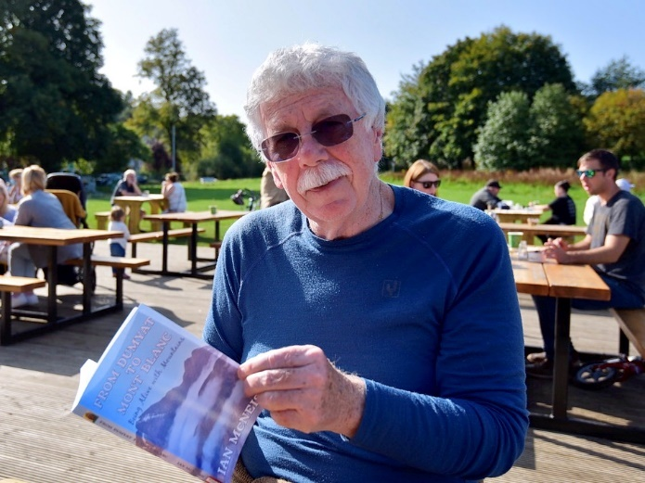

***ian mcneish***

**One morning Glasgow woke, rubbed the sleep from its eyes and went to work.**

***by Malky McEwan,***

Glasgow passed the statue and rubbed its eyes again. It couldn’t believe the effrontery — someone had placed a traffic cone on the Duke of Wellington’s head.

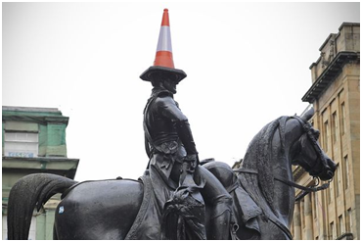

The statue of the Duke of Wellington astride his horse was erected in 1844 and there it stood, with little fanfare for one-hundred and forty years.

Abused by a cone, — placed by a drunken reveller, no doubt. The council promptly had it removed.

The next week another cone appeared on his head, and the council removed that too - and the next one and the one after that. It became a ritual. Whenever they removed a cone, a few days later another one would appear.

The council weren’t happy; they complained to the police.

The night shift sergeant picked two rookie cops fresh out of the box, sticky tape still stuck to their uniform.

“Guys, you will do foot patrol in the city centre this evening. For your information, the council removed the cone from the Duke of Wellington statue today. Can you bear that in mind when you are on patrol tonight, please.”

The two rookie cops arrived back at the station to finish their shift in the morning.

“How did you get on?”

“Fine sarge.”

“Did you remember the statue?”

“Yes, sarge,” the two cops looked at each other, pleased with themselves, “we did.”

“Well done, was there any trouble?”

“No sarge, we just waited until it was dead quiet and put it back. Don’t worry, nobody saw us.”

There are some quarters who believe the practice is disrespectful.

Arthur Wellesley, 1st Duke of Wellington was best known for giving his name to the wellington boot (also defeating Napoleon at the Battle of Waterloo).

He is a military hero who should be respected. Being an object of ridicule is not how the City Council wanted him remembered, they wanted to restore his dignity.

They put forward a plan to heighten the plinth to prevent anyone from climbing the statue.

There was an uproar.

Glaswegians are proud of their culture and they wanted to keep the cone.

It isn't just the locals who loved the cone, fans of the iconic red and white hat from all over the world signed a petition to keep it. It was an ill-advised plan, gallus Glaswegians would have taken it as a challenge. It wouldn't prevent it, it would only make it more dangerous. The council backed down.

It has become an emblem for Glasgow, it promotes tourism; Lonely Planet named it as one of the top ten bizarre monuments on earth.

Old ‘conehead’ has become a symbol of Glasgow’s way of life. Glaswegians revel in the absurd, they cock a snook at authority and they don’t give a damn what people think.

I love it.

Every time I see that cone atop the Duke’s head I can’t help but smile.

I carried on down Queen Street to have another shufti. The statue came into view. Instead of a single cone, there were six piled up on the Duke’s head and a single cone on the horse’s head; I couldn’t help but burst out laughing.

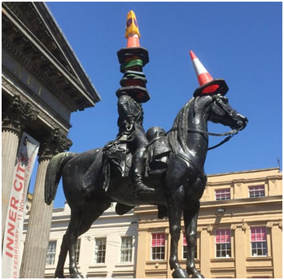

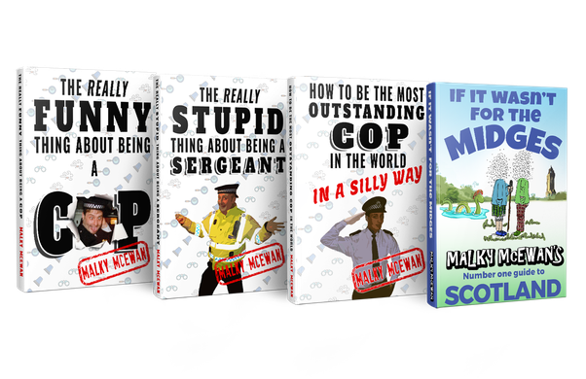

**Some of Malky’s books: all available from the author or through The *Writes* Bookshop.**

**Tales from Madeleine’s’ Patch**

<https://www.facebook.com/madeleinespatch/>

***by Steve Parnwell***

**Dawn Breaker**

On the gymnasium wall at HMS Ganges in Suffolk, formerly a naval training base and latterly Shotley Police Training Centre was, and for all I know still maybe, a large mural script of Rudyard Kipling’s *“If”*. In the 1970/80’s a frequently duplicated poem *“Desiderata”* adorned the walls of virtually every office in Cambridgeshire Constabulary. Sometimes cited as “Anonymous from a gravestone in Baltimore” or “Max Ehrmann's 1920's poem”. Whatever the origins, it is a powerful writing that captured the imagination of many people and was popularised in Les Crane’s 1971 music chart hit (<https://www.youtube.com/watch?v=2yNJaKF9sXA>.).

My father once told me if I could live by the tenets of these two writings, I would not go far wrong. Perhaps a simple undramatic statement but then my father was not one for verbosity. Nevertheless, over the years through the many blows that life has dealt me, I have strived to honour that advice. Failing on many occasions, it has, however, been an unfaltering credo that steered my path through the storms, challenges and travails that beset each of us. I return to both poems sometimes merely to reaffirm my raison d'être, for it is easy to lose sight of the important when the mundane triviality of mere existence intrudes.

One such challenge was presented to me as a young police Inspector in charge of “Red Section” at Cambridge’s Parkside Police Station in the early 1980’s.

In those days we worked a straight 4-week shift system of Earlies -7am-3pm Lates -3pm -11pm and Nights 11pm -7am. Occasionally we would have to work the “Steaming Boot” regime: nights, followed next day by one late shift, followed by an early shift which meant you were either working or sleeping and thus never had time to take your boots off in between.

As Red Section approached its turn on “Nights” we were acutely aware that each day for the past month when we paraded for duty we would be assailed by a number of crime reports relating to a spate of burglaries that happened overnight whilst people were asleep in their beds. Following several early morning disturbances during which the perpetrator made off and mysteriously disappeared by the time the emergency response vehicles arrived at the scene, the burglar was nick named “The Dawn Breaker.”

As our night shifts approached, the senior divisional officers were getting decidedly twitchy as the press were lambasting them for lack of successful actions in bringing the thief to justice. Speaking as one who has personally experienced a break-in, I can testify that an invasion of your home is deeply unsettling and when this is coupled with it being carried out whilst one is asleep I can imagine the added fear and anxiety this would engender is greatly magnified and the public had every right to question what their local police were doing about it.

Against this backdrop I decided that Red Section would do all it could to bring these crimes to a halt. To this end I deployed several plain clothed officers on foot and in unmarked vehicles within the eastern side of Cambridge where most of the crimes had been committed. Nothing unremarkable in that you may say, and I would agree with you. Nevertheless, it did set up the circumstances in which the following scenario unfolded.

Round about 5 a.m. I was in my office at Parkside, the particular duties I was engaged in escape me now, but suddenly over the pocket phone which I monitored as I went about my other section tasks, there came an urgent call for “Cambridge 1” the local Sector Panda Car to respond. A male person had been disturbed in suspicious circumstances and had made off on foot from a plain clothes officer in the Queen Edith’s Way vicinity. “This is it.” I thought, “We must not lose this opportunity by merely sending one response vehicle.”

As I grabbed my pocket phone radio and tunic, I raced down the corridor to the car park, calling to report writing officers to follow me, as I did so I called upon the Divisional Control Room to deploy every one of my section vehicles within the city that was unassigned and for those engaged in dealing with prisoners to bang them up in the cells and to deploy too. I instructed the Control Room to deploy officers in a ring at every junction within a 1 block radius of the scene and to stop all and everything that moved.

Attending the scene, I spoke with the plain clothes officer, Police Constable John Van Wyk who stated that he had spotted a man acting suspiciously near a vehicle and as he approached the man had ran off and rapidly disappeared. John showed me where he had disappeared and during a quick debriefing, I asked John how far the man could have gotten since he was last seen up till now. He assured me that he could not have gotten far.

Based on that information I pulled the deployed officers into a tighter ring so that each one could see their colleagues on either side of them in effectively a ring of visual containment while we waited for day light. For some reason,

the dog handler was not available at that time so that resource was not available to me.

The time ticked by as I waited for daylight to break so we could commence an effective search and I became acutely aware that a drizzle was now falling in one of those fine but penetrative rains that saturate the outer weft of your clothes. I realised that in the haste to deploy, my waterproof anorak was still on the back of the chair in my office. I was also aware that several of my officers were also in similar situations ably reminded by the Control operator as he relayed calls from officers, particularly the old sweats as to how long they were going to have to stand around like this getting wet?

This is when the peer pressure started to build. I responded by instructing all officers to stand their ground until further notice from me. I knew this would not be a popular command and if it did not pay off, the canteen gossip would be rife with all the usual expletives. But then, we can’t make every judgment on the basis of a popularity contest and sometimes not everyone has the big picture or even all the straight edges in which to frame the puzzle.

By now it was daylight and the early turn shift would soon be booking on wanting to take over the vehicles, so once again I asked John Van Wyk how sure he was as to how far the man could have gone before we established the cordon? He assured me he was certain it was not far.

Putting my faith in John I called up the control room and said “As soon as the day shift arrives give my compliments to their Inspector and ask him to send me all of his available officers to me for a final deep sweep of the area. Also, by this time, the dog handler had arrived and having witnessed and taken part in many almost miraculous track and arrests by our excellent dogs and their brilliant handlers (more of this in a future article), I was certain that if John was correct, we must soon be able to locate the suspect, or at least flush him out. Memories came to mind of when I was a youth, and used to flush

game to the waiting guns on the boxing day shoots, earning half a crown for a day’s beating duties in winters that were much colder than they are now.

The day shift arrived *en masse* and reported to me for instructions. I deployed them in a line, garden by garden to hand search every nook and cranny knocking each householder up as we went to explain what we were doing in their garden. Within five minutes officers returned with a small, unassuming middle-aged man with balding hair. He wore a crumpled brown checked jacket and tie which clashed incongruously with a pair of white plimsols.

Back in the cell block, as the dayshift CID prepared to interview him, I took the opportunity to look my adversary in the eye. He sat hunched forlornly in the corner of the cell but as I entered, he looked up and in a flash of recognition he smiled resignedly as our eyes locked momentarily.

It transpired that he had given himself up, realising that the ring of observers gave him nowhere to go and his hiding position on top of a shed roof was becoming increasingly untenable as daylight broke. His hideout was not far from where he had last been seen and within a stone’s throw of my location. He could apparently see me illuminated by the streetlights and in the cover of darkness had heard my instructions for the officers to stand firm.

Subsequently he admitted a string of burglaries and the people of Cambridge could sleep soundly again. As could, presumably, the senior officers now that their press haranguing would cease.

It emerged that he usually hid-up in a camper van after the break-ins and then mingled with normal daytime traffic when it got busy. He also said that when he was disturbed, he would secret himself away and wait until the police had attended and left again after usually a cursory search around, before resuming to make his escape. He was amazed at the tenacity of our team particularly as he too was getting very wet up on the shed roof.

I left the CID to it while I went home to sleep and then to tend my small holding with my wife Madeleine until it was time to start the day shifts.

Back on day shift a week later, the Divisional Superintendent spoke to me as we met casually at the station photocopier. He mentioned the incident and informed me that John Van Wyk was to receive a Chief Constable’s commendation for flushing out the criminal and that he had nominated me too, but the Divisional Chief Superintendent had overruled it saying “At his rank he is only doing his duty.”

There is a saying in the Police there is often a thin line between a commendation and a bollocking. Chances taken that go wrong end in a reprimand or worse, whilst others that go right can lead to recognition by the powers that be. On this occasion I was on the receiving end of neither and as the Chief Superintendent in his wisdom had stated, I was merely doing my duty.

But when I look back and consider the peer pressure, a saturating rain and a lock down of the entire Division’s resources for almost two hrs in the face of chuntering from some of the bedraggled troops who were beginning to question the wisdom of the exercise, I hear the echo of Kipling’s words “If……...”

Read them sometime, perhaps you will understand what I mean. I commend them and the wisdom of Desiderata to you. No doubt the universe is unfolding as it should.

<https://www.facebook.com/madeleinespatch/>

**Nature Notes**

***by Steve Parnwell***

Seasons move on. Blossom in the hedge transforms to hips, haws and drupes. All precursors to a bountiful autumn harvest yet to come. Green now, but autumnal riots of orange, red and purple fruits will feed the wildlife and provide forage for others who may fancy a tipple of sloe gin or rosehip syrup to help stave off winter’s chill.

Punctuated by splashes of pink great-willow herb, dense stands of common reed are beginning to flower along the margins of the drain at Madeleine’s Patch. At Madeleine’s Patch HQ, early fruits are ripening; strawberries, raspberries, cherries and redcurrants bring their subtle touch to the garden. Dreams of summer fruit pudding are thwarted as the early bird literally steals a march on would be fruit pickers, but we don’t begrudge the loss of the fruit to the songsters that grace the garden with their melodious tunes. They truly do sing for their suppers. Or breakfasts at least.

Early nesters have fledged their broods now and yet the young magpie and jackdaw chicks still noisily beg for food from their parents crouched in submissive mode with beaks agape, who could resist their supplications? Young blue tits and great tits bedecked in their pristine pastel coloured feathers regularly visit the feeders to peck at the peanuts.

The newly planted hedges are holding their own and weeding between the shrubs to reduce competition for light and water is almost finished.

The unusually strong winds for this time of year surf through the tops of the willows sounding like waves crashing on the shore, yet in the sunny secluded shelter of the more mature hedges, butterflies and other insects are still able to go about their business unheeding of the turbulence above them. A clear sign that micro-habitats are a worthwhile feature for wildlife.

A family of whitethroats flit along the hedge as I walk past, while a wren sounds its “tik” “tik” warning call like one pebble striking another and is joined by a chaffinch with its sharper “cheep” “cheep” call.

Pollinators are still active from dawn to dusk in the ornamental borders at Madeleine’s Patch HQ. Our borders are an eclectic mix with many wildflowers being deliberately retained. I know this will be an anathema to many gardeners but when we view the insect pollinators swarming over a patch of wild scentless mayweed with its delicate filigree foliage and daisy like flowers we think “if it ain’t broke don’t fix it”.

An intriguing black bumblebee is a frequent visitor and has been identified as a melanistic variation of the Ruderal Bumblebee (*Bombus ruderatus*) designated as nationally scarce and a UK Priority Species. Another newcomer to Patch HQ and comparatively new to the UK is the Tree Bumblebee which is nesting in a bird box. By end of July the colony will have died off leaving the queen to overwinter. A very tiny bee with bulging pollen baskets has also been spotted on the mayweed and has yet to be identified.

A scarce chaser dragonfly – scarce by name and scarce by UK designation has taken up residence and hopefully will spawn in the ponds this year.

Sitting by the water vole pond I am suddenly struck by the fact that as a child, when I roamed the countryside near Cambridge, I could often hear the quiet lazy crunch of water voles chewing on reeds and grasses, a tell-tale sign long before I was near enough to see them squatting on the banks of the ditch opposite my childhood home. Clearly my hearing is not as good as it once was as it is many years since I have heard that evocative sound. This is of course also indicative of the fact that over the past 30 years or so water vole populations (‘Ratty’ from Wind in the Willows) have crashed by 90%. Their presence in our new pond is the epitome of what we are striving to achieve. A small success in the fight against the relentless devastation of our countryside.

Purple thistles now stand tall among the grasses a pretty flower but a menace when the thistle down floats far and wide to colonise new areas. We leave a few for the pollinators to take their sup.

And who knows? A fairy may be in need of a lift to be wafted on the gentle breeze, parachuting to magical places. All things are possible in an infinite universe. Just do the maths. Why, only last week I sent away a vast number of monkeys trying to sell me the complete works of Shakespeare. Basically, I was a bit dubious of copyright despite the fact that I would be paying them peanuts.

A whimsical fantasy maybe but seriously though, false oat-grass, common on almost every roadside verge is turning from green to the colour of straw. Similarly, in the cereal prairies surrounding Madeleine’s Patch the wheat and barley crops are almost imperceptibly ripening day by day and harvest time is not far away. The summer solstice has come and gone and now the evenings will draw in. Gradually at first but we cannot hold back the encroaching darkness. However, light can still help us find our way. Just as Madeleine’s Patch is providing a beacon of hope for our small populations of local wildlife, perhaps others can too shine some light to hold back the dark destruction of the habitats and species, we share this planet with? The lockdown has shown that nature can recover if treated with care, yet still doom-monger politicians (30 June 2020) seek to ridicule and undermine the protection of biodiversity by crass, ill-informed sound bite statements that do them no credit and send out dangerous signals for the future of UK’s beleaguered wildlife. Where do you stand? Rainbow Warrior in the sunlight or “Daft” Vader on the dark side?

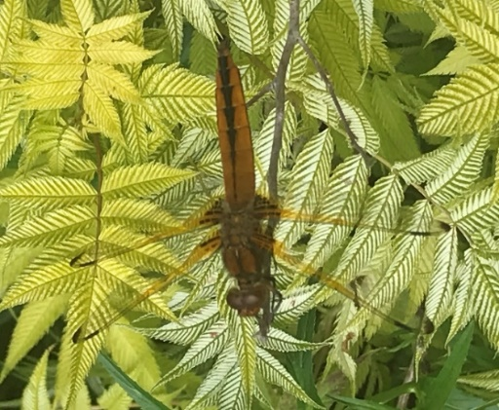

Scarce chaser dragonfly Madeleine’s Patch HQ

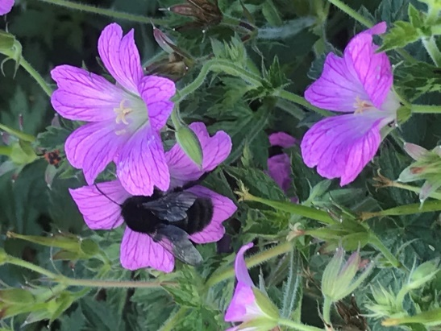

Melanistic *Bombus ruderatus* at Madeleine’s Patch HQ

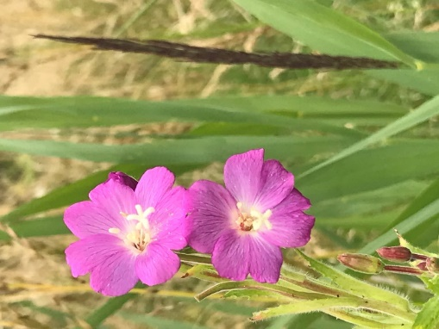

Great willowherb juxtaposed with brown

flower of newly unfurling common reed

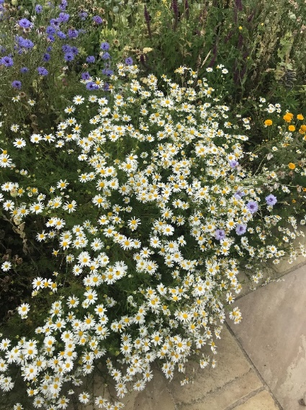

Scentless mayweed in flower border at

Madeleine’s Patch HQ

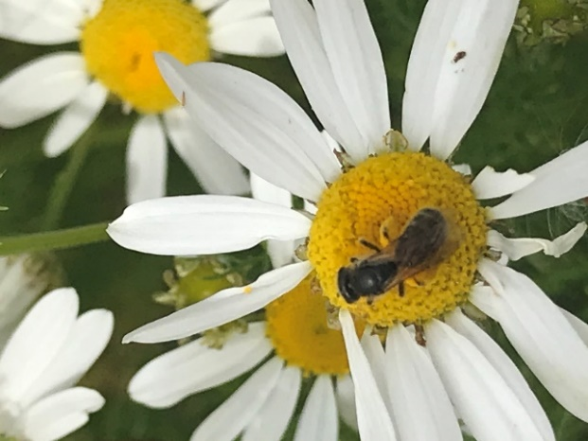

Small unidentified bee (as yet)

on scentless mayweed at

Madeleine’s Patch HQ

**The Bookshop:**

**Candy *by JaD***

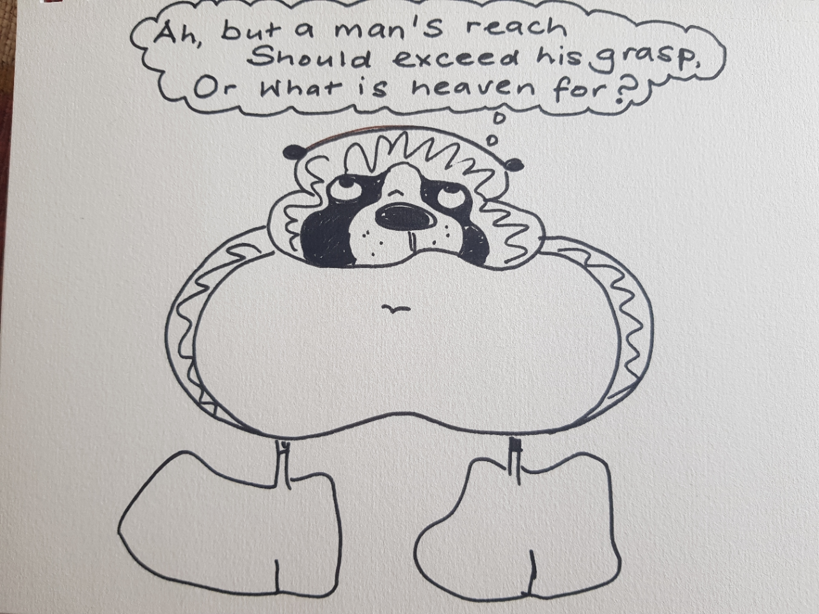

‘Go placidly amidst the noise and haste?’

(Max Ehrmann)

(See ‘Dawn Breaker’ by Steve Parnwell)

**All books available through the magazine or direct from the authors. This is a selection of our writers only; we want to build up The Bookshop to be comprehensive service to our members so if you would like your books shown here please send us the cover photo, RRP, with a two-line description of the topic.**

**We are intending to have a web-site shop in due course.**

**Also check out the Group Facebook page; ‘International Bookshop’ which has space for listing all our member’s works.**

**If you would like us to carry details of your works in *‘Writes’* and on the website (eventually) please can you supply (up to date) the following:**

* **A photo of the front cover in good resolution**
* **A two-line description of the content and genre**
* **Your name and your writer’s name**
* **A brief 100-word bio of your writing career**
* **The Recommended Retail Price (RRP) and any discount offers.**

**Please note that ‘The Bookshop’ is still under construction here!! It will not appear every edition but please send all details you might like in ‘The Bookshop’.**

**The Station Cat Writes…**

**The Cat** has of course been busy but keeps a watch out for what is going on…well he tries to…

**One for the diary -** should be fabulous: please follow the link:

**May-Britt Ronnebro**, the Secretary-General of IPA and a great supporter of our Writers SIG and Global Writers Forum, is lecturing in an online seminar in two parts at the London Policing College on:

**‘Delivery of Policing in the Covid-19 Pandemic – a Comparison Across Countries’**

**26th and 27th of October 2020**

https://policinginthetimeofpandemic.eventbrite.com

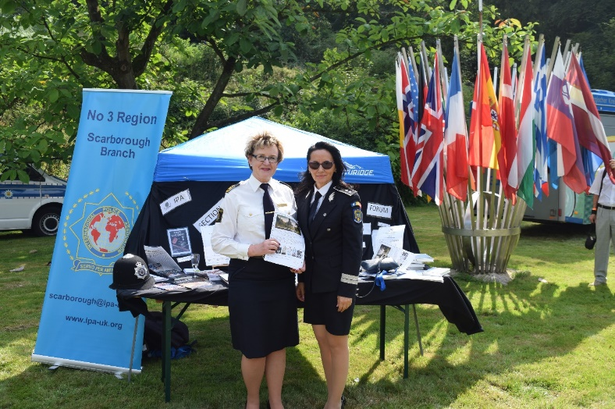

May-Britt Ronnebro and the Section Romania President at the Writers SIG stall at Gimborn’s 50th  IBZ anniversary celebrations in 2019

***Thank you all, wonderful writers; please stay safe and well.***

***Editorial Note: This newsletter is copyright to Bryn Stowe Publications and the IPA. Individual submission copyright remains with the contributing authors. For any corrections or omissions please mail:***

***The Editor, ‘Writes’:*** [***davidlewis@brynstowe.co.uk***](mailto:davidlewis@brynstowe.co.uk)

***©IPA and Bryn Stowe Publications 2020***